SUBCOURSE EDITION
AV0584 A

US ARMY AVIATION CENTER

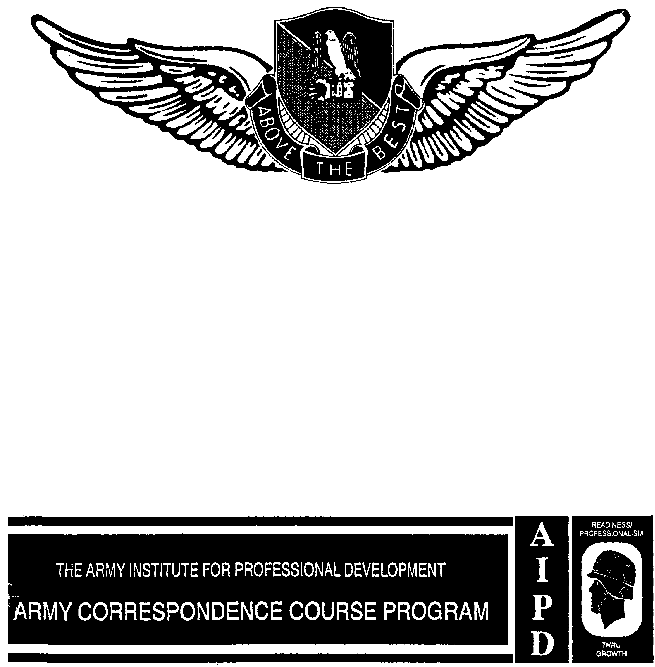

SAFETY PROGRAMS

THIS SUBCOURSE HAS BEEN REVIEWED FOR OPERATIONS SECURITY CONSIDERATIONS.

SAFETY PROGRAMS

Subcourse Number AV0584

EDITION A

United States Army Aviation Center
Fort Rucker, Alabama 36362-5000

8 Credit Hours

Edition Date: December 1992

SUBCOURSE OVERVIEW

This subcourse reflects safety programs designed to reduce and keep to a minimum accidental manpower and monetary losses, thus providing more efficient use of resources and advancing the combat effectiveness of the Army. These programs also have the goal of providing a safe and healthful environment at all times for all Army personnel and others exposed to Army operations.

No prerequisites exist for this subcourse.

This subcourse reflects the current doctrine when it was prepared. In your own work, always refer to the latest publications.

Unless otherwise stated, the masculine gender of singular pronouns refers to men and women.

TERMINAL LEARNING OBJECTIVE

ACTION: You will recognize basic federal documents that include the Occupational Safety and Health Administration (OSHA) programs, identify OSHA program areas, and describe the implementation of OSHA within the Army. You will describe the organizational structure and list the objectives of the Army Safety Program (ASP). You will describe the safety awards program and distinguish between the awards of Excellence, Merit, and Honor. You will identify the impact of drug and alcohol abuse on accidents and develop a successful drug and alcohol abuse prevention program.

AV0584
CONDITION: You will use the material in this subcourse.

STANDARD: To prove competency of this task, you must achieve a minimum of 70 percent on the examination.

AV0584
TABLE OF CONTENTS

Section Page

Lesson 1: THE OCCUPATIONAL SAFETY AND HEALTH PROGRAM 1-1

DOD Occupational Safety and Health
Implementation 1-2
The Occupational Safety and Health Act 1-2
The Occupational Safety and Health Adminis-
tration and the Army Safety Program 1-5
Organizing for Compliance 1-8
Creating Support for the Occupational Safety
and Health Administration 1-17
Employee Rights 1-21
Violation Detection and Correction 1-25
Compliance Priorities 1-27
When the Occupational Safety and Health
Administration Representative Arrives 1-36
The Occupational Safety and Health
Administration Action Program 1-38

Practice Exercise 1-41

Answer Key and Feedback 1-43

Lesson 2: THE ARMY SAFETY PROGRAM 2-1
Part A: GENERAL 2-2

Safety Goals 2-2
Objectives 2-2
Policy 2-3
Responsibilities 2-4
Personnel Compliance and
Evaluation 2-9

Part B: PROCEDURES FOR ORGANIZING THE ARMY
SAFETY PROGRAM 2-10

Procedures 2-10
Program Evaluation 2-12

i AV0584
Section Page

Part C: HAZARD IDENTIFICATION 2-12

Hazard Analysis Procedures 2-12
Inspections 2-13
Reporting Accident Causal Factors 2-17
Reports of Unsafe or Unhealthful
Conditions 2-17

Part D: ANALYSIS OF CAUSAL RELATIONSHIPS 2-19

Origin of Accidents 2-19
Procedures for Gathering Data 2-20
Periodic Analysis 2-20
Modification of Analytical
Procedures 2-20

Part E: ACCIDENT PREVENTION: SAFETY,
PROMOTION, TRAINING, AND AWARDS 2-20

Decisions of Risk 2-20
Physical Standards 2-21
Violation Correction Policy 2-23
Abatement Program Procedures 2-23
Safety Training and Education
Standards 2-24
Motivation for Safety 2-28
Safety Awards 2-28

Practice Exercise 2-31

Answer Key and Feedback 2-34

LESSON 3: DRUG AND ALCOHOL ABUSE 3-1

Alcohol as an Accident Causation Factor 3-2
Controlling Alcohol as an Accident Causation
Factor 3-5
Specific Programs 3-6

Practice Exercise 3-9

Answer Key and Feedback 3-11

APPENDIX A. SAFETY PROGRAM EVALUATION CHECKLIST A-1

APPENDIX B. ALCOHOL AND ACCIDENTS: A FACT SHEET B-1

ii AV0584
Section Page

APPENDIX C PUBLICATION EXTRACTS C-1

DODD 1000.3 Accident Prevention,
Safety, and Occupational
Health Policy for the
Department of Defense

Glossary G-1

iii AV0584
LESSON 1

THE OCCUPATIONAL SAFETY AND HEALTH PROGRAM

Critical Task: None

OVERVIEW

LESSON DESCRIPTION:

This lesson will help you recognize basic federal documents that include the Occupational Safety and Health Administration (OSHA) programs, identify OSHA program areas, and describe the implementation of OSHA within the Army.

TERMINAL LEARNING OBJECTIVE:

ACTION: You will recognize basic federal documents that include the OSHA programs, identify OSHA program areas, and describe the implementation of OSHA within the Army.

CONDITION: You will use the lesson text to complete the action.

STANDARD: You will recognize basic federal documents that include the OSHA programs, identify OSHA program areas, and describe the implementation of OSHA within the Army according to this lesson.

REFERENCE: The material in this lesson was derived from the following publications: AR 385-10, AR 385-40, and DOD Directive (DODD) 1000.3.

INTRODUCTION

The integration of OSHA requirements in 29 CFR Part 1960 and the requirements in DODD 1000.3 are required to accommodate the situation of the armed forces. They are designed to reduce and minimize accidental manpower and equipment losses. These programs are to provide a safe and helpful environment to all military personnel and all others exposed to Army operations.

1-1 AV0584
1. DOD OCCUPATIONAL SAFETY AND HEALTH ACT IMPLEMENTATION

Based on the guidance published by the OSHA in 29 CFR Part 1960, the DOD has published its own directives and instructions for the component services. DOD has altered some of the requirements contained in Part 1960 to accommodate the special situation of the Armed Forces.

a. The basic DOD policy statement on safety and occupational health is contained in DOD Directive (DODD) 1000.3, Safety and Occupational Health Policy for the Department of Defense (Appendix C). This directive states DOD safety and health policy emphasizing damage control as well as injury prevention. It makes reference to systems safety as a required element of component programs.

b. DOD policy on OSHA and component contractor relationships is shown in DOD Instruction (DODI) 1000.18, Federal and State Occupational Safety and Health Inspections and Investigations at Contractor Workplaces on Department of Defense Installations. This instruction details policy on inspections and investigations of accidents occurring in contractor operations on DOD installations. DOD has agreed not to interfere with such inspections. Since most Army installations have contractor operations of various kinds, it is proper to study provisions of this directive in some detail.

c. DODI 1000.19, Mishap Investigation, Reporting and Recordkeeping, is the basis of Army accident reporting and accident costing procedures contained in AR 385-40.

d. DODI 6055.1, Department of Defense Occupational Safety and Health Program, is the detailed DOD implementation of Part 1960. Key concepts contained in DODI 6055.1 include the procedure for prioritizing violations that adds a chance estimate, the abatement plan, and variance provisions. DODD 1000.3 and DODI 6055.1 are implemented in AR 385-10.

e. Actual operating guidance is contained in the Army regulations that implement DOD guidance. Most Army safety professionals, however, will see the merit in studying and clearly understanding the continuity of policy beginning with the Occupational Safety and Health Act (OSHAct), moving to Executive Order (EO) 12196 that ordered federal agencies to comply, then to Part 1960, to DOD policy, and finally to Army implementation.

2. THE OCCUPATIONAL SAFETY AND HEALTH ACT

a. The best purpose and objective statement ever written on the OSHAct was prepared by Congress and put into the Act in 1970. The Act itself incorporates provisions intended to realize these goals. The

1-2 AV0584
findings and purpose statement reads as in Figure 1-1.

b. Clearly the Act is bold in its conception and objectives and provides for a total occupational accident prevention effort on a nationwide scale. Implementation of the Act involves three separate agencies: the Department of Labor (DOL) (including OSHA and the Bureau of Labor Statistics [BLS]), Department of Health Education and Welfare (DHEW), and the Occupational Safety and Health Review Commission (OSHRC). Since this Act has a far-reaching impact on the accident prevention field, it is worthwhile to look at the functions and organizations of each of these agencies created by the Act.

c. The OSHA is divided into three major program areas. These areas and their key functions are:

(1) National Programs

The key functions of national programs are standards development and issuance and setting up the Federal Agencies Program. Included also is OSHA training and education of in-house staff and employees and employers in general.

(2) Regional Programs

The key functions of regional programs are providing national support for development of state plans and approval of them and monitoring and assessing the effectiveness of the federal and state compliance efforts. Other key functions are assuring effective implementation of the compliance program through inspections and providing technical help as needed.

(3) Administrative Programs

The key functions of administrative programs are providing personnel management, financial management, and administrative services for OSHA; and providing information systems services for OSHA and data to improve management. Included also is performing management analysis reviews to improve overall OSHA efficiency and effectiveness.

d. The OSHRC is a quasi-judicial, presidentially-appointed board that has the mission of judging the merits of contested citations. Under the Act, an employer who is cited for a standards violation can contest that citation. His case will be heard by an administrative law judge. The three-member review commission itself then can review the law judge's findings and can make its own final determination supporting or overturning the law judge's findings. The employer unsatisfied with the OSHRC proceedings can get further review in a US Court of Appeals.

1-3 AV0584
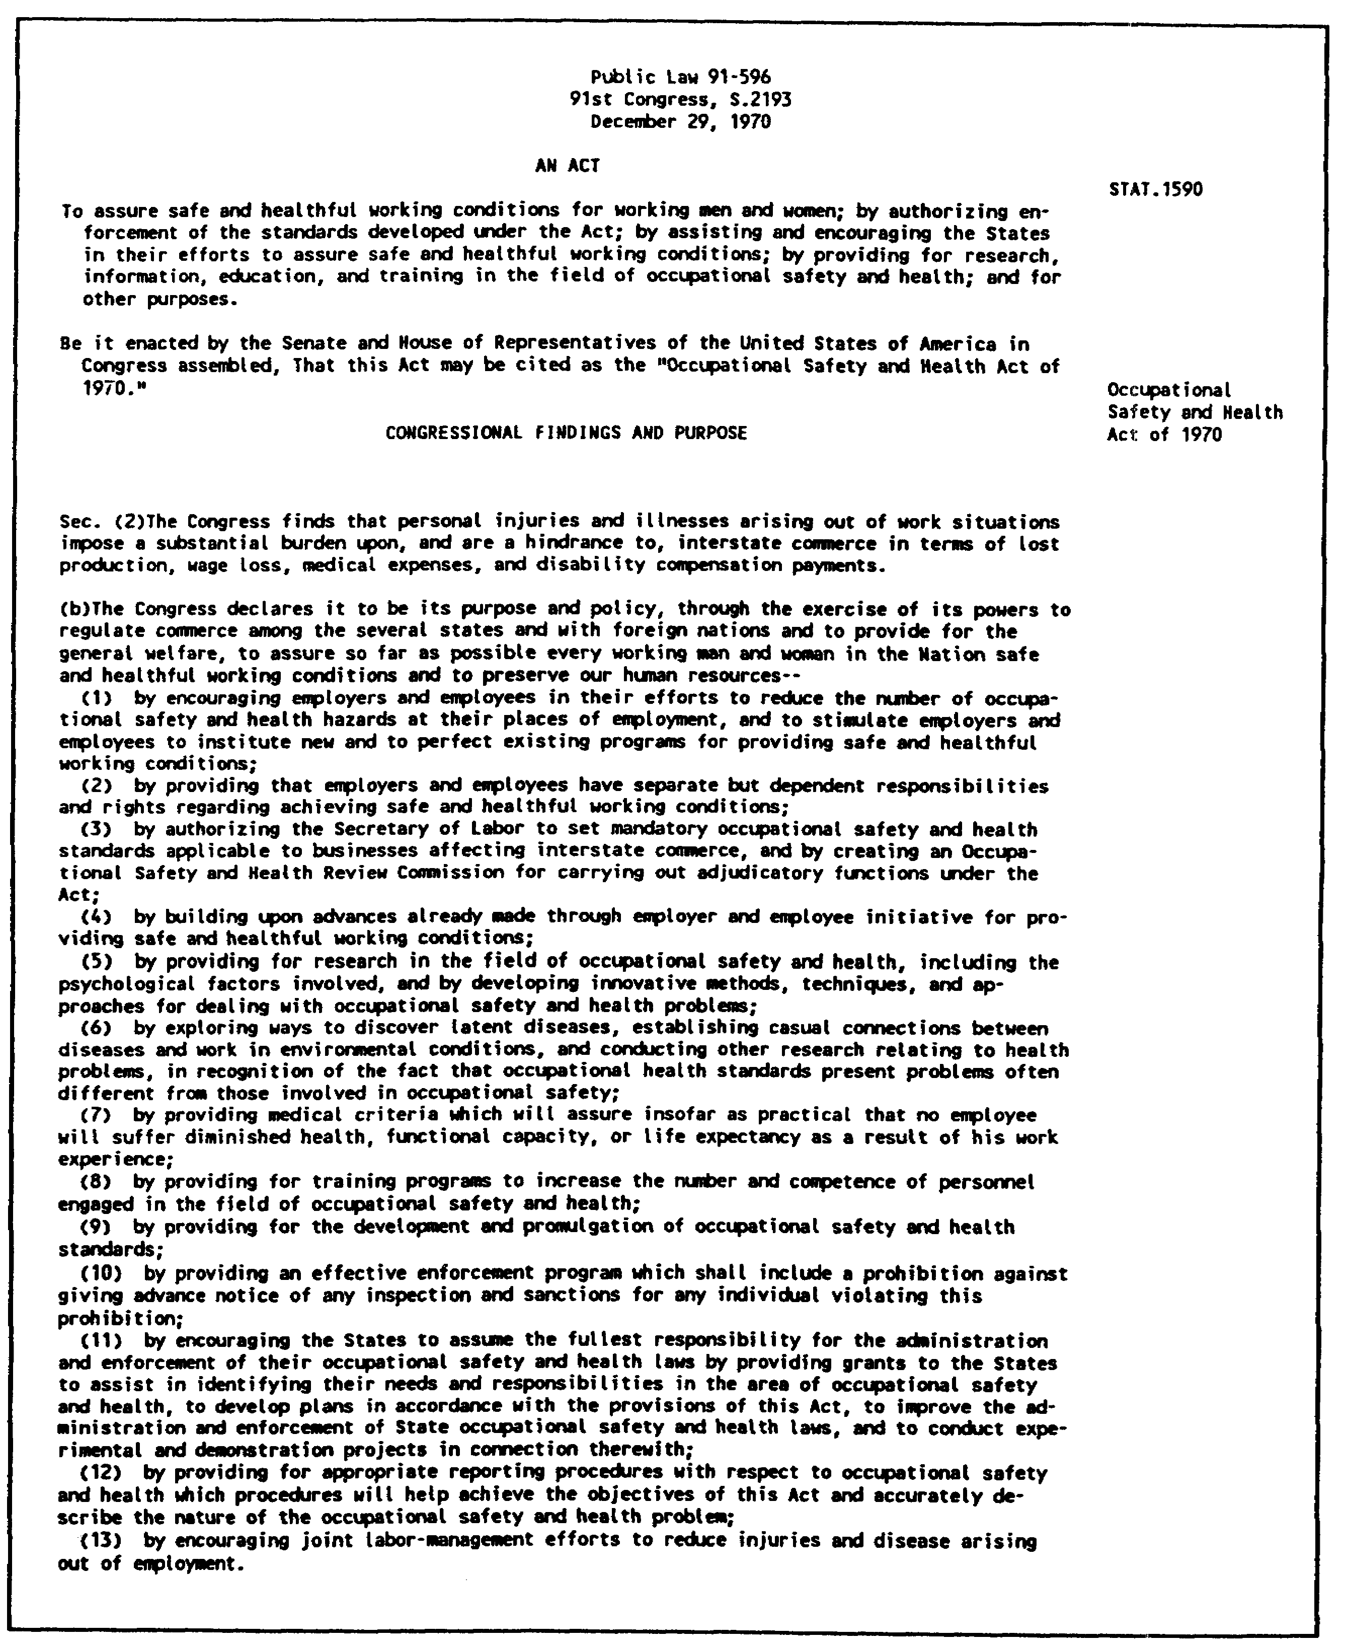

Figure 1-1. The Occupational Safety and Health Act

1-4 AV0584
e. The National Institute for Occupational Safety and Health (NIOSH) has a mission of research, education, and training related to occupational safety and health (OSH). NIOSH is located in DHEW's Center for Disease Control. NIOSH's mission statement includes—

(1) Developing recommended OSH standards.

(2) Conducting research experiments and demonstrations related to OSH.

(3) Conducting educational programs and research (mostly by contract) to provide an adequate supply of qualified personnel to carry out the purposes of the OSHAct.

(4) Providing selected employer and employee services including--

(a) Hazard evaluation including on-site evaluations of potentially toxic substances used or found on the job.

(b) Technical information that provides specific hazard and control information on various toxic materials.

(c) Accident prevention that provides technical help for controlling on-the-job injuries including the evaluation of special problems.

(d) Industrial hygiene that provides the same kind of advice on industrial hygiene problems.

(e) Medical services that provide advice on occupational medicine and nursing problems.

f. The BLS has the statistical job in the safety and health area. They complete injury and illness data and make statistical studies and design in coordination with OSHA and NIOSH in the statistical evaluation scheme.

3. THE OCCUPATIONAL SAFETY AND HEALTH ADMINISTRATION AND THE ARMY SAFETY PROGRAM

a. The OSHAct was passed in 1970. The Army followed most of the Act the day it was passed. The same is true with most of Part 1960, although in some cases the specific procedures it prescribed varied with many existing Army procedures. The Army safety manager has the task of deciding how the OSHAct shall be integrated into the existing Army safety program (ASP). Clearly there are many aspects of the OSHAct that overlap existing programs. It is equally clear there are many aspects of the OSHAct, such as employee rights, inspection

1-5 AV0584
procedures, and reporting, that are unique to the OSHAct. When deciding how to relate the OSHAct to the existing ASP, the safety manager has several alternative approaches such as--

(1) Total integration with all OSHAct requirements absorbed into the ASP.

(2) Total integration of overlapping aspects keeping a separate identity of unique OSHAct requirements.

(3) Keeping two separately identified programs. In reality this choice is even more complex than the others since the chances range from total integration to total separation on a continuous spectrum on which these three options are only representative points.

b. The purpose of this section is to present issues and ideas that will aid the safety manager in deciding what solution to this problem is most correct for his organization within the overall guidance contained in AR 385-10. First, the organizational, regulatory, efficiency, economical, and priority aspects of the question will be discussed. Next, the scope of the OSHAct will be discussed in detail in comparison with the scope of the ASP. Potential points of integration then will be presented, followed by a suggested general solution to the problem presented as proposed policy statements.

(1) Causation Model

A useful means of making this comparison is the causation model depicted in Figure 1-2. Using this model makes it possible to identify rather clearly the major points of difference between the OSHAct and the ASP.

(a) Result. Beginning at the point of RESULT (Figure 1-2), it is immediately apparent that the total scope of the OSHAct affects about 20 percent of the concerns of the ASP. For instance, the OSHAct does not have standards for, or an interest in, off-duty accidents that account for nearly 50 percent of the Army's injury experience. For the remaining on-the-job accidents, the OSHAct has little to say in its standards about vehicle safety, combat training, mission protection, damage-related accidents, or other major areas of ASP concern. The OSHAct in 1960.1 restates the fact in the Act itself that its intention is to provide safe and healthful working conditions for employees. Accordingly, in some respects, the OSHAct can be regarded as a specialty area, such as on-the-job safety and health, comparable in scope and significance to privately owned vehicle safety efforts, sports and recreation, and other major areas of interest in injury prevention. In other respects the OSHAct, because of its legal

1-6 AV0584
mandates, poses special requirements and problems. In any case, a summary of the RESULT point would have to conclude that the OSHAct addresses less than 20 percent of a well-managed safety program. As far as specific standards related to the RESULT point, OSHA's group of fire fighting and first-aid standards are far below the quality of typical Army disaster plans and continuity of operations plans.

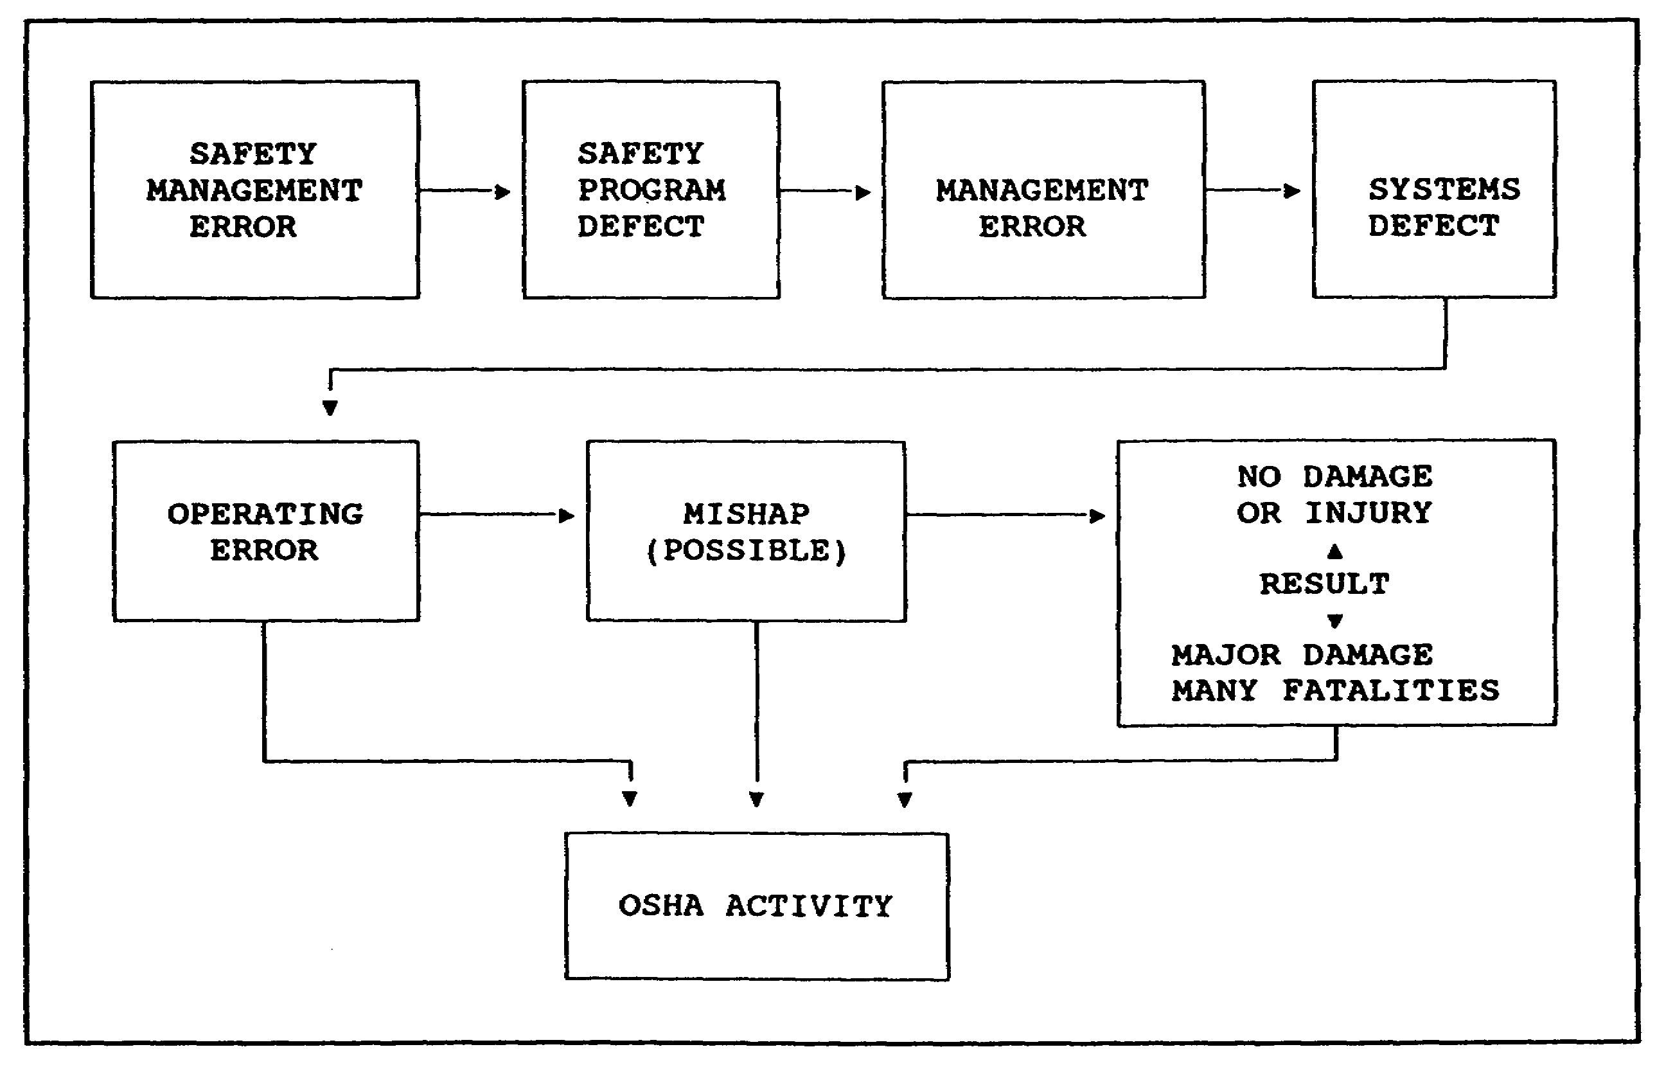

Figure 1-2. OSHAct and the Army causation model

(b) Mishap. Focusing next on MISHAP, we find that the OSHA does have several standards with the goal of limiting the capability of a specific incident to cause injury or death. Standards requiring guards and use of protective equipment are examples since many of these devices have value only after the failure of some machine part. Other standards, such as those related to quantity distance criteria for explosives and petroleum, have been set to prevent injury or death even if of an explosion or fire. Again, these standards are far less comprehensive than those contained in such publications as TM 743-200-1.

(c) Operating error. This point is an interesting study in the effect that requirements of law can have on safety procedures. In the private sector the OSHA inspector must show, if challenged, proof that a violation existed. This emphasis on unsafe conditions (90

1-7 AV0584
percent or more) is directly opposite to the central role that research studies say is played by unsafe acts. One must conclude that this emphasis on unsafe conditions is dictated by legal needs rather than a rational allocation of effort. Studies conducted in England and Canada and by the OSHA itself have confirmed significant deficiencies in an operating-condition-oriented approach.

(d) Systems defects. In many ways Part 1960 is an excellent program document. It does have some significant deficiencies, however. For instance, there is no requirement for a systems safety program. This program is one of the core elements of the ASP. The initial version of Part 1960 lacked any meaningful reference to safety training, a clear omission now remedied by Subpart H. Other similar omissions show that Part 1960 cannot be the sole basis of a complete safety program.

(e) Management error. Neither the technical standards, such as Part 1910, nor the program standard addresses this point in any detail.

(f) Safety program defect. Part 1960 prescribes several elements that a safety program should have. Included are reporting specifications, inspection procedures, safety committees, and so on. Other major areas (control, causation analysis, hazard analysis, and major aspects of countermeasure design) are not covered.

(g) Safety management error. Except for the training provisions of Part 1960, Subpart H does not cover the various intrasafety aspects of organization, motivation, and task design.

(2) Potential for Integration of OSHA and ASP

If integration is shown as the most desirable policy, it is useful to examine how this integration might be achieved. Figure 1-3 depicts the five major functions involved in the injury prevention program and how an OSHAct compliance effort might effectively blend in.

4. ORGANIZING FOR COMPLIANCE

The first action the safety manager should take as he prepares to manage the OSHAct compliance program is to determine precisely what tasks have to be accomplished. Once these are clearly outlined, it will be possible to determine the personnel selection criteria, training requirements, and material support that are proper for accomplishing those tasks. OSHA regulations set some specific responsibilities that fall on operators, supervisors, managers, and safety managers. In addition to these specific regulatory responsibilities, there

1-8 AV0584
are OSHA-related responsibilities that are inherent in the organizational position and function of these groups and in the overall mission of OSHAct compliance. The task outline below is a complete list of OSHA-related (not necessarily safety-related) tasks for each group. Where the task has a regulatory basis, it is referenced. If a safety manager is satisfied that each task is being accomplished as effectively as possible, then he has a complete OSHA compliance program. If some tasks remain undone or are being done poorly, then the safety manager's job is not finished.

a. Operator-Related OSHA Tasks (Figure 1-4)

(1) Exercise Rights

In addition to the explicit OSHA requirement to train employees in their rights, there is the implicit understanding that you also must train the man how to exercise those rights. In a moral sense then, to deny a man full knowledge of his rights and a practical means to exercise them, is to deny effectively him his rights. Specific employee rights include--

(a) Representation as an employee on a safety committee.

(b) Access to organizational safety regulations and policy documents.

(c) The right to complain about safety and health conditions and receive an answer.

(d) The right to participate in safety and health inspections in specified ways.

(e) Immunity from reprisals for exercising OSHAct rights.

(f) Access to information on hazards in the working environment.

(g) An opportunity to comment on new standards and variances.

(2) Obey Safety Rules

The employee is specifically required to obey management-set safety rules. Management is given the right and, indeed, the responsibility to prevent or correct violations of the standards by employees. Implicit here is the need for management to assure that workers know and are suitably motivated to obey the rules.

1-9 AV0584
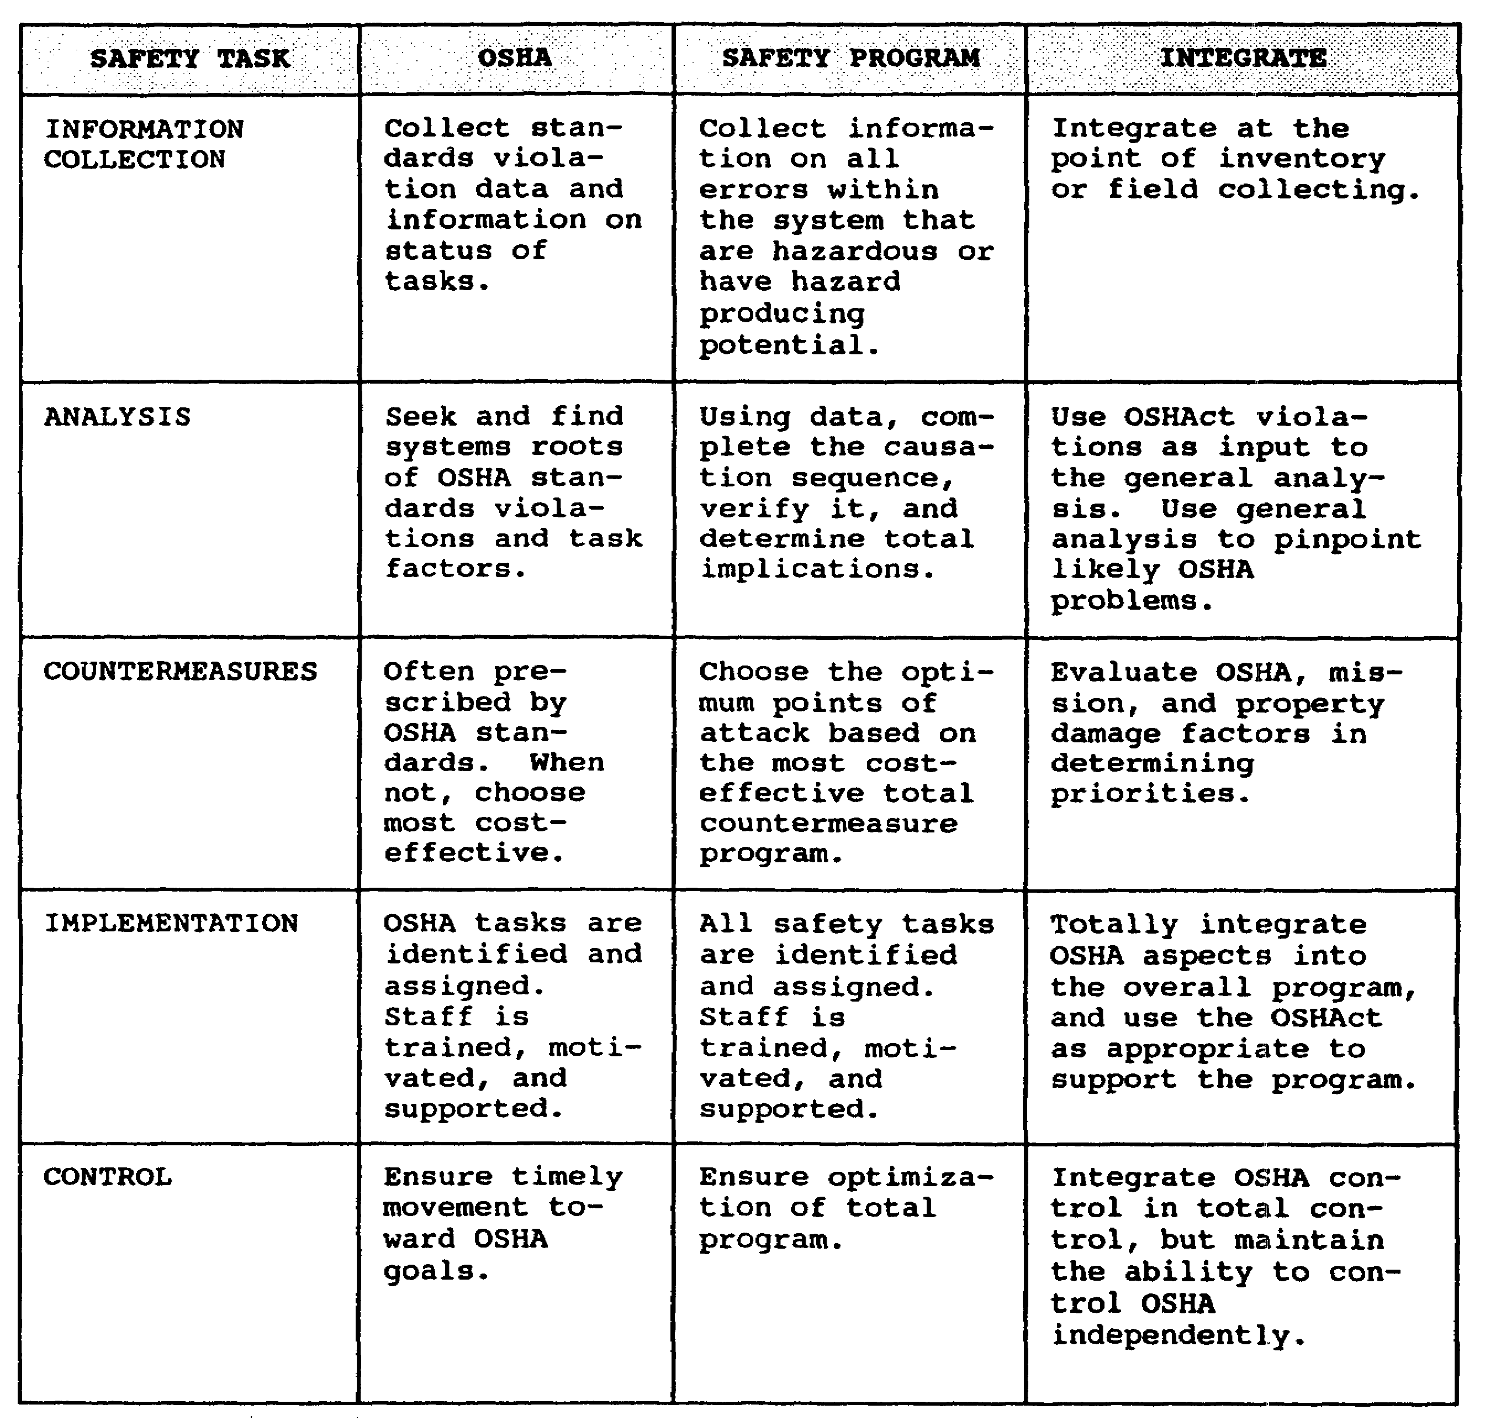

Figure 1-3. Integrate Occupational Safety and Health Act

(3) Report Hazards

The employee is explicitly directed to report hazards. Clearly, management has the responsibility to provide an easy-to-use, responsive hazard reporting procedure and to train and motivate the employee to use it.

1-10 AV0584
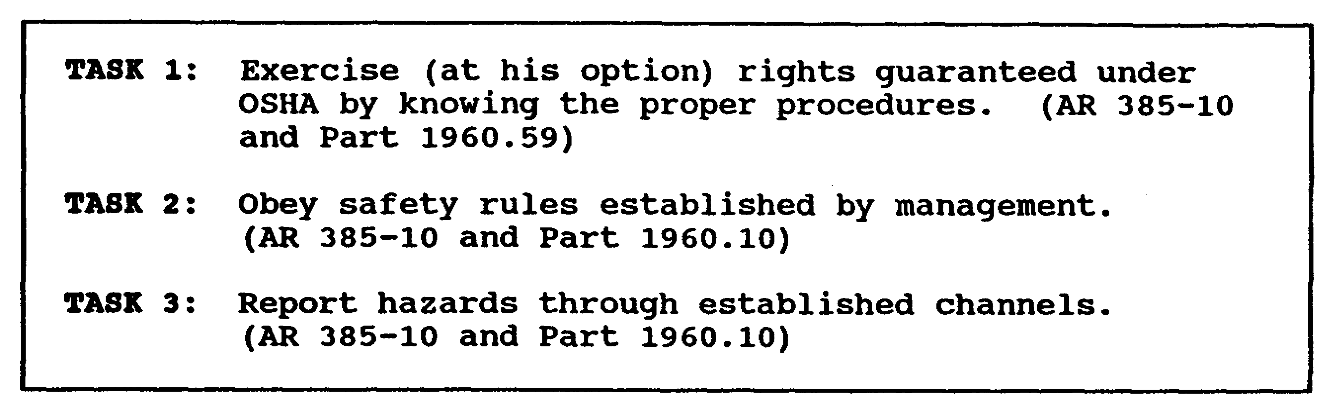

Figure 1-4. Operator-related Occupation Safety and Health
Administration tasks

b. Supervisor-Related OSHA Tasks (Figure 1-5)

(1) Exercise Your Rights as an Employee

Every supervisor within the federal establishment is an employee as well as a supervisor. Thus, each has the right to exercise all the rights granted to employees by the Act and its standards.

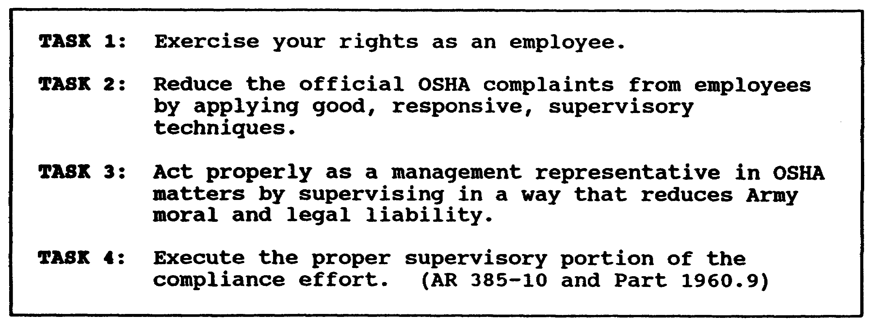

Figure 1-5. Supervisor-related Occupational Safety and Health Administration tasks

(2) Reduce Official OSHA Complaints from Employees

This is a task not mentioned in the standards but one that is dictated by good management. Formal OSHA complaints involve formal investigations and formal replies. If the employee chooses to appeal to OSHA, the administrative cost of such a complaint can amount

1-11 AV0584
to several thousand dollars. How much better it is if supervisors are aware of this and take special pains to get employees to report their grievances informally to the supervisor for quick action. When supervision is responsive, there is little need for expensive, formal OSHA complaints.

(3) Act Properly as a Management Representative in OSHA-Related Matters by Supervising in a Way That Reduces Army Moral and Legal Liability

Many arguments exist about the legal liabilities of federal agencies to their employees. Some recent legal decisions in the private sector have been very interesting and could possibly be applied, to some extent, to federal agencies in the future. One of these relates to the supervisor's role as a representative of higher management. The OSHRC has repeatedly held that if management has a safety rule that is consistently enforced, a random violation detected during an OSHA inspection does not mean it is a citable violation. On the other hand, where management has set up a rule, but supervisors have not enforced it, all violations are citable against the employer. OSHRC also has ruled that the proof in setting up a past enforcement pattern is on the employer. Thus, the supervisor has a key role in assuring enforcement of set company rules that implement OSHA standards. If the supervisor doesn't enforce the rules, the commander is open to citation though he may have set up the right policy.

(4) Execute the Proper Supervisory Portion of the Compliance Effort

Supervisors may be assigned the mission of detecting and starting corrective action on various standard violations. They may be a key element in various other OSHA compliance programs. They will need training and education, motivation, and support in executing these responsibilities that will vary from installation to installation.

c. Manager-Related OSHA Tasks (Figure 1-6)

(1) Motivate Concern About OSHA Compliance

OSHA compliance is a command mission and, therefore, warrants command emphasis and leadership. It is the safety manager's task to motivate the commander to motivate his people and to recommend to the commander effective ways to do this.

1-12 AV0584
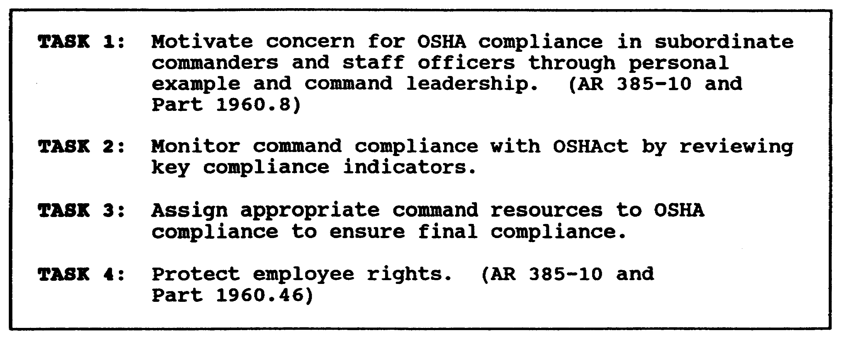

Figure 1-6. Manager-related Occupational Safety and Health

(2) Monitor Command Compliance with OSHA

Command implies control. Each commander should have key indicators that tell him how well OSHA compliance is progressing.

(3) Assign Adequate Resources to OSHA Compliance

Management deals with realities. The realities of an OSHA compliance program are that it must have enough resources such as funds, qualified personnel, and equipment and supplies to assure systematic, steady progression toward the compliance goal. Again, the safety manager must guide and motivate the commander in accomplishing this key task.

(4) Protect Employee Rights

This is self-explanatory.

d. Safety Manager-Related OSHA Tasks (Figure 1-7)

(1) Keep Current on OSHA Developments

OSHA is developmental in nature. Several hundred changes in the standards have been made with many more to come. Many of these changes are not well publicized but have a definite impact on program implementation. The safety manager must have a means of keeping current on these rapid developments. To fail to keep up will inevitably mean erroneous recommendations and expensive mistakes.

1-13 AV0584
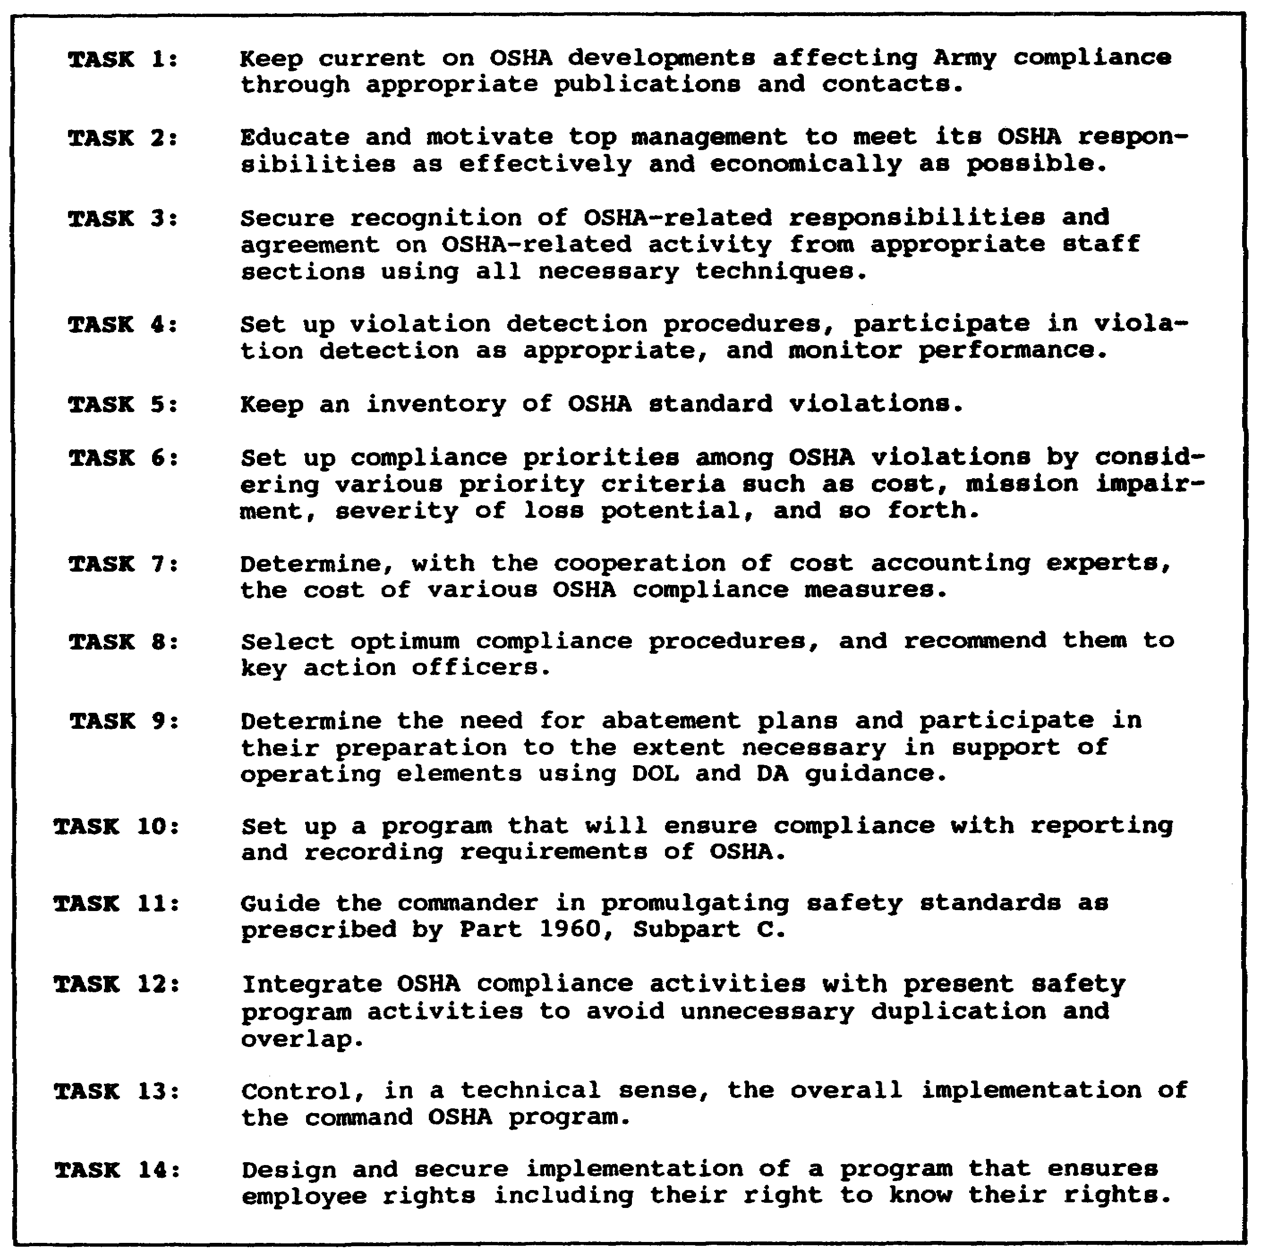

Figure 1-7. Safety manager-related Occupational Safety and
Health Administration tasks

(2) Educate and Motivate Management

As in any other area of safety, the commander has responsibility for OSHA compliance. The commander, however, hires the safety manager to keep him informed of ways to execute his responsibility and to assure that he gives it suitable

1-14 AV0584
emphasis as a commander. A key duty of the safety manager, therefore, is to keep top managers informed and provide them with channels for command participation in the program.

(3) Secure Recognition of OSHA-Related Responsibilities and Agreement on OSHA-Related Activity from Proper Staff Sections

OSHA compliance cannot be achieved through the efforts of the safety manager alone. It must involve the entire staff. The safety manager must determine what each staff section should be doing and sell that staff one way or another on doing it.

(4) Set up Violation Detection Procedures and Monitor their Performance

At the very heart of the standards compliance aspect of OSHAct is the need to find every violation of standards. This is a massive job, even on small installations. The design of the system to detect violations will be a major determinant of the overall effectiveness of the OSHA program.

(5) Keep an Inventory of OSHA Standards Violations

Detecting violations is not enough. Records of their location, nature, frequency, and such must be kept either by manual or automatic data processing methods. The difference in the time involved in doing this efficiently compared to the time involved in doing it inefficiently can be very large.

(6) Set up Compliance Priorities

It is extremely unlikely that any installation will have the funds for instant total OSHA compliance. It will be necessary, however, to determine compliance priorities. These priorities will depend on a rather complex combination of cost, mission impairment potential, severity of loss potential, and such.

(7) Determine the Cost of OSHA Compliance Measures

Cost is the key to countermeasures. Only by knowing cost can the relative cost effectiveness of various compliance strategies be confirmed. Budgeting, priority selection, and other management aspects of the OSHA program also depend on having reliable estimates of compliance costs.

1-15 AV0584
(8) Select the Best Compliance Measures

Based on cost estimates and countermeasure effectiveness, someone, often the safety manager helped by others, must determine the best way to correct each violation.

(9) Determine the Need for Variances and Abatement Plans, and Help in Their Preparation

Abatement plans will often be required. Variances will often be desirable and necessary. Managing the efficient preparation and accuracy of these documents will certainly require safety manager participation.

(10) Set up an Inquiry Reporting and Recording Procedure

This technical activity will require close compliance with the standards and will obviously involve the safety manager.

(11) Provide Guidance in Promulgating Standards

Part 1960, Subpart C, contains specific guidance on standard adoption procedures. The safety manager has the responsibility to assure compliance with these guidelines.

(12) Integrate OSHAct with the Overall Safety Program

Total compliance with the OSHAct does not form a complete safety program. Neither does a good safety program assure complete compliance with OSHAct. OSHAct compliance must be made an integral part of the overall safety program so as far as possible every OSHA-related action supports broader safety program objectives.

(13) Control Implementation of OSHAct

Somebody has to determine how well OSHA compliance is proceeding. The only way this can be done objectively is to develop measurable standards that measure actual progress by monitoring key indicators such as numbers of violations dropped, complaints responded to, OSHA training completed, and similar key factors. Without such indicators there can be no real management of the compliance effort.

(14) Design and get Implementation of a Program to Assure Protection of Employee OSHAct Rights

As pointed out earlier, rights can only be exercised when channels are made available and people are made aware of their rights. The safety manager has a central role in designing these channels and

1-16 AV0584
seeing that they remain open and responsive.

5. CREATING SUPPORT FOR THE OCCUPATIONAL SAFETY AND HEALTH ADMINISTRATION

a. Figure 1-8 depicts one view of how motivation is created within an organizational structure. First, as shown in the lefthand block, the safety manager must identify exactly what tasks the organization must accomplish to achieve the desired level of OSHA compliance. These tasks have been described to some degree before. Of course, as a safety manager designs specific procedures for accomplishing the safety management tasks, additional details in the form of more specific task statements can be added. The safety manager also will add standards of performance to many task statements. Thus, instead of simply stating, "Determine the cost of violation correction," it may be desirable to state, "Complete an accurate engineering cost estimate on all violations or violation groups within ten days following the month of detection and assign the appropriate budget category." This process of identifying, and to some extent specifying, standards for tasks is an essential first step in the motivation process. The next step in the process is task assignment. Each staff section has specific areas of functional responsibility. OSHA tasks should be assigned similarly. Cost estimating of facility replacement or upgrading is a Director of Facility Engineering responsibility on the typical installation. Similarly, cost estimating of OSHA-induced equipment replacements or revisions should be a Director of Industrial Relations responsibility on a priority basis. Most of the other OSHA-related tasks can be connected to an existing functional responsibility of one staff section or another.

b. Once deciding where a responsibility belongs, you need to get it assigned to that staff section. Figure 1-9 depicts some of the methods that may be useful in getting various OSHA task responsibilities built into the system. The real roots of successful OSHA management lie in this process of task assignment. Only when each staff section knows and accepts what it is to do will the OSHA program have rationality, continuity, and resultant direction.

c. The third element is accountability. We need only ask ourselves what we do best, and we will usually give one or both of the following answers: "Things I enjoy most" or "Things others watch and care about." There is little chance that OSHA tasks will be accomplished because of the love of doing them. This leaves the element of accountability as the primary method of stimulating interest in task achievement. The safety manager must convince the commander and key staff officers that someone

1-17 AV0584
is interested in the goal of OSHA accomplishment and that performance is being monitored. This can be done by--

(1) Creating awareness of the congressional and executive mandates on federal agency safety and health programs. A list of these is depicted at Figure 1-10. Ensure all key personnel are aware of current congressional oversight hearings and General Accounting Office (GAO) reviews.

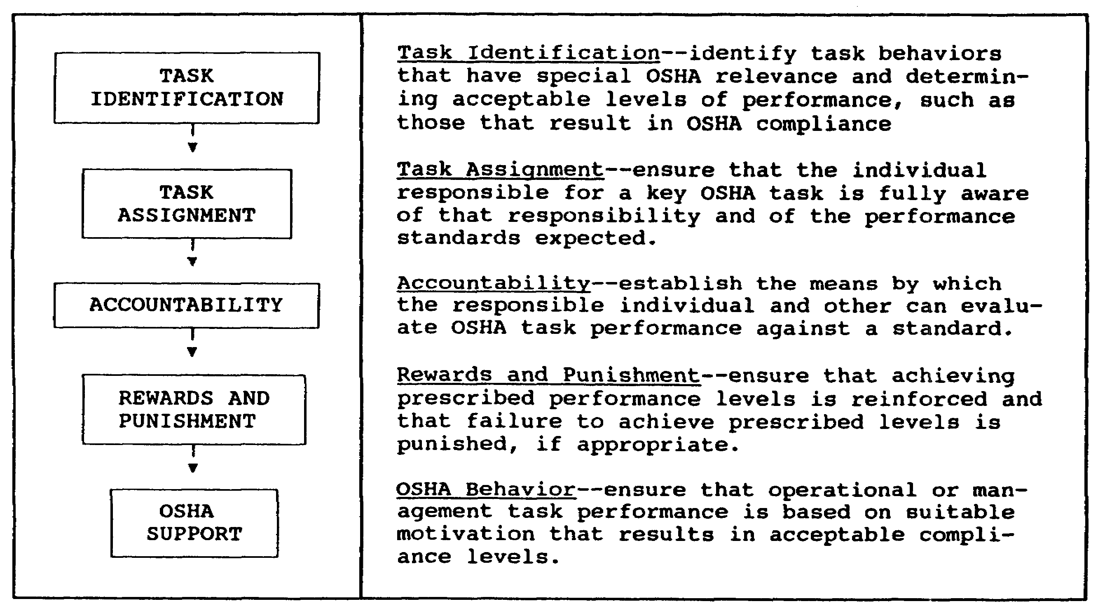

Figure 1-8. Organizational motivation

(2) Creating awareness of the potential for accountability that exists in the employee complaint channel.

(3) Identifying measurable standards for all major tasks and providing regular summaries of these to responsible staff officers and the commander. Make progress reports on these goals a part of command status briefings. Provide program reviews in quarterly reviews and safety committees.

(4) Discreetly encouraging competition between staff sections or line organizations.

1-18 AV0584
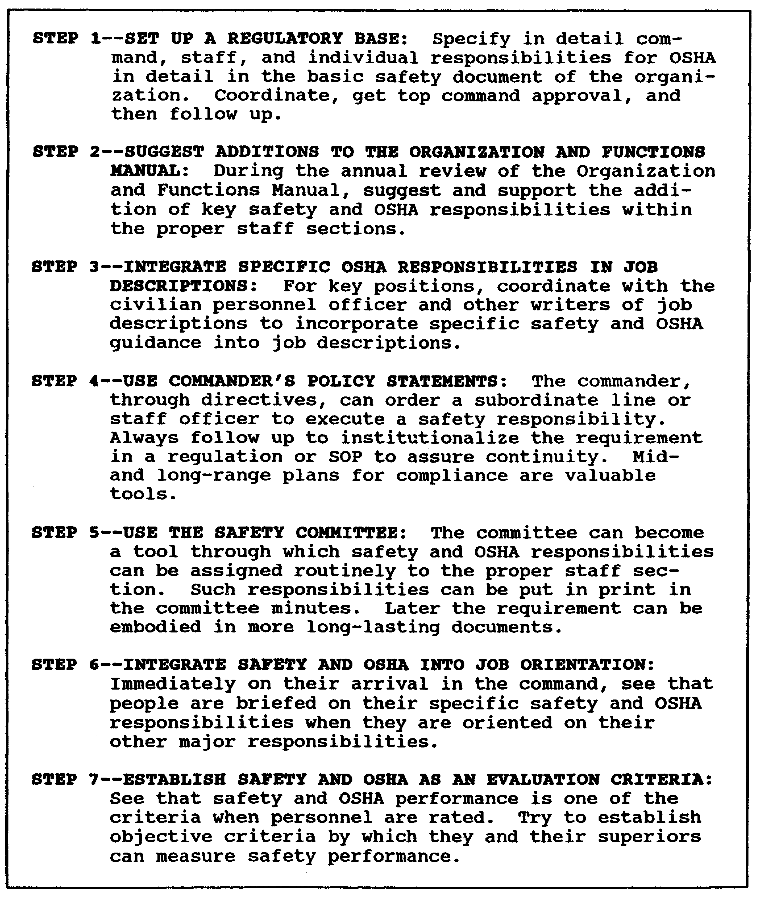

Figure 1-9. Fixing Occupational Safety and Health
Administration and safety responsibilities

1-19 AV0584
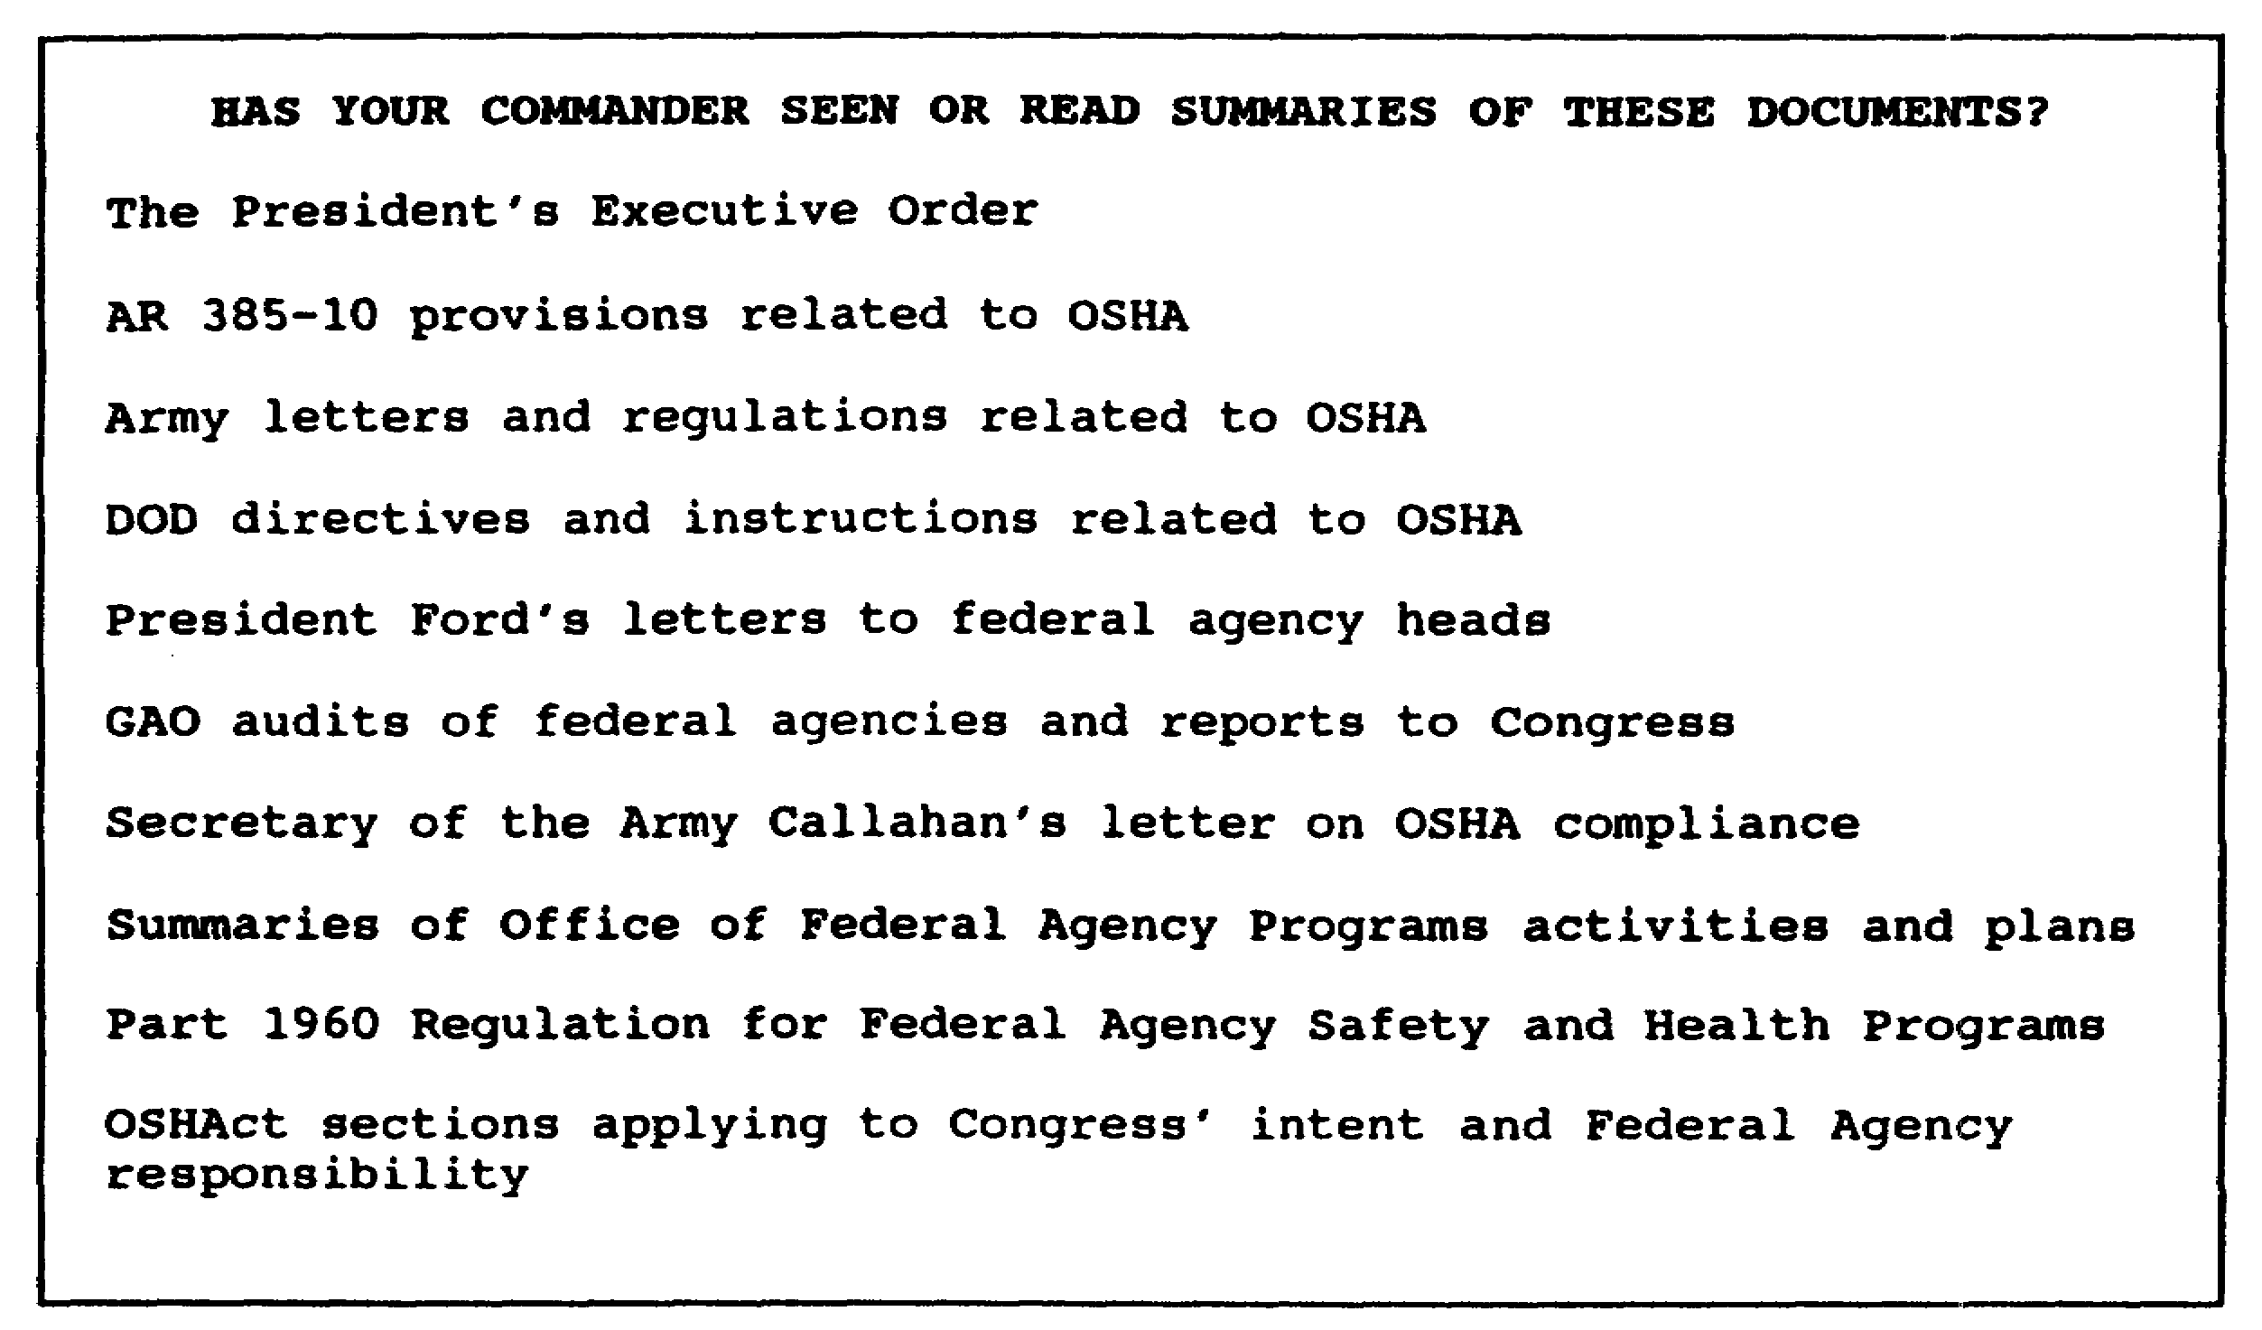

Figure 1-10. Occupational Safety and Health Administration
related documents

d. Rewards and punishment are the payoff in the motivation sequence. Ultimately, behavioral scientists tell us that behavior characteristics (how often a behavior will be repeated and how well it will be accomplished) are determined by the results of that behavior. Thus, rewards (praise, self esteem, money, or security) can be defined as events following behavior that make it more likely that the behavior will occur again. Punishment (fines, ridicule, and insecurity such as a threat to job continuity), on the other hand, is an event following a behavior that makes that behavior less likely to occur. In creating support for OSHA, the safety manager must assure that those who have assigned OSHA tasks are aware that their progress is being monitored (accountability) and that how much or how little progress they achieve makes a difference (reward or punishment). The reward or punishment may not be an award or a fine. It may be something far more subtle such as self-congratulation for meeting a specified goal or some form of informal recognition from a commander or chief of staff.

e. The safety manager can make his own task of motivating support for OSHA easier by making the various tasks he seeks to have accomplished as simple as possible. If we desire to have a laborer move 5 cubic yards of gravel 50 yards but tell him he can only use a shovel to move it, he will charge us a lot because the job involves a lot of effort. On the other hand, if we provide him with a front-end loader,

1-20 AV0584
he will charge far less because the job is now easy. Similarly, the safety manager can often simplify OSHA-related task accomplishment by providing training aids such as checklists or guides. The easier the job is made, the easier the task of motivating task execution becomes. Examples of task simplification techniques are shown at Figure 1-11.

6. EMPLOYEE RIGHTS

a. A major area of emphasis within the federal agency OSHA is the effort to involve the employee in the overall safety and health program. This effort is clearly reflected in Part 1960 in the form of specific employee rights. We will look at these rights in detail to include some management considerations involved in assuring the employee is granted his rights.

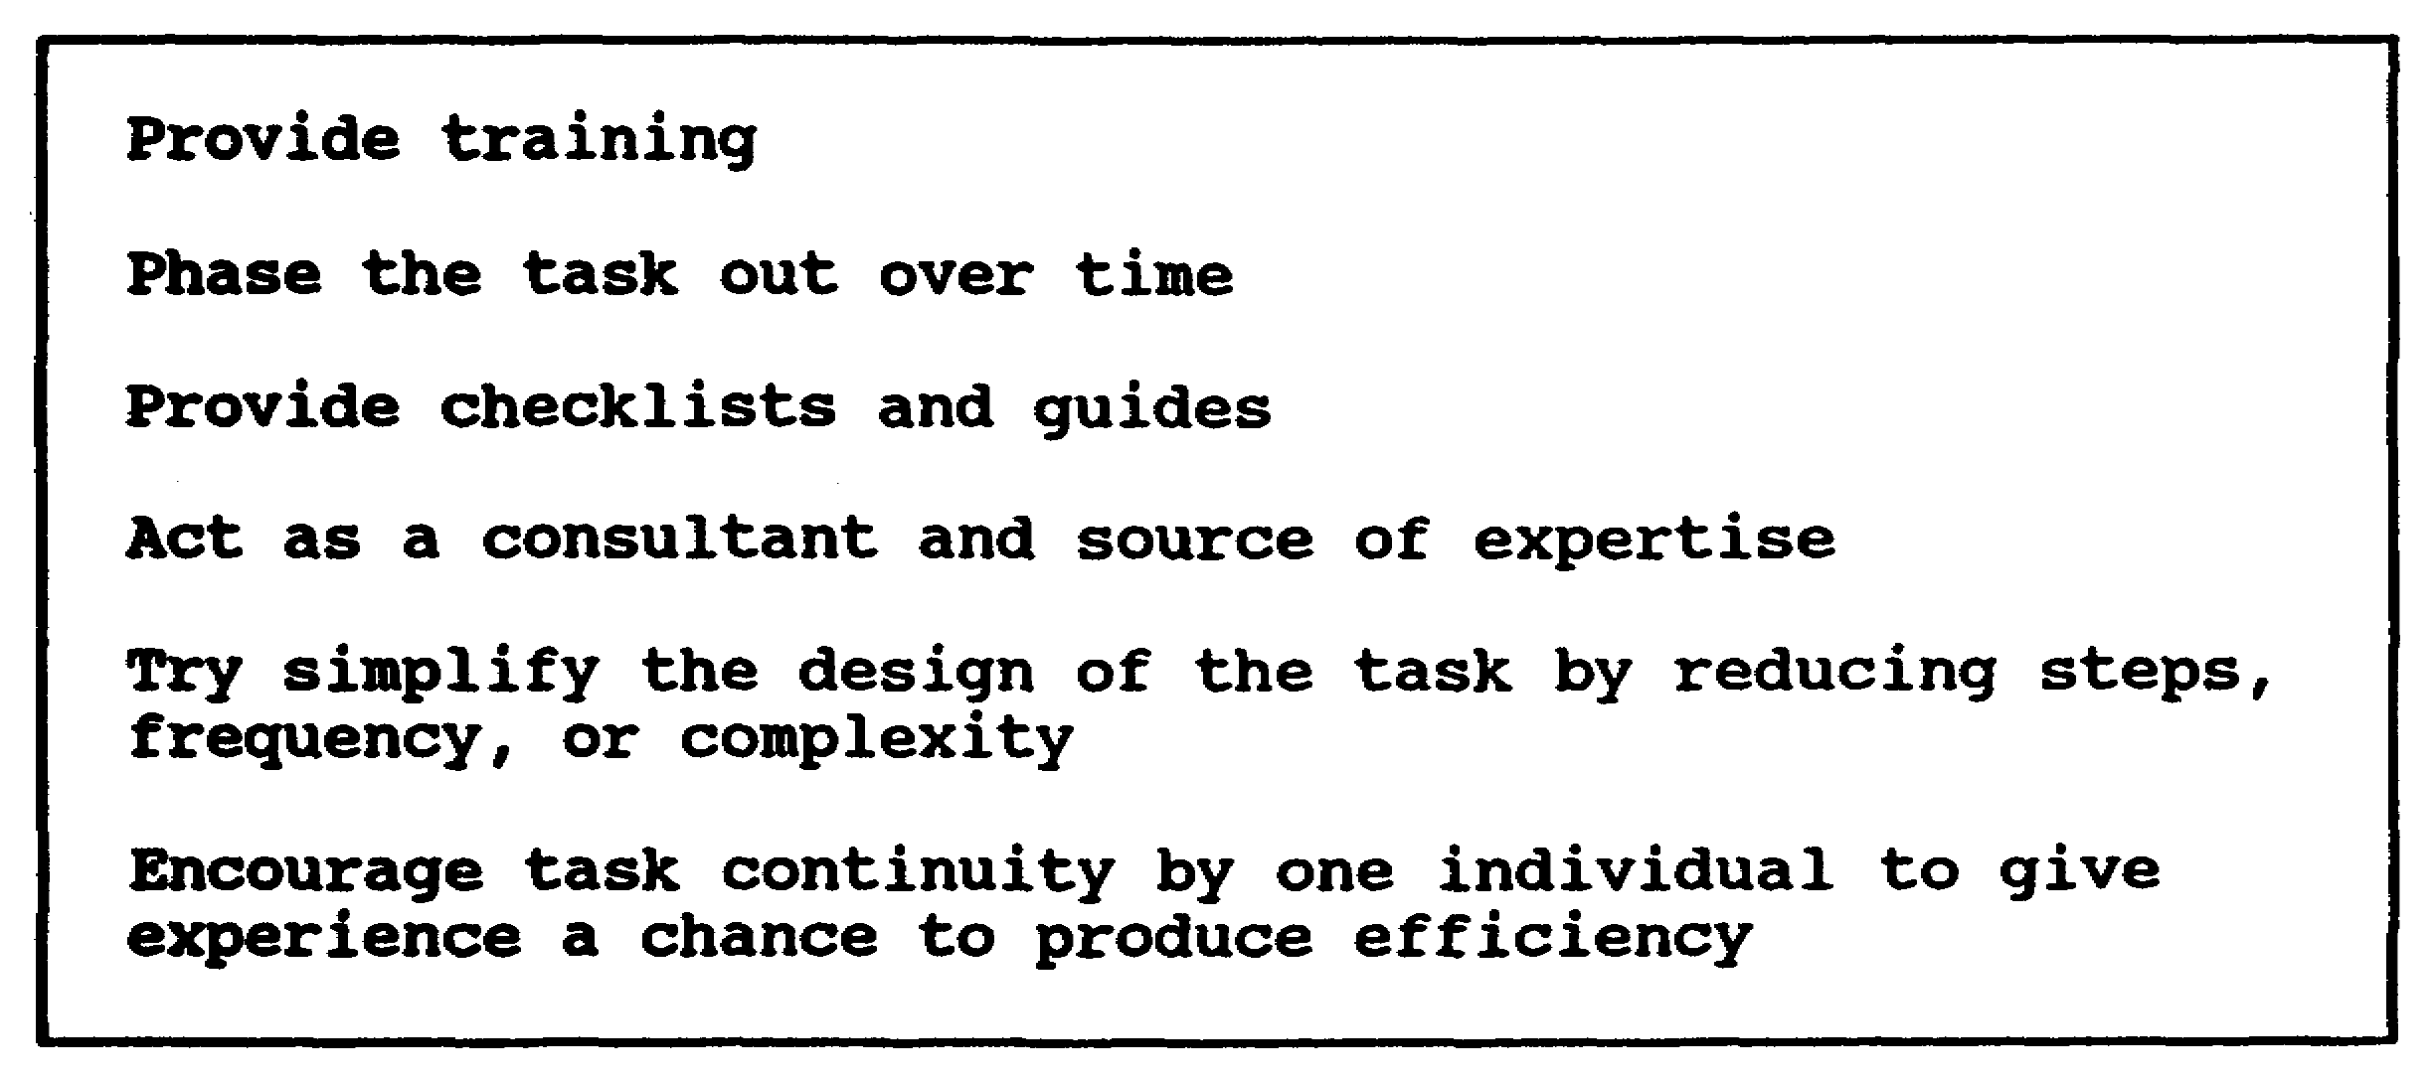

Figure 1-11. Task simplification techniques

(1) The Right to be Represented on Setting up a Safety and Health Committee (Part 1960.17)

Employee representatives will be included in the safety and health committee. This does NOT mean that the employee representatives will be union representatives if a union exists. That is a question for collective bargaining. It also does not mean that employees must be represented on existing management safety and health committees. It means only what it says--there will be a management-employee safety and health committee, and this committee should be engaged in the kinds of activities outlined in Figure 1-12.

1-21 AV0584
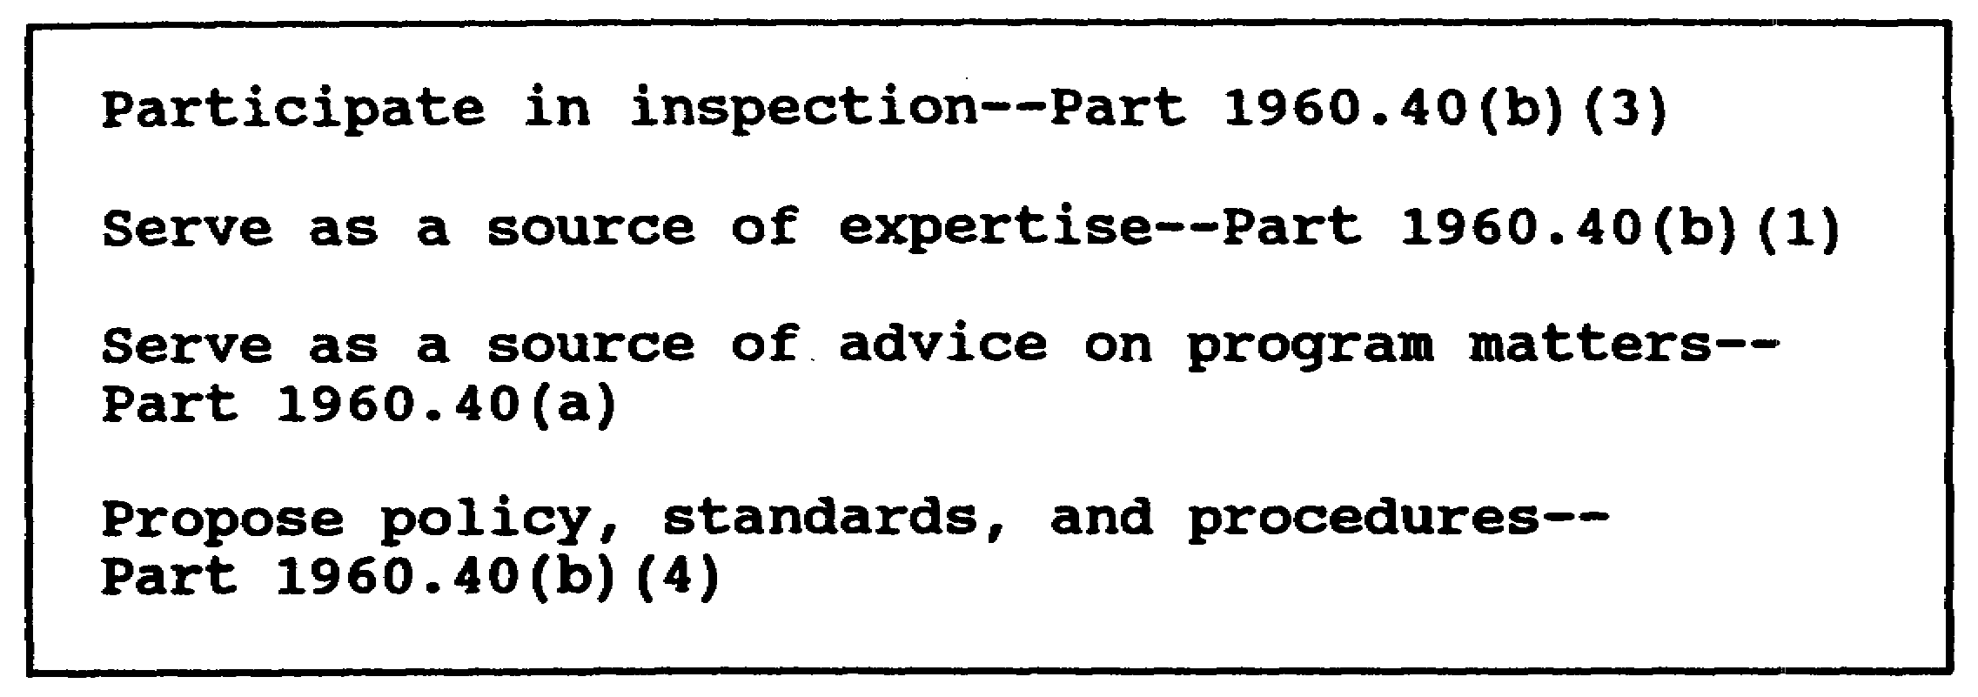

Figure 1-12. Possible OSHA Safety Committee activities

(2) Access to Records

Under the provisions of Part 1960.71, each federal agency shall post a copy of the occupational inquiries and illnesses that show the safety performance of the organization. This access includes annual summaries and actual supplemental records according to applicable Freedom of Information and Privacy Act provisions. Part 1960.12 also requires the agency to make available copies of the OSHAct, EO, Part 1960, and details of the agency's safety and health program and standards.

(3) The Right to Complain

The employee has the right to complain about job safety and health conditions and receive a reply. AR 385-10 sets normal procedures by which such a complaint should be submitted using DA Form 4755 (Employee Report of Alleged Unsafe or Unhealthful Working Conditions)(Figure 1-13). A civilian employee dissatisfied with the disposition of his complaint can request DOL involvement. The employee also has the option of requesting that his identity be kept confidential. As a rule, formal OSHA complaints are undesirable from a management perspective because of the expense and time involved in processing them. It is far more desirable to encourage employees to first take up the problem with their supervisor. The supervisor should be responsive to all legitimate complaints. When the supervisor does his job, formal complaints will be very few.

(4) The Right to Participate in Inspections

Part 1960.27(a) states that employee representatives should be asked to participate in the inspection. Part 1960.27(d) offers employees the right to bring suspected safety or health violations to the attention of the inspector.

1-22 AV0584
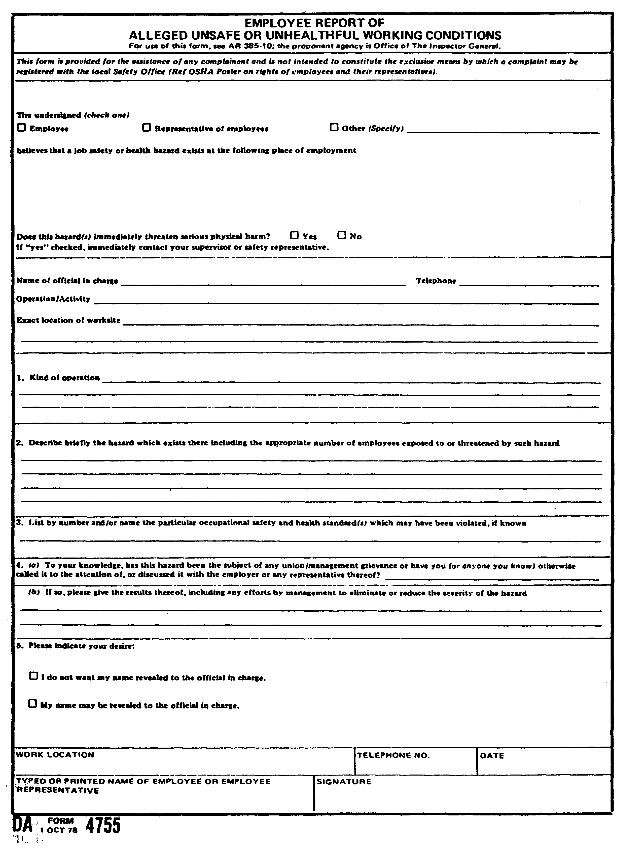

Figure 1-13. DA Form 4755

1-23 AV0584
(5) The Right to Refuse Work in Imminent Danger Situations

This right is not detailed in Part 1960 but has been set by legal precedent. An employee may refuse to work without penalty if the job he is refusing to perform involves imminent danger situations. Particularly vulnerable situations are those where two or more serious accidents have occurred without effective corrective action. The employee can easily support his claim that injury can be expected before corrective action by pointing to the record. Typically, the expertise of the safety manager will be used to make the judgment of imminence.

(6) Right to Comment on Standards Adoption

Parts 1960.16 and 1960.17 include requirements for employee consultation on the safety and health regulations of an agency. This consultation is advisory only and does not bind the agency head to adopt suggestions he may receive.

(7) Immunity from Reprisals for Exercising his Right

Part 1960, Subpart G, protects the employee against adverse action of any kind resulting from the exercise of his OSHAct rights. DOL in the private sector has not hesitated to intervene in such discrimination cases, as a rule forcing retraction of all adverse actions involved. Figure 1-14 depicts a safety valve proposed to try head off discrimination complaints.

b. A significant management decision related to employee rights is deciding how aggressively to promote such rights and in what ways to promote them. A logical solution to this question is to promote the formal OSHAct rights but stress the management preferred method of executing the right. For instance, the employee has the right to submit an official OSHA complaint, but management would prefer that the matter be resolved by the first line supervisor. In this case the OSHAct right can be shown but the preferred method is stressed. In doing this, management not only follows the law but can make significant progress toward realizing its own objectives in this area. The other benefits management can realize from a properly handled promotion effort in this area include--

(1) Reduced administration and associated expenses.

(2) Promotion of useful employee participation in the program.

1-24 AV0584
(3) Development of better management-employee relations.

c. When management is active in promoting employee rights, it can channelize to a significant degree the employee's behavior into avenues that more fully satisfy employees and managers. Since the result of interference in employees rights may be very embarrassing to the commander, procedures may be needed to limit the chances of such interference.

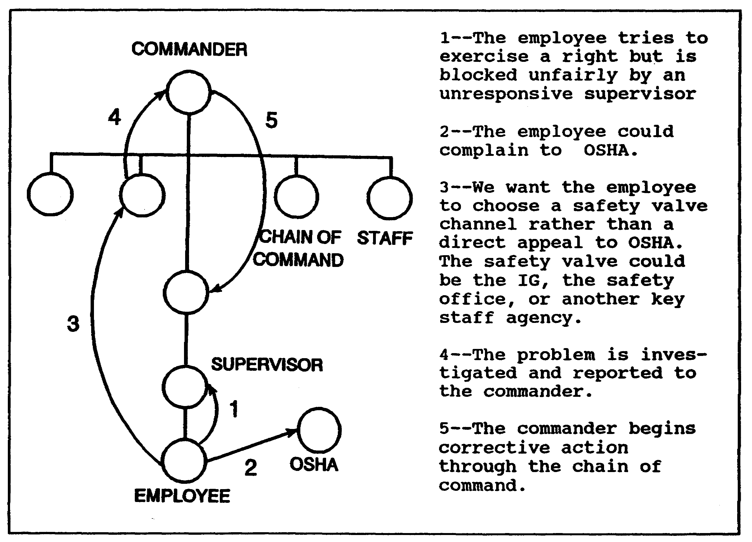

Figure 1-14. Complaint safety valve

7. VIOLATION DETECTION AND CORRECTION

a. For resource requirements and visibility, probably the biggest overall task associated with OSHA is the detection and elimination of unsafe and unhealthful working conditions mandated by EO 12196, paragraph 1-2; Part 1960, Subpart D; and AR 385-10, chapter 3. In the interest of efficient, economical management, the various subtasks associated with this mandate must be viewed as an integrated process

1-25 AV0584
beginning with detection and ranging through ultimate abatement. Figure 1-15 depicts this process and its various subtasks. The reader should not forget, however, that all the pieces of this process must be put together so all the parts function effectively as a whole.

(1) Supervisors

As violation detectors, supervisors have advantages and disadvantages (Figure 1-16). Given these strengths and weaknesses, supervisors could be very effective in identifying standards violations directly applicable to their operations provided the standards are not excessively complex. Use of checklists is a probable need since most supervisors will not readily accept the difficulties involved in wading through an elaborate, cross-referenced set of standards.

(2) Technical Specialists

These are people on the staff or in operating units who have special expertise in some OSHA-related area. Typically, these specialists already have specific responsibilities for safety and health within their areas of expertise. They are usually highly trained professionals. Usually all that will be needed is to integrate them into an overall OSHAct violation detection and recording program and motivate them to intensify and accelerate their detection activities by imposing compliance plans and detection deadlines.

EXAMPLES: Electricians, building inspectors, or pressure vessel inspectors from the Facilities Engineer; occupational health experts from the surgeon's office; or fire prevention specialists from the Facilities Engineer's office.

(3) The Safety Office

There are some sections of the standards that are so complex that people cannot be expected to comprehend and apply them. There is no expertise on the staff in many of these areas. It is in these sections that the safety staff will have to assume the detection responsibility such as are guarding mechanical power presses and abrasive wheel machines, and ladder standards. The safety staff will also will be active in spot-checking the activities of supervisors and technical specialists and in backing them up, using their set information system.

b. DOD Inspection Procedures

Whatever choice is made about the inspection method, DOD requirements as shown in AR 385-10 must be adhered to.

1-26 AV0584
Figure 1-17 is a summary of these requirements to be followed whenever applicable.

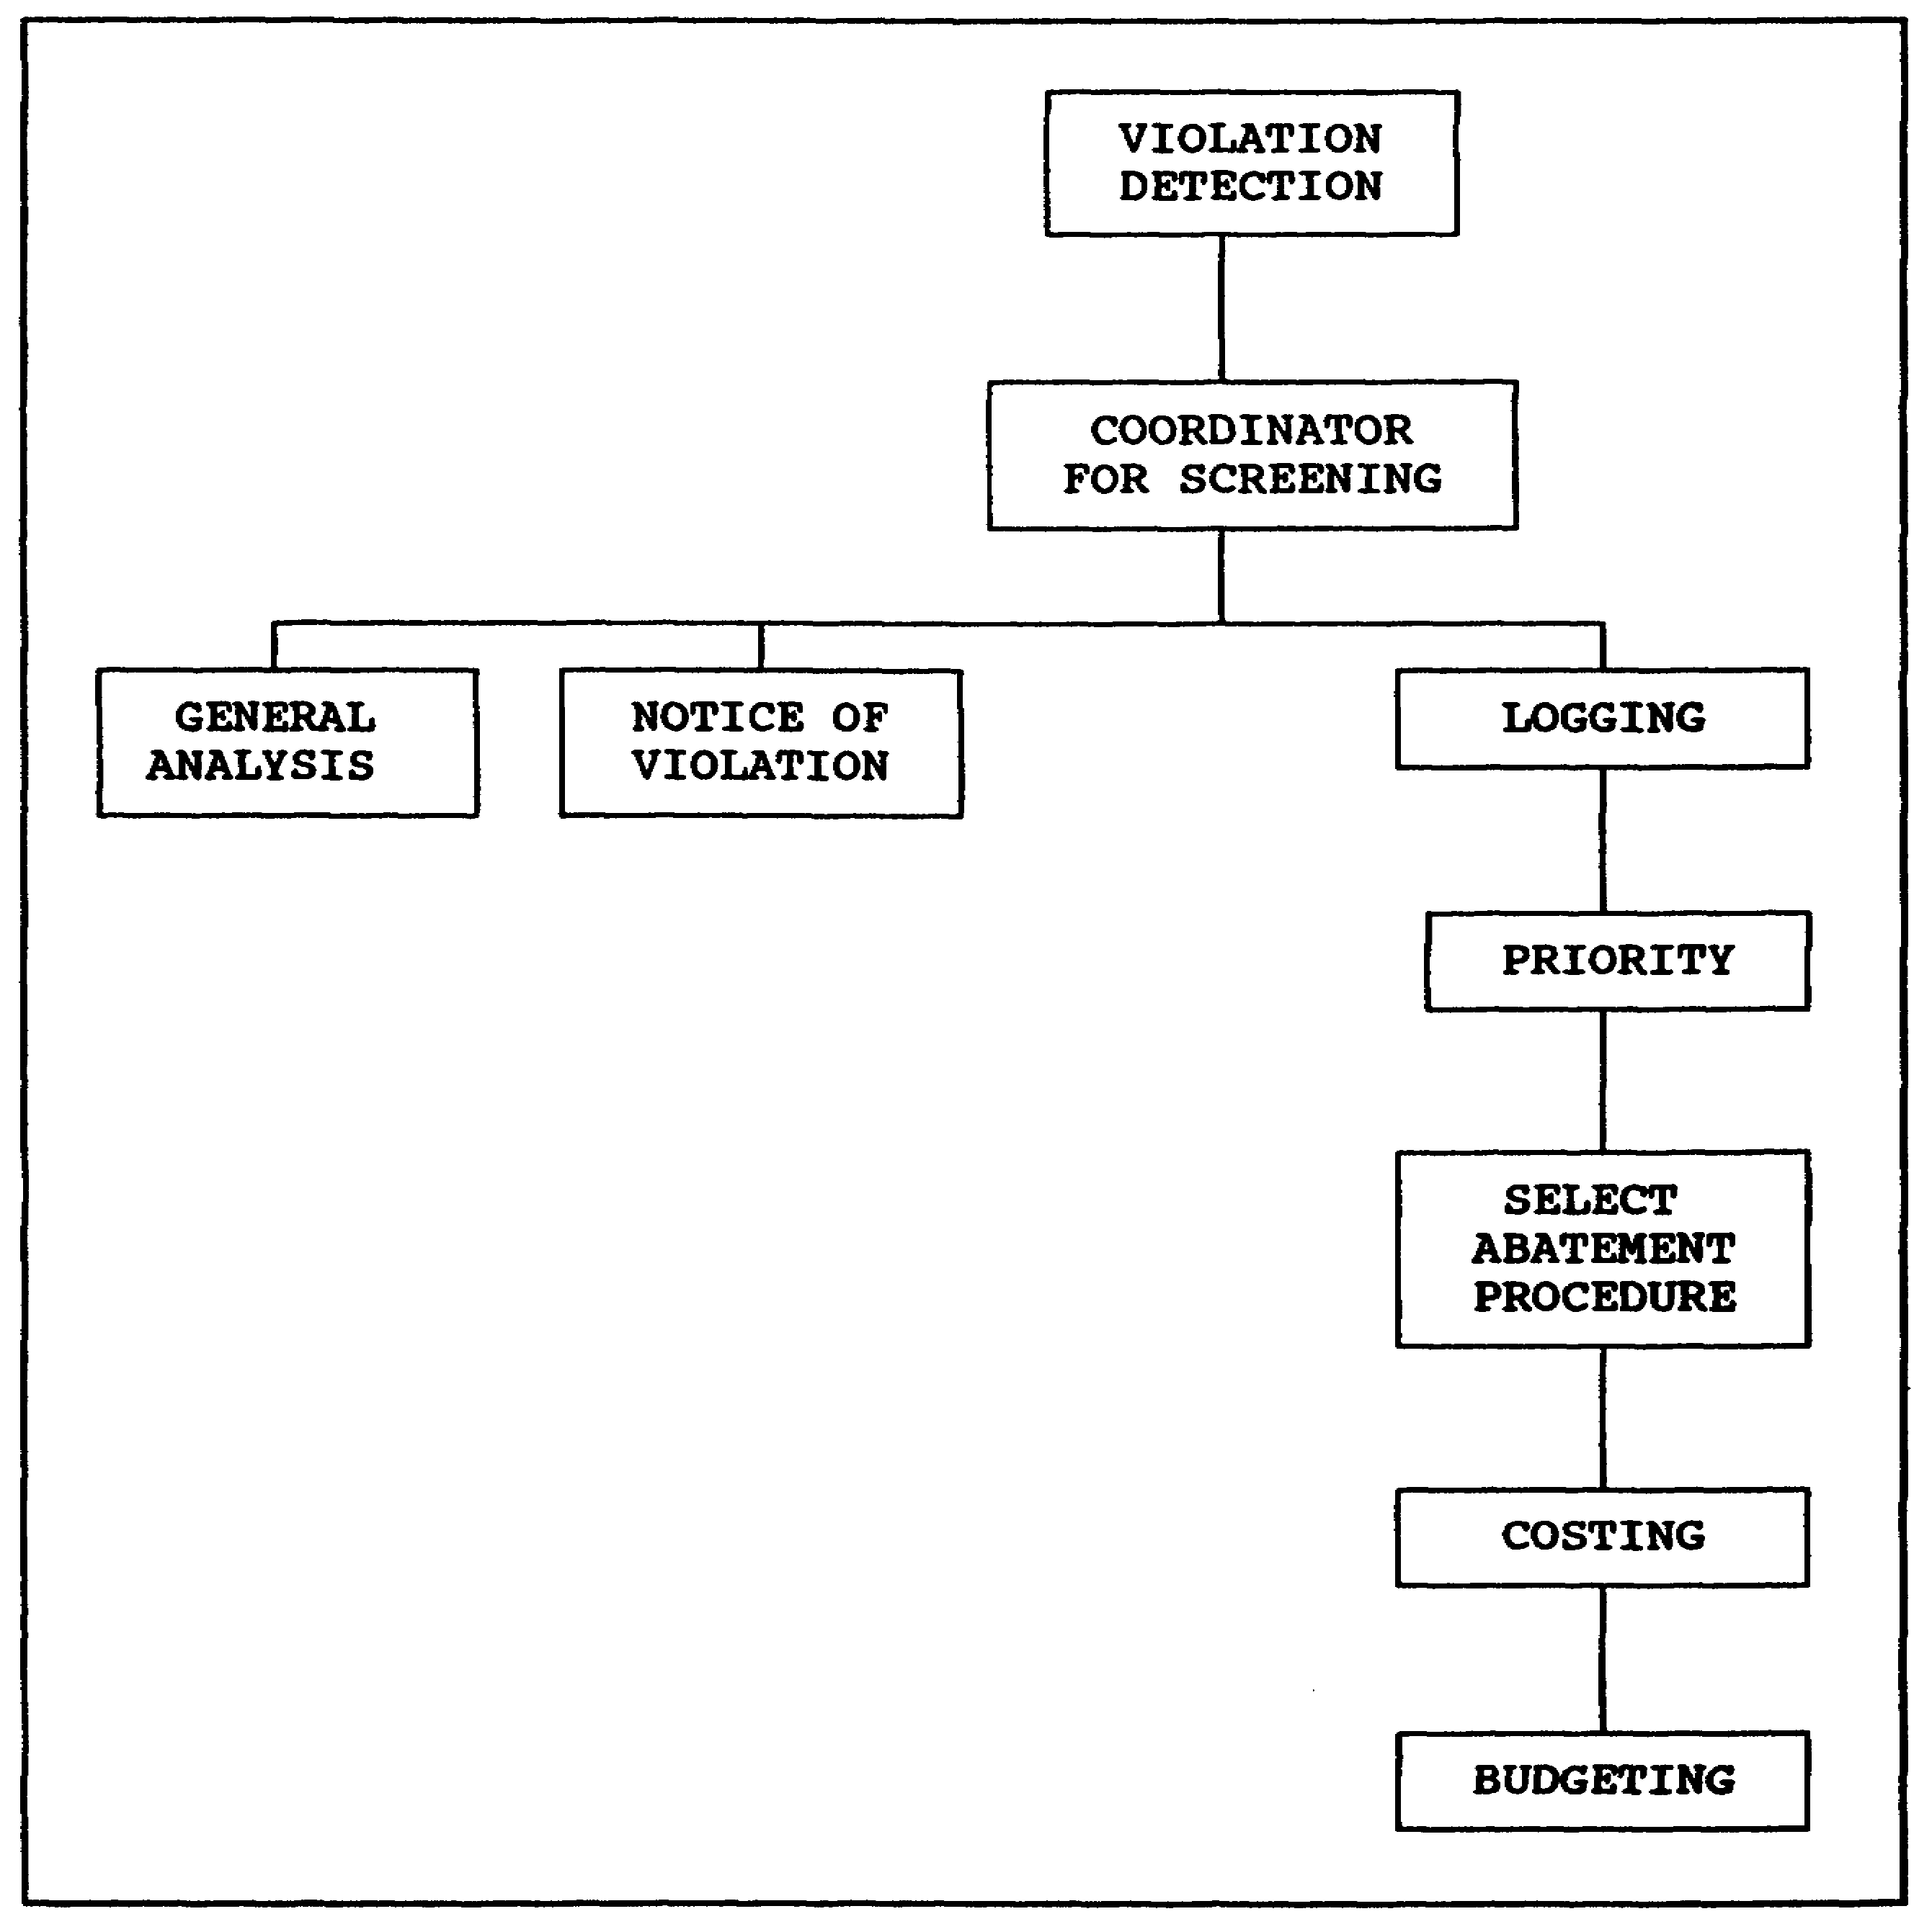

Figure 1-15. The violation detection and correction process

8. COMPLIANCE PRIORITIES

OSHAct violation criteria are directly tied to the injury potential of violations. The criteria are not concerned with property damage,

1-27 AV0584
mission impairment, or other related impacts. While they are not used in the Army, every safety professional should have a thorough understanding of them because of their influence on policy. The definitions in Figure 1-18 are excerpted from the OSHA Field Operations Manual.

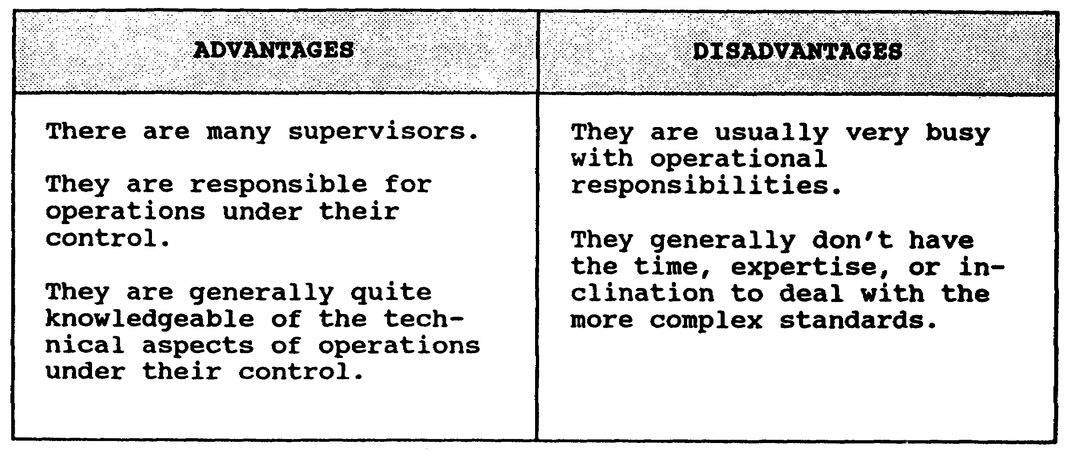

Figure 1-16. Supervisors as violation detectors

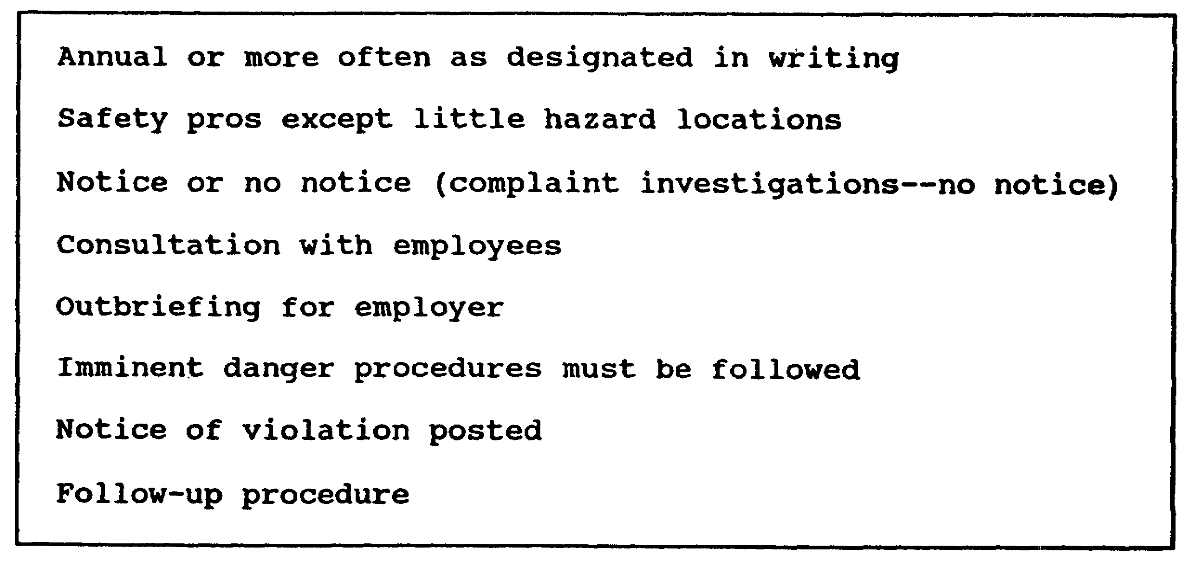

Figure 1-17. Characteristics of the DOD occupational safety
and health inspection

1-28 AV0584
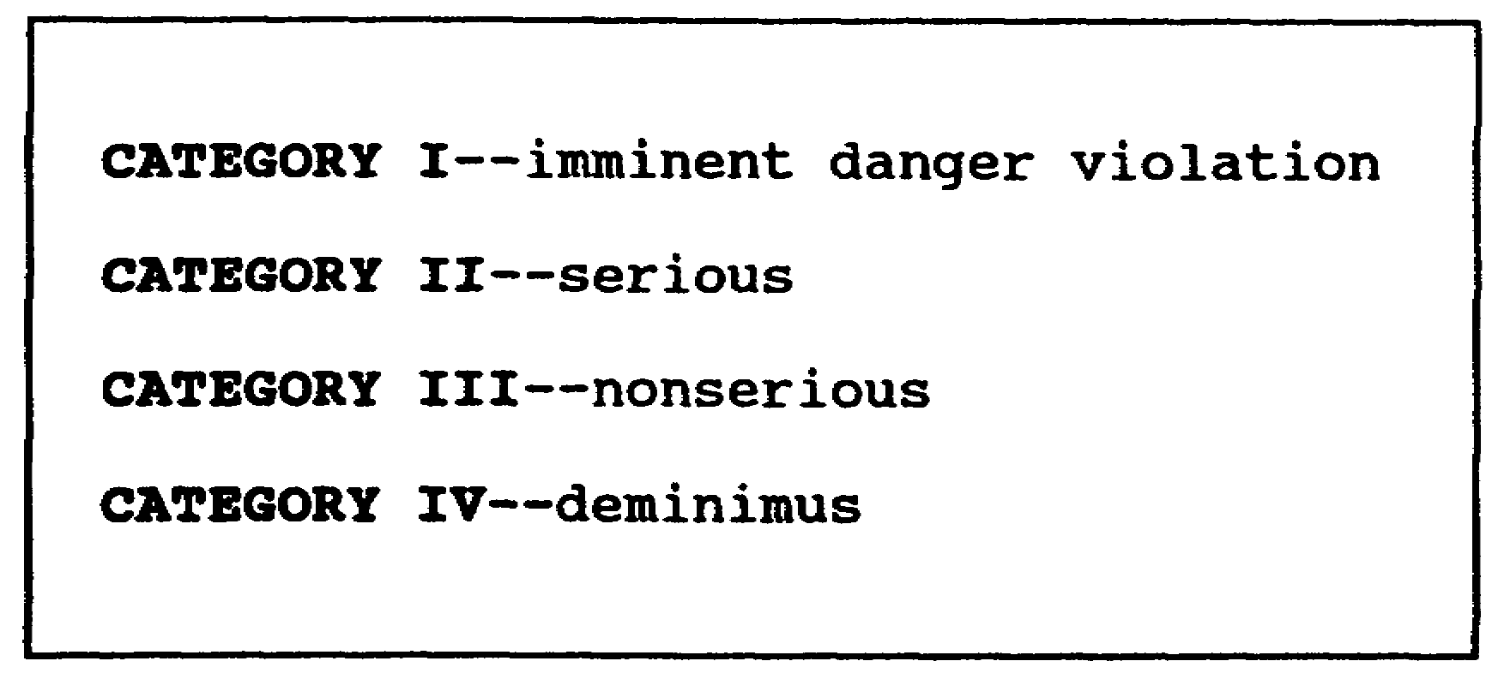

Figure 1-18. Violation definitions

a. Imminent Danger

(1) Section 13.(a) of the Act defines imminent danger as--

. . .any conditions or practices in any place of employment which are such that a danger exists which could be expected to cause death or serious physical harm immediately or before the imminence of such danger can be ended through the enforcement procedures otherwise provided by this Act.

(2) For a condition or practice to be an imminent danger situation, it must be concluded there is a reasonable expectation that a condition or practice could cause death or serious physical harm immediately or before the imminence of the danger can be ended.

(a) Serious physical harm is that type of harm that could cause permanent or prolonged impairment of the body or is the type of harm, that while not impairing the body on a prolonged basis, could cause such temporary disablement that would warrant in-patient treatment at a hospital.

(b) The required immanency would be present where it is believed that death or serious physical harm could occur immediately or certainly within a short time.

(c) For a health hazard to be an imminent danger situation, it must be concluded there is a reasonable expectation that toxic substances or health hazards are present and exposure to them will cause irreversible harm to such a degree as to shorten life or cause reduction in physical or mental efficiency though the resulting

1-29 AV0584
irreversible harm may not manifest itself immediately. Until specific instructions are received, no imminent danger notices should be issued for health hazard imminent danger situations without consultation with the National Office, Division of Occupational Health Programming. Further specific instructions will be contained in sample data sheets from the National Office.

(3) There are certain preinspection procedures for handling imminent danger situations. Any allegation of imminent danger received by an OSHA office shall be handled according to the following procedures:

(a) The area director shall immediately find out where there is a reasonable basis for the allegation. He then shall alert the assistant regional director and the regional solicitor to the situation.

(b) If the imminent danger allegation appears to the area director to have merit, he shall determine the requirements for, and select, a compliance safety and health officer (CSHO) to conduct the inspection.

(c) When an immediate inspection cannot be made, the area director or CSHO shall contact the employer immediately, find as many details as possible about the situation, and try to have any employee affected by imminent danger voluntarily removed from that danger situation. The area director or CSHO should determine what steps, if any, the employer intends to use to end the danger.

(d) Proper steps shall be taken to prepare for and conduct an inspection according to the procedures in (3) above whether or not the employer shows that he will try to end the danger.

(e) The inspection of a work place believed to contain an imminent danger should be thoroughly planned and quickly accomplished.

(4) Technical Considerations

The area director and CSHO should review the known facts and find out what technical equipment and personnel may be necessary to conduct the inspection.

(a) In highly technical situations, consideration should be given to use specialists, such as industrial hygienists, from regional technical support staff, staff from other regions, National Office staff, staff of the NIOSH, or other governmental agencies.

1-30 AV0584
(b) Calibration and testing of equipment to be used must be current.

b. Serious Violations

(1) Section 17.(k) of the OSHAct provides—

. . . a serious violation shall be thought to exist in a place of employment if there is a substantial probability that death or serious physical harm could result from a condition which exists, or from one or more practices, means, methods, operations, or processes which have been adopted or are in use, in such place of employment unless the employer did not, and could not, with the exercise of reasonable diligence, know of the presence of the violation.

(2) To determine if a violation is serious, the CSHO must decide if there a strong chance that death or serious physical harm could result. If so, did the employer know, or with the exercise of reasonable diligence should he have known, of the hazard?

NOTE: The extent of knowledge is not a factor in federal agency "serious" notices of violation.

(3) The following paragraphs cover the general policy guidelines for determining whether a violation is serious.

(a) What is meant by "substantial probability?" To determine if a violation creates a strong chance of death or serious physical harm, two factors must first be met. First, that the violating condition could result in accident or illness. Second, if the accident or illness occurred, there is a real chance, considering experience gained by general observation of similar work situations in industry, that the result would be death or serious physical harm. The hypothetical examples below of violations are intended to illustrate the differences in substantial probability:

EXAMPLES: If a fire extinguisher does not have a durable tag attached to show maintenance or recharge date, the violating condition would not likely result in an accident.
Workers next to a welding area were not provided with protection from the rays by screens, shields, or goggles. This

1-31 AV0584
violating condition could result in an accident. The injury would not likely be serious physical harm.
An open sided platform 60 feet above the ground does not have guardrails or toe boards. The violating condition could result in an accident. The injury would most likely be serious physical harm.

(b) What is meant by "serious physical harm?" Serious physical harm is that type of harm that could cause permanent or prolonged impairment of the body or is the type of harm that, while not impairing the body on a prolonged basis, could cause such temporary disablement that would warrant in-patient treatment at a hospital. Examples of permanent or prolonged impairment are situations in which a strong chance exists that a part of the body would be crushed or severed (amputation of an arm, leg, finger, or loss of an eye) or that makes a part of the body functionally useless or largely reduced in efficiency on or off the job (bones in a limb shattered so severely that mobility or dexterity would be reduced) permanently. Temporary disablement that would warrant in-patient treatment at a hospital includes those situations in which a strong chance of burns, concussions, simple fractures, and wounds involving a great loss of blood and that require extensive suturing or other healing aids. Serious physical harm also includes that type of nonreadily observable harm that could inhibit an internal bodily system in the performance of its normal function to such a degree as to shorten life or cause reduction in physical or mental efficiency, even if a remission of the condition may be accomplished through later abatement or medical treatment. Guidelines have been issued for certain toxic substances for which exposure levels constituting serious physical harm have been determined. The CSHO must consider the most likely results of the hazard when assessing serious physical harm. Such assessment must be independent of any consideration of what effect abatement or medical treatment would have on the injury. Where the hazard has already resulted in an accident, a resulting injury would be relevant in determining the probable result of an accident. The resulting injury, however, is not conclusive of the type of injury (or illness) that is the probable result of the violation.

(c) What is meant by "known or could have known?" A violation is serious if there is a strong chance that death or serious physical harm could result unless the employer ". . . did not, and could not, with the exercise of reasonable diligence, know of the presence of the violation." If the CSHO is satisfied that the employer actually knew of the condition that constituted the violation, the knowledge requirement is met. Often, the CSHO will not determine employer knowledge. In such an event, the reasonable diligence test must be applied; that is, could the employer, through the exercise of reasonable diligence, have known of the violation, assuming the employer

1-32 AV0584
is safety conscious and has the technical expertise normally expected of an employer engaged in that particular activity (business).

c. Nonserious Violations

This type of citation shall be issued in situations where an accident or occupational illness resulting from violation of a standard would probably not cause death or serious physical harm but would have a direct or immediate relationship to safety or health of employees.

EXAMPLE: A nonserious violation is the lack of a guardrail at a height from which a fall would more probably result in only a mild sprain or cut and abrasions; that is, something less than serious physical harm.

(1) Grouping Related Nonserious Violations where Grouping Results in a serious Violation

A citation for serious violation may be issued for a group of individual violations that, when taken by themselves, would be nonserious. When considered together, however, these violations would be serious in the sense that in combination they present a strong chance of injury resulting in death or serious physical harm to employees.

(2) Grouping Results in a Higher Gravity Nonserious Violation

Nonserious violations also may be grouped together and cited as a nonserious violation. For this to happen, both of the following conditions must be present:

(a) All violations must be present in the same piece of equipment.

(b) The conditions affect the overall gravity of possible injury resulting from an accident.

d. Deminimis

Section 9 of the Act provides that "The Secretary may prescribe procedures for the issuance of a notice instead a citation regarding deminimis violations which have no direct or immediate relationship to safety or health." (Emphasis added.) Therefore, where a violation of a standard does not immediately or directly relate to safety or health, it would be proper to issue a notice of deminimis violation, rather than a citation. Such use of the notice of deminimis violation might be proper in situations involving standards containing physical specificity where a slight deviation would not have an immediate or direct relationship to safety or health. No penalties

1-33 AV0584
are proposed for deminimis notices, and there is no abatement requirement. No further enforcement action should be taken though the employer has not corrected the deminimis condition.

EXAMPLE: The slight deviation that may be a deminimis violation may be where the height of letters on an exit sign is not in strict conformity with the size requirements of a standard. If such a deviation is significant (has a direct relationship to safety or health), a citation would be issued.

e. Willful

(1) Notices of violation of the willful and repeated kinds are not provided for within Part 1960. Information on these kinds of violations as applied in the private sector is provided only as background. A willful violation may exist under the Act where the evidence shows either the employer committed an intentional and knowing, as contrasted with inadvertent, violation of the Act and the employer is conscious of what he is doing is a violation of the Act . . . or that though the employer was not consciously violating the Act, he was aware that a hazardous condition existed and made no reasonable effort to end the condition. It is not necessary the violation be committed with a bad purpose, or an evil intent, to be thought willful under the Act. It is enough that the act was deliberate, voluntary, or intentional as distinguished from those that were inadvertent, accidental, or ordinarily negligent.

(2) The CSHO should carefully develop all evidence available that would show an employer's awareness of the disregard for his statutory obligations or of the hazardous conditions. Willfulness would exist if an employer has been advised by employees or employee representatives of an alleged hazardous condition and the employer makes no reasonable effort to be sure the condition exists. Additional factors that can influence a decision whether violations are willful include--

(a) What is the nature of the employer's business and what knowledge of safety and health matters could reasonably be expected in that industry.

(b) What precautions did the employer take to guard against violations. Are there trained safety personnel responsible for setting up and implementing a company safety program, or is this matter ignored?

(c) Whether the general application of the Act has been called to the employer's attention, and whether similar violations have been called to his attention.

1-34 AV0584
(d) Whether the nature and extent of the violations shown are such that a purposeful disregard of statutory obligations becomes clear.

(3) In an accident investigation as soon as there is reason to believe a willful violation resulted in a fatality, the regional solicitor shall be contacted for instructions. Where possible, this should be done before starting the investigation.

f. Repeated

(1) Violation of any standard rule, order, regulation, or the general duty clause may be cited as repeated under Section 17.(a) where, on reinspection, another violation of the before cited section of a standard, rule, order, regulation, or condition violating the general duty clause is found.

(2) Repeated violations differ from willful violations in that they may result from an inadvertent, accidental, or ordinarily negligent act. A willful violation need not be one for which the employer has been previously cited. Where a repeated violation also meets the criteria for a willful violation, a citation for willful violation will be issued.

(3) Repeated violations also are to be distinguished from a failure to abate. If on reinspection a violation of a before cited standard is found but such violation does not involve the same piece of equipment or the same location within an establishment or work site, the violation may be repeated. If on reinspection a violation or a previously cited standard is found on the same piece of equipment or in the same location and the evidence shows that the violation has continued uncorrected since the original inspection, then there has been a failure to abate. If, however, the violation was not continuous (that is, if it had been corrected and recurred), the later recurrence is a repeated violation.

(4) Where a violation of a previously cited condition is clear and that first violation has been contested and has not yet become a final order of the OSHRC, the second violation should nevertheless be cited as a repeated violation after notifying the assistant regional director. Such a citation shall state that the prior violation on which this repeated citation is based has been contested and that this citation is automatically rescinded if the prior citation does not become a final order of the OSHRC.

(5) To consider whether a violation is repeated, citations issued to employers having fixed establishments (factories, terminals, or stores) will be limited to the cited establishment. For employers engaged in businesses having no fixed establishments (construction,

1-35 AV0584
painting, or excavation) repeated violations will be alleged based on prior violations occurring within the same state. Note that the geographic scope for maritime employees is more restrictive; that is, limited to a designated port area.

(6) The CSHO shall make every effort specifically to locate and identify every incident of each violation at the time of inspection so later it can be determined whether that violating condition is a failure to abate or a repeated violation.

NOTE: The question of whether to issue a citation for a willful or repeated violation will frequently raise difficult issues of law and policy, including the evaluation of complex and factual situations. Accordingly, no citation for a willful or repeated violation shall be issued without consultation.

9. WHEN THE OCCUPATIONAL SAFETY AND HEALTH ADMINISTRATION REPRESENTATIVE ARRIVES

OSHA has not paid much attention to federal agencies. This phase of inattention is rapidly coming to a close; OSHA has added a full-time federal agency position to each of its 10 regions and has increased its federal agency staff in Washington. These personnel changes, coupled with the policy changes arising from EO 11807 and Part 1960, increase the chance that Army installations will be visited by OSHA inspectors. There also will probably be intensified OSHA-oriented inspections from higher headquarters. This increased chance of a visit makes it highly desirable that the safety manager be prepared and has an organized plan ready to go when OSHA day comes. Preparation consists of three phases. The first is setting the basic policy on OSHA inspections. The second covers various administrative preparations that should be taken to ensure a smooth inspection. Finally, there are the actions that take place on the day the inspector actually occurs. Each of these is sufficiently involved to warrant a detailed inspection.

a. Set Basic Policy

The typical OSHA inspection will not involve much advance notice of the visit. Indeed, it is possible to get a visit from the OSHA representative without any advance notice. Accordingly, the preparations for inspection must be made now and not in the 15 minutes that might be available after the OSHA representative arrives. First, assure that the commander and key staff officers are fully informed on the OSHA. They should already be aware of the potential for such inspections and should be forewarned of their impact and significance. Second, there should be published guidance on entrance and exit procedures. Who should welcome and who should attend the exit briefing

1-36 AV0584
by OSHA? What identification should be required? How about security clearance verification? What steps can be taken to orient the visiting inspector and give a favorable initial impression? Third, it should be clearly understood by all personnel that it is command policy to cooperate with OSHA inspectors. Any limitations on inspections should be specified in advance so there will be no misunderstanding. Setting up these procedures in advance will avoid the panic and confusion that so often characterizes the handling of a surprise inspection.

b. Administrative Preparation

(1) Many things can be done before an OSHA inspection to help assure a favorable inspection. The first is to prepare some basic information that OSHA is going to need to make their inspection. This data will normally include--

(a) Number of employees.

(b) Brief mission statement to include major operational activities and a map.

(c) Variance documentation, if any.

(d) Good faith documentation.

(e) Copies of required logs and reports.

(f) OSHA program documents.

(g) Installation compliance plan.

(h) List of classified areas to which access may be restricted.

(i) List of working contractors on post.

(j) A proposed schedule.

(2) All of this material can be prepared in the form of a packet that could be kept by the individual assigned as escort officer. The escort officer and one alternate should be appointed in advance, and they should be trained in their duties. The escort officer is a key person in the overall OSHA inspection, and his training and preparation deserves some attention and careful planning. In view of the relative rarity of these inspections and their significance, naming the safety manager as the escort officer is not inappropriate. The escort officer also might be assigned as the man to plan and trigger the "OSHA inspection alert system." This system would enable the escort officer to alert all major operating divisions of the presence of an OSHA inspector

1-37 AV0584
and would enable them to correct minor transient violations that exist from time-to-time in even the safest environment. Using these few extra minutes in the various operating elements can make the difference between just a good inspection and an excellent showing.

c. Inspection Day

(1) When inspection day comes, all should be in readiness. The actual inspection might include the scenario in Figure 1-19.

(2) Careful preparation for inspection and a skillful, diplomatic escort officer can be almost as important in lending to the success of an inspection as is the actual physical condition of the facility. OSHA inspectors will not visit often, but when they do, it will be serious business. Be sure you are prepared.

10. THE OCCUPATIONAL SAFETY AND HEALTH ADMINISTRATION ACTION PROGRAM

a. Other things that can make the Army safety manager's OSHA program more effective are as follows:

(1) Become a student of the Act and the standards--be a Ph.D. of OSHA.

(2) Work closely with the local OSHA office on an official and personal basis.

(3) Take advantage of training opportunities that may be opening in your area in colleges and universities and of special courses sponsored by the DOL.

(4) Subscribe to and review publications and research reports from the NIOSH to help you be aware of current developments in your profession.

b. Activity in these areas will round out and enrich your professional background and make you more effective as a safety manager.

1-38 AV0584
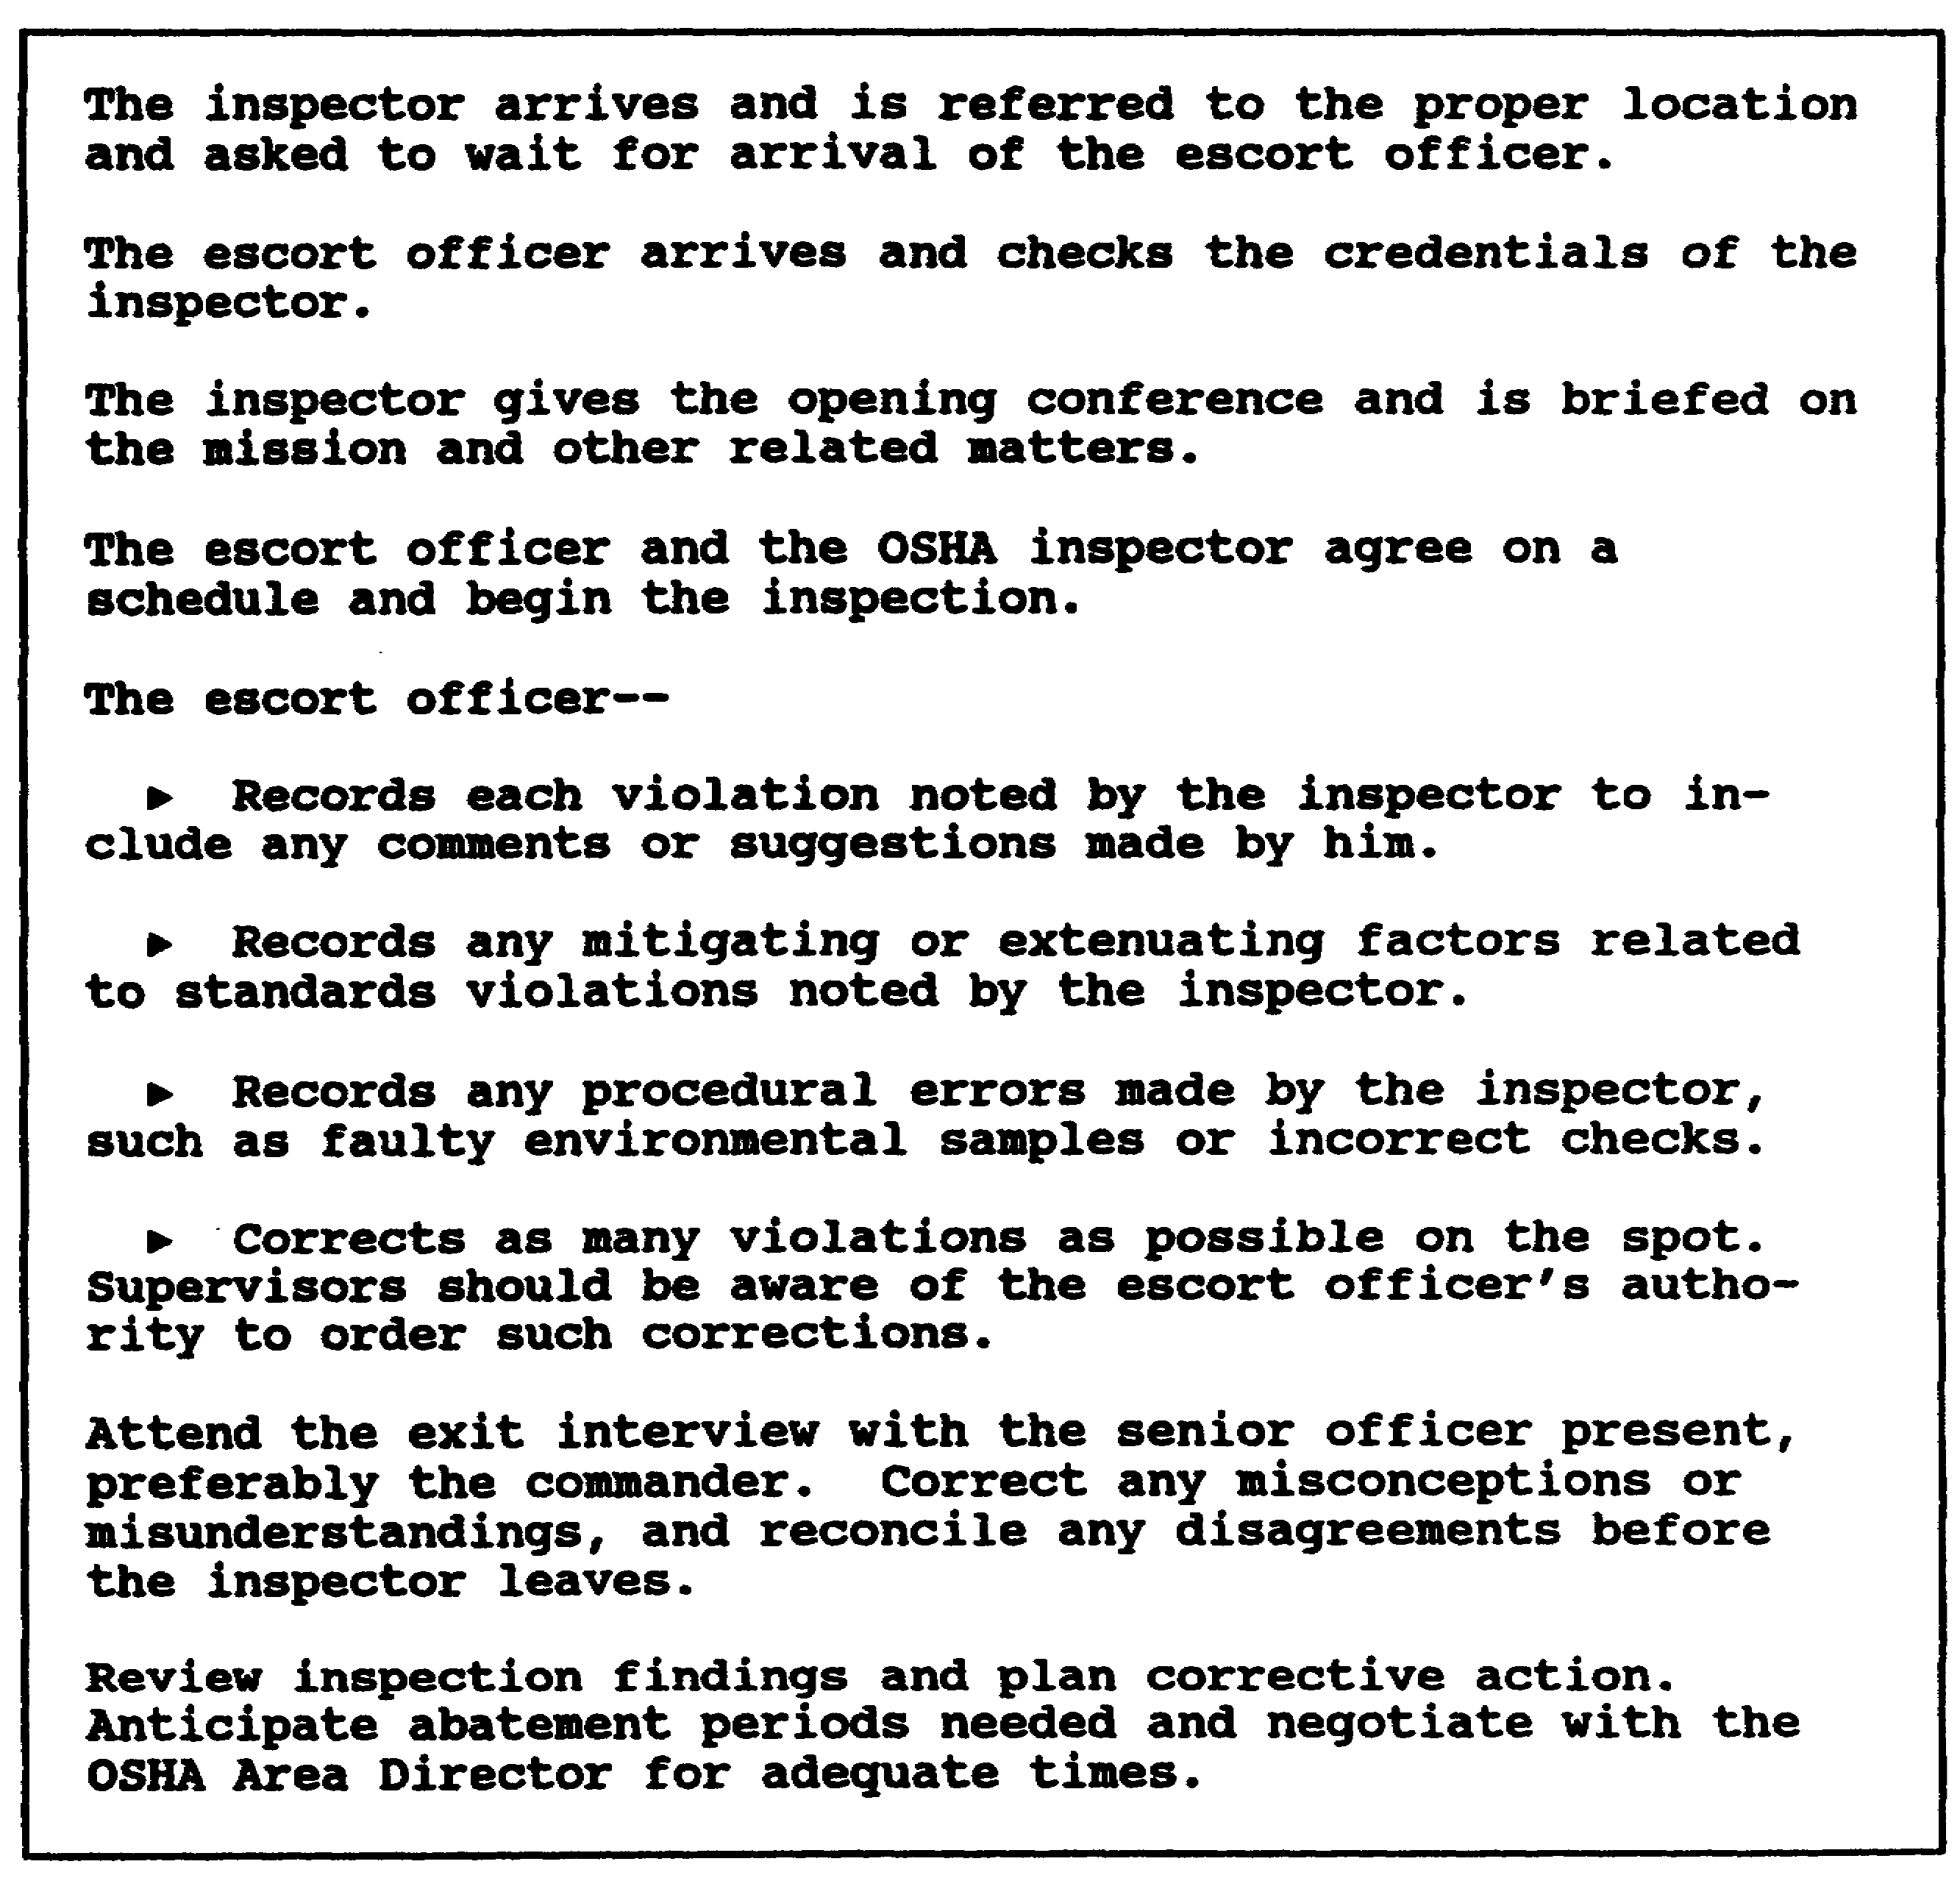

Figure 1-19. inspection scenario

1-39 AV0584
LESSON 1

PRACTICE EXERCISE

The following items will test your grasp of the lesson material. Each item has only one correct answer. When you complete the exercise, check your answers with the answer key that follows. If you answer any item incorrectly, restudy that part of the
lesson.

1. What documents would a safety progressional consult to clearly understand the continuity of safety policy in the federal agency OSHA program?

A. OSHAct only
B. OSHAct and EO 12196 only
C. 29 CFR Part 1960 and EO 12196 only
D. OSHAct, EO 12196, and 29 CFR Part 1960

2. DODD 1000.3, "Accident Prevention Safety and Occupational Health Policy," is based on what guidance?

A. AR 385-10
B. EO 10287
C. DODI 1000.18
D. 29 CFR Part 1960

3. The OSHRC

A. can change standards at will.
B. reviews a standard for accuracy.
C. reviews and passes judgment on appeals of citations.
D. reviews the annual accident report summary for significant findings.

4. In relating OSHA to the existing ASP, the safety manager should

A. integrate all OSHA requirements into the ASP.
B. keep two separately identifiable programs.
C. use whichever approach listed above best suits the circumstances.
D. integrate overlapping aspects keeping a separate identity of unique OSHA requirements.

1-41 AV0584
5. Employee rights under OSHA include the right to

A. get federal court review of inspections.
B. vote on all safety standards affecting their work place.
C. sue federal agencies for damages resulting from injuries.
D. make complaints, participate in inspections, and have access to safety records.

6. AR 385-10 sets normal procedures by which a complaint should be submitted using

A. DA Form 2807.
B. DA Form 4755.
C. DOD Form 4753.
D. OSHA Form 4375.

7. The OSHA is divided into three major program areas: standards development and issuance, OSHA training and education, and Federal Agencies Program.

A. true
B. false

8. Implementation of the OSHAct involves three separate agencies--the BLS, DHEW, and the OSHRC.

A. true
B. false

9. Supervisors can be very effective in identifying standard violations directly applicable to their operations.

A. true
B. false

10. Identifying the safety officer as an official escort officer and planning an "OSHA inspection alert system" to alert all major operating divisions of an inspector's presence are direct violations of 29 CFR Part 1960.

A. true
B. false

1-42 AV0584
LESSON 1

PRACTICE EXERCISE

ANSWER KEY AND FEEDBACK

Item Correct Answer and Feedback

1. D. OSHAct, EO 12196, and 29 CFR Part 1960.

Although answers A, B, and C are all parts of the complete answer, the correct response is D. (page 1-2, para 1e)

2. D. 29 CFR Part 9160.

Actual operating guidance is contained in the ARs that implement DOD guidance. (page 1-2, para 1)

3. C. reviews and passes judgment on appeals of citations.

The OSHRC reviews the decisions of an administrative law judge and either supports or overturns the findings. (page 1-3, para 2d)

4. C. use whichever approach listed above best suits the circumstances.

The Army safety manager's major purpose is to decide how the OSHAct will be integrated into the existing Army safety program (ASP). (page 1-5, para 3a)

1-43 AV0584
Item Correct Answer and Feedback

5. D. make complaints, participate in inspections, and have access to safety records.

This is one of many rights under OSHA. It also is a requirement that employees be trained in their rights and how to exercise them. (page 1-9, para 4a(1))

6. B. DA Form 4755.

DA Form 4755 (Employee Report of Alleged Unsafe or Unhealthful Working Conditions) is used to request DOL involvement. The preferred method is to encourage employees to first take up the problem with their supervisor. (page 1-22, para 6a(3))

7. B. false

OSHA is divided into national, regional, and administrative programs. (page 1-3, para 2c)

8. A. false

The three separate agencies involved are the BLS, OSHRC, and the NIOSH. (page 1-3, para 2d, and page 1-5, para 2e, and f)

9. A. true

Supervisors manage and operate systems but will need training, education, motivation, and support in executing these responsibilities. (page 1-12, para 4b(4))

10. B. false

The safety officer is the best choice for performing the duties of escort. He will be the most knowledgeable of safety issues and is in the best position to quickly implement corrective actions. (page 1-37, para 9b(2))

1-44 AV0584
LESSON 2

THE ARMY SAFETY PROGRAM

Critical Task: None.

OVERVIEW

LESSON DESCRIPTION:

This lesson will help you describe the organizational structure and list the objectives of the Army Safety Program (ASP); describe the safety awards program; and distinguish between the awards of Excellence, Merit, and Honor.

TERMINAL LEARNING OBJECTIVE:

ACTION: Describe the organizational structure and list the objectives of the Army Safety Program (ASP); describe the safety awards program; and distinguish between the awards of Excellence, Merit, and Honor.

CONDITION: You may use the lesson text to complete the action.

STANDARD: You will use the lesson text to describe the organizational structure and list the objectives of the Army Safety Program (ASP); describe the safety awards program; and distinguish between the awards of Excellence, Merit, and Honor according to this lesson.

REFERENCE: The material in this lesson was derived from the following publications: AR 385-10; AR 385-40; and DOD Directive (DODD) 1000.3.

INTRODUCTION

AR 385-10 sets up the ASP and prescribes policies, procedures, and guidelines for implementing the safety program including the Occupational Safety and Health Act and DOD requirements through-out the DA. It is applicable to all commands, installations, activities, and units of the Army, including the Army National Guard and United States Army Reserve (USAR).

2-1 AV0584
NOTE: For the explanation of terms used in this lesson, see the
glossary.

Part A--GENERAL

1. SAFETY GOALS

The safety goals of the Army reduce and keep to a minimum accidental manpower and monetary losses, thus providing more efficient use of resources and advancing the combat effectiveness of the Army. These goals also provide a safe and healthful environment always for all Army personnel and others exposed to Army operations.

2. OBJECTIVES

The objectives of the safety goals are achieved through the following safety program objectives:

a. Prevention of Injury and Occupational Illness

Prevention reduces the frequency and severity of injuries and occupational illnesses resulting from Army operations. It improves employee morale and efficiency and reduces the cost associated with loss of production, compensation payments, sick leave use, and other related expenses.

b. Damage Control

Damage control aims at detecting and eliminating the causes of preventable, accidental damage to Army and non-Army property as a result of Army operations.

c. Accident Prevention

Accident prevention involves using special techniques to detect unsafe behavior and conditions and to prevent accidents.

d. Compliance with Statutory and Regulatory Requirements

This objective uses the specialized experience of the safety staff to assure consistent, economical compliance with applicable safety requirements of the host nation, federal statutes, Army regulations, and Status of Forces Agreements.

e. Liability Limitation

This objective involves prompt and prudent action to reduce the likelihood of liability against the Army.

2-2 AV0584
f. Occupational Health

Occupational health involves implementing AR 40-5 to assure the physical and mental health of all personnel in cooperation with safety personnel.

3. POLICY

The policies below will be followed by commanders and program managers at all levels in implementing the ASP including Occupational Safety and Health Administration (OSHA) requirements.

a. The safety program will fully support the Army mission while lessening adverse impact on operations.

b. Accident prevention is a command responsibility. Commanders must assure compliance with the safety program and set necessary additional requirements to assure the safety of personnel under their control. Safety requirements set by higher headquarters normally will not be waived without the approval of that headquarters. This does not prevent the commander from issuing temporary waivers in emergencies when, in his judgment, a waiver is justified. All such waivers must be reviewed later by higher authority.

c. To assure efficient accident prevention efforts throughout the Army and to reduce accidents in general problem areas common to several commands, objectives and projects will be developed centrally. The Army Safety Management Information System ends duplicated effort. Command safety data managers will coordinate studies and evaluations with commands having similar operational responsibilities.

d. Programs developed centrally should allow subordinate commanders enough flexibility to develop alternative approaches to meet their individual needs.

e. Hazard analysis procedures will be used to identify and control hazards in systems, facilities, and operations during the planning stages. Commanders must emphasize using such early detection techniques on a priority basis ;over techniques that rely on detecting hazards or accident causes after an activity is operational or after an accident has occurred.

f. Available resources must be applied against hazards on a "worst-first" basis. Evaluation of hazard priority must include consideration of the overall potential results defined by degree of injury, occupational illness, and damage. Mission, legal, and statutory implications of each hazardous situation also must be considered.

2-3 AV0584
4. RESPONSIBILITIES

a. The Assistant Secretary of the Army (Installations, Logistics. and Financial Management)(ASA [IL&FM])

The ASA (IL&FM) is the principal advisor and assistant to the Secretary of the Army for Army safety and OSHA matters. His responsibilities are listed in Figure 2-1.

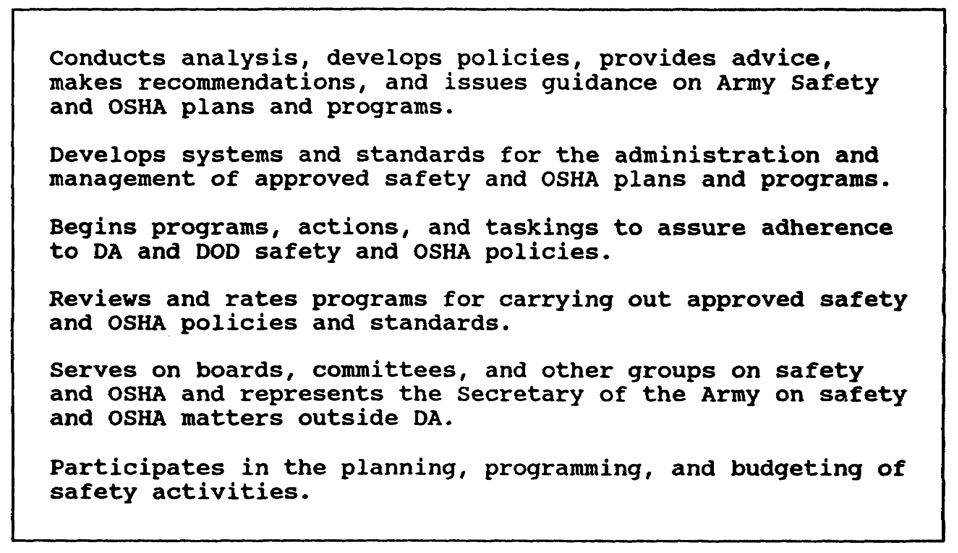

Figure 2-1. Assistant Secretary of the Army (IL&FM) responsibilities

b. The Deputy Assistant Secretary of the Army for Environment, Safety, and Occupational Health

The Deputy Assistant Secretary will help the ASA IL&FM in carrying out the responsibilities in Figure 2-1.

c. The Deputy Chief of Staff for Personnel (DCSPER)

The DCSPER's responsibilities are listed in Figure 2-2.

d. The Director, Human Resources Development, DCSPER

This director will exercise staff supervision of the US ASP for the DCSPER.

2-4 AV0584
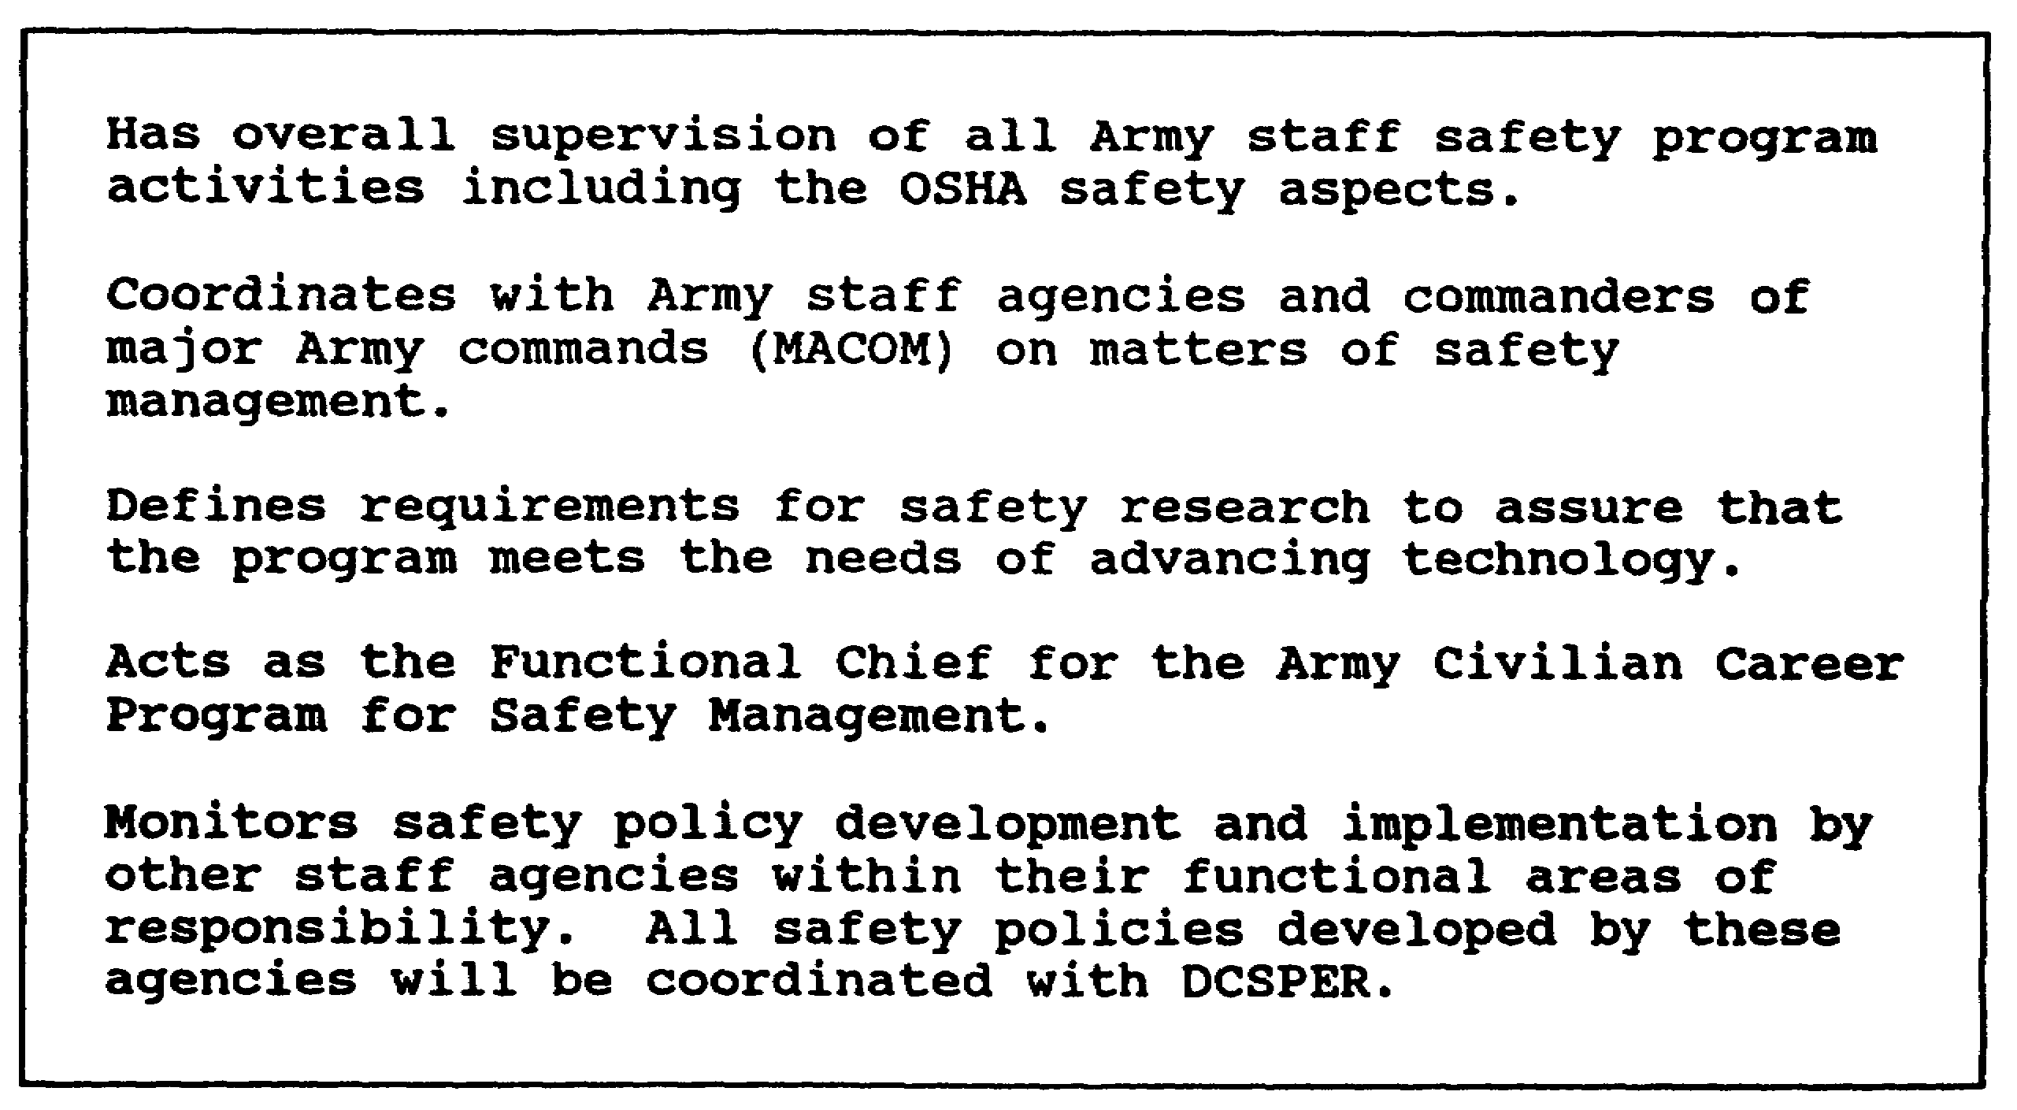

Figure 2-2. Deputy Chief of Staff for Personnel responsibilities

e. The Director of Army Safety, Office of the Chief of Staff. Army

This director will perform the duties in Figure 2-3.

f. The Commander, USASC

The commander's responsibilities are listed in Figure 2-4.

g. The Deputy Chief of Staff for operations and Plans

The Deputy Chief of Staff for Operations and Plans will set policy for the Army Nuclear and Chemical Surety Programs. He also will establish policy for the Army Flight Standardization Program.

h. The Deputy Chief of Staff for Logistics (DCSLOG)

The DCSLOG will set policy for safety in packaging hazardous materials and for the Army's Oil Analysis Program. He also establishes policy for safety-of-flight messages for the Army aviation safety effort.

2-5 AV0584
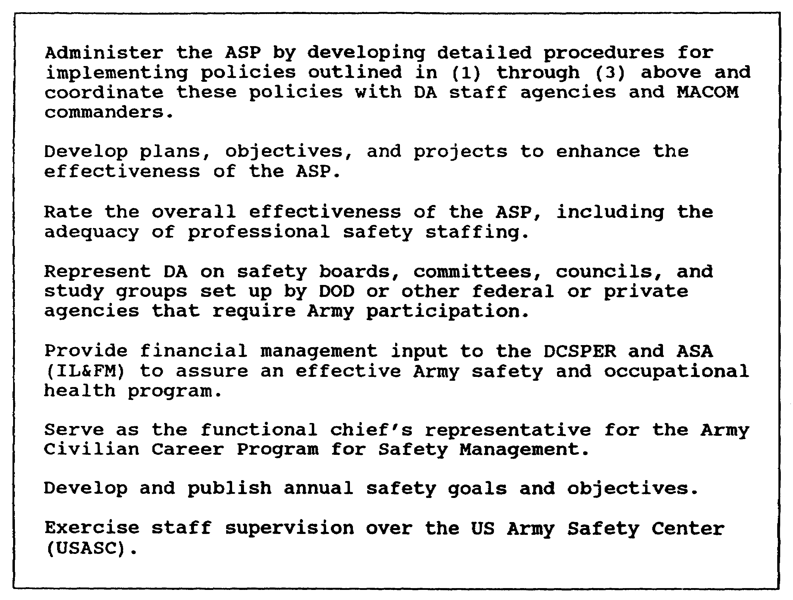

Figure 2-3. Director of Army Safety responsibilities

i. The Surgeon General

The Surgeon General through the Health Services Command, will set policy for--

(1) Occupational health education programs.

(2) Formulating occupational health standards.

(3) Keeping the Army Hazardous Information System.

(4) Determining occupational health program priorities.

(5) Acquisitioning medical materiel and health hazard review for nonmedical materiel.

2-6 AV0584
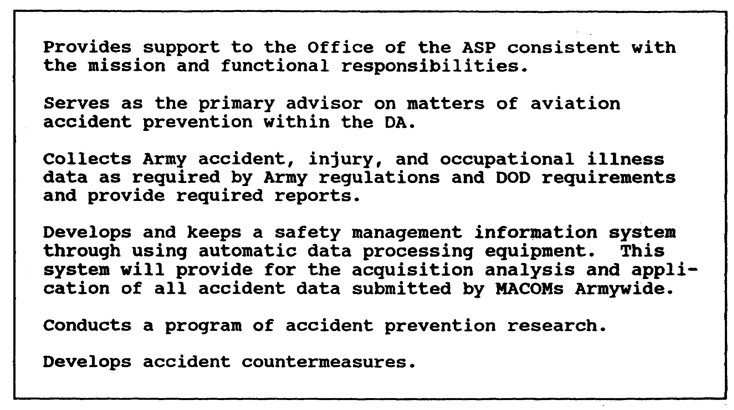

Figure 2-4. USASC Commander's responsibilities

(6) Collecting and disposing epidemiologic data to assess occupational health effectiveness.

(7) Safety and health aspects of operations involving nonionizing radiation and ionizing radiation for human use.

(8) The Army Occupational Health Program to include specific industrial hygiene and occupational and aviation medicine.

j. The Chief of Engineers

The Chief of Engineers will set policy for--

(1) Nuclear weapon fire fighting.

(2) Nuclear reactor safety and reporting procedures.

(3) All safety aspects of fire prevention and protection.

(4) Safety in all Army civil works and military works construction.

2-7 AV0584
(5) Disposing of real estate contaminated by explosives and radioactive or other hazardous material.

(6) Compliance with OSHA standards in the design, construction, and renovation of new or existing facilities.

k. The Deputy Chief of Staff for Research, Development, and Acquisition (DCSRDA)

The DCSRDA will set policy for the safety aspects of design and development of nuclear weapon systems.

l. MACOM Commanders

All MACOM commanders will follow the safety and occupational health requirements of AR 385-10. If a MACOM commander determines that these requirements are incompatible with achieving his mission, he will request a waiver of the specific requirements from HQDA, ATTN: DAPE-HRS, Washington, DC 20310. In addition to these general command responsibilities for the ASP, specific responsibilities have been assigned to the MACOMs listed below.

(1) The commanding general (CG), US Army Materiel Command (AMC), will set policy for transporting radiological materials, nonhuman applications of radioactive materials, and licenses and authorizations for radioactive materials. The AMC also sets policy for radioactive waste disposal, hazard classification of ammunition and explosives, and compatibility of new materiel with OSHA standards.

(2) The Commander, Military Traffic Management Command, will set Army policy for safety in maritime operations within the continental United States (CONUS) and selected overseas locations and safety in operations requiring DOD compliance with Department of Transportation hazardous materials regulations. The commander also will set policy for exemption requests by DOD components for shipments of hazardous materials by DOD shippers that do not follow Department of Transportation regulations.

(3) The CG, US Army Training and Doctrine Command (TRADOC), is responsible for integrating accident prevention doctrine into all training procedures and techniques to be applied by the Army in the field and by Army Reserve components in CONUS. He also will assure that safety and occupational health training and related techniques are included in the curricula of proper Army schools. The CG, TRADOC, also is responsible for incorporating basic safe practices and physical standards set up by materiel developing agencies into safe operating procedures for inclusion in field manuals, training circulars, and other documents. Adding system safety elements to requirements documents,

2-8 AV0584
providing new equipment training and operational testing, and developing range safety criteria for publication also are areas of responsibility.

(4) The CG, US Army Forces Command (FORSCOM), is responsible for setting safety requirements and guidance for use in Army exercises and maneuvers in which FORSCOM participates or exercises operational control. He provides copies of such guidance to HQDA, ATTN: DAPE-HRS, and to USASC for review and distribution to other MACOMs having similar missions. The CG, FORSCOM, also is responsible for assuring that CONUS Army commands provide effective program guidance to the USAR.

(5) Army component commanders of overseas commands will provide safety services as requested by Army elements of Military Help Advisory Groups and missions within their geographical responsible area.

(6) Research and materiel developing agencies--the CG, AMC; CG, US Army Communications Command; the Chief of Engineers; The Surgeon General; and the Ballistic Missile Defense Manager--are responsible for developing safety criteria in materiel design and setting up in publications (technical manuals, and bulletins) the basic safety practices and physical standards for equipment and systems that they develop.

(7) For joint commands and exercises, the CG of each overseas MACOM within a joint command, the commander of each Army unit or activity in a jointly occupied installation, and the commander of each Army unit in a joint exercise will carry out his portion of the command safety program. They also will coordinate with proper commanders of other services within the joint command or exercise to assure safe practices and physical standards within all operations.

m. The Adjutant General (AG)

The AG will provide accident prevention leadership and support for HQDA staff elements and their subordinate activities.

5. PERSONNEL COMPLIANCE AND EVALUATION

All Army personnel will follow safety regulations, occupational safety and health (OSH) standards, and other safety directives and orders. The success of officials, supervisors, and operating personnel in performing OSH responsibilities will be considered in performance appraisals.

2-9 AV0584
Part B. PROCEDURES FOR ORGANIZING THE ARMY SAFETY PROGRAM

6. PROCEDURES

In setting up the command safety program, each MACOM and installation commander will--

a. Appoint an official to help implement the safety program and OSHA requirements. Duties performed by this official, normally the Command Safety Director, will include developing policy and plans, procedures, objectives, and projects as specified in AR 385-10. This staff official will report directly to the commander on all safety program and OSHA matters.

b. Provide enough funds and qualified staffing for the safety program. As a minimum, this staff will perform standard safety functions and tasks specified as follows:

(1) Interpret safety policies and procedures.

(2) Provide direction for the safety segment of the civilian career program.

(3) Help subordinate commanders in developing safety aspects of training exercises.

(4) Keep close liaison with other staff agencies in all relevant safety matters.

(5) Conduct surveys and inspections of accident prevention programs and activities.

(6) Provide technical help in accident investigating and reporting to assure accuracy and completeness.

(7) Analyze field exercise accidents to determine causal factors, and provide proper preventive measures.

(8) Provide technical and professional help to end or control unsafe behavior and unsafe environment.

(9) Determine the need for safety promotional and educational materials within the command; get and distribute these materials.

(10) Provide accident prevention material, and assure high quality training for civilian and military safety personnel at all levels.

2-10 AV0584
(11) Provide for setting up and implementing plans, policies, and procedures for conducting safety programs at all levels of command.

(12) Review plans for proposed demonstrations, exhibits, exercises, or contingencies to assure the safety of Army personnel and the public.

(13) Assure that adequate safe practices and safe physical standards are incorporated in operating procedures, manuals, directives, and other instructions.

(14) Help subordinate commanders in determining the numbers and qualifications of personnel necessary to assure an effective accident prevention effort.

(15) Set up and keep liaison with other military services, federal and civilian agencies, and most nations overseas to assure cooperation on matters of mutual concern.

(16) Develop recommendations for corrective measures where warranted by adverse accident rates or trends, hazardous conditions or procedures, or other deficiencies.

(17) Serve as principal staff advisor, technical consultant, and coordinator to the command and the staff in planning, organizing, directing, and checking all safety program elements within the command.

(18) Collect, analyze, and send data on the accident experience of the command and subordinate elements. Prepare progress reports of safety activities and other reports and studies required by higher authority.

NOTE: The above functions and tasks should be expanded as resource availability permits.

c. Support Army efforts to develop military and civilian safety and OSHA expertise through training programs and effective career development and management procedures.

d. Assure that safe practices and safe physical standards are incorporated in all regulations, directives, SOPs, special orders, and training doctrine.

e. Adopt command safety objectives consistent with those in AR 385-10 and develop implementing plans to follow all requirements of the regulation. Implementing plans will be realistic in their time frames and resource demands and will be approved by the commander or his authorized representative.

2-11 AV0584
f. Provide normal safety services to tenant and satellite activities, based on mutually acceptable terms, that must follow legal mandates and to achieve accident prevention objectives. Such services will be given without imposing on command responsibility.

g. Set up measures to protect personnel against discriminatory actions or reprisals resulting from exercising safety and health rights provided by the regulation.

h. Set up procedures to assure compliance with OSHA inspections of all applicable contract operations under their supervision.

i. Provide safety services to USAR units in their geographical responsible area.

j. Set up a Safety and Occupational Health Advisory Council Committee composed of representatives of management and military and civilian operating personnel. The council will review accident experience and suggest countermeasures and safety campaigns for implementation. The council will be chaired by the installation commander or his representative and will meet on a regularly scheduled basis. Minutes of the meetings will be approved by the installation commander or his representative. MACOMs may authorize exceptions to this requirement where an installation population is so small that a council is not warranted.

k. Where participation in OSHA activities is required by this regulation, use of official time is authorized.

7. PROGRAM EVALUATION

a. HQDA Office, DCSPER, will conduct periodic (at least triennially) evaluations of MACOM safety programs using the evaluation checklist at appendix A. Additional evaluation criteria may be used to meet specific MACOM program needs.

b. MACOM commanders will conduct annual help visits and safety program evaluations of subordinate commands using applicable survey criteria that may be supplemented by additional evaluation criteria for specific command or installation OSH programs.

Part C--HAZARD IDENTIFICATION

8. HAZARD ANALYSIS PROCEDURES

a. Commanders involved in developing Army materiel will follow the system safety provisions of AR 385-16. Other commanders will

2-12 AV0584
determine the applicability of hazard analysis procedures to their safety requirements.

b. As a minimum, hazard analysis procedures will be the priority method used to detect accident threats to key missions and hazards likely to produce high frequency or high severity personnel injuries, high dollar losses, or losses likely to produce significant legal action or public discredit to the Army. These techniques include preliminary hazard analysis, failure mode and effect, and fault-free analysis techniques (AR 385-16).

9. INSPECTIONS

The procedures outlined below, shown as Standard Army Safety and Occupational Health Inspections (SASOHI), are mandatory and will be followed on all installation level inspections. Additional procedures also are authorized.

a. All facilities will be inspected at least annually using the SASOHI procedures. Facilities and operations involving special hazards will be inspected more frequently determined by the assigned OSH official.

b. All SASOHI will be conducted by qualified civilian or military safety and health professionals, except -that nonspecialist personnel may be used to inspect facilities specified as entailing little risk by the OSH official.

c. SASOHI may be conducted with or without prior notice. No notice of inspections will be used when safety and health personnel determine they will provide a more meaningful assessment of actual operating conditions and practices.

d. The installation commander, or his assigned representative, may deny the right of accompaniment to any person, who, in their judgment, is interfering with the inspection.

e. The inspector conducting SASOHI will consult a sampling of personnel on matters affecting their safety and health and offer them the opportunity to identify unsafe or unhealthful working conditions in the work areas.

f. When an imminent danger situation is discovered, the immediate supervisor and activity head will be told ASAP. The inspector will provide technical advice to the supervisor on the scene. The supervisor will correct the condition or withdraw personnel from exposure. If the inspector finds the hazard cannot be immediately eliminated, he will tell the installation OSH official. If this official finds that corrective action is inadequate, he will secure approval of the commander or his authorized representative for measures to be taken to

2-13 AV0584
prevent employee exposure to the hazard. Imminent danger hazards from which personnel have been withdrawn as an interim measure will be identified on the form described in i below.

g. Written reports of violations resulting from SASOHI will be provided to the head of the activity or the commander of the unit inspected. These reports will cite hazards and safety management deficiencies and will recommend corrective actions. DA Form 4753 (Notice of Unsafe or Unhealthful Working Conditions) (Figure 2-5) may be used for this purpose. Violations of standards that cannot be corrected within 30 calendar days of discovery will be recorded and kept at the installation or DA Form 4756 (Installation Hazard Abatement Plan).

h. Notices of violations detected during SASOHI for hazards in Category I (Catastrophic: May cause death or loss of a facility) or Category II (Critical: May cause severe injury, severe occupational illness, or major property damage) will be placed on a DA Form 4753. This form will be conspicuously posted at or near the location of the hazard.

i. All violations of standards detected during SASOHI will be entered on DA Form 4754 (Violation Inventory Log)(Figure 2-6). This log will be used to monitor compliance. It will show all violations in order of discovery, prescribed abatement date, and the date for follow-up on correction of deficiencies.

j. Procedures will be set up to follow up on the correction of deficiencies identified during a SASOHI. If corrective action has not been accomplished or it is discovered that interim safety measures are not being enforced, the inspector will inform the installation OSH official who will determine remedial action to include letting the installation commander know, if appropriate. For all uncorrected violations, entries will be made in the correct blocks on DA Form 4754, reflecting the revised corrective action schedule and proper remarks.

k. According to the provisions of EO 12196, OSHA and National Institute for Occupational Safety and Health officials, acting as representatives of the Secretary of Labor, are authorized to conduct announced or unannounced inspections of all Army workplaces except military and nonmilitary unique workplaces that are staffed exclusively with military personnel.

(1) Such inspections may be in response to a complaint from an Army employee or an employee representative. They may be scheduled as part of OSHA's annual evaluation of agency programs or may be solely at the discretion of the Secretary of Labor.

2-14 AV0584
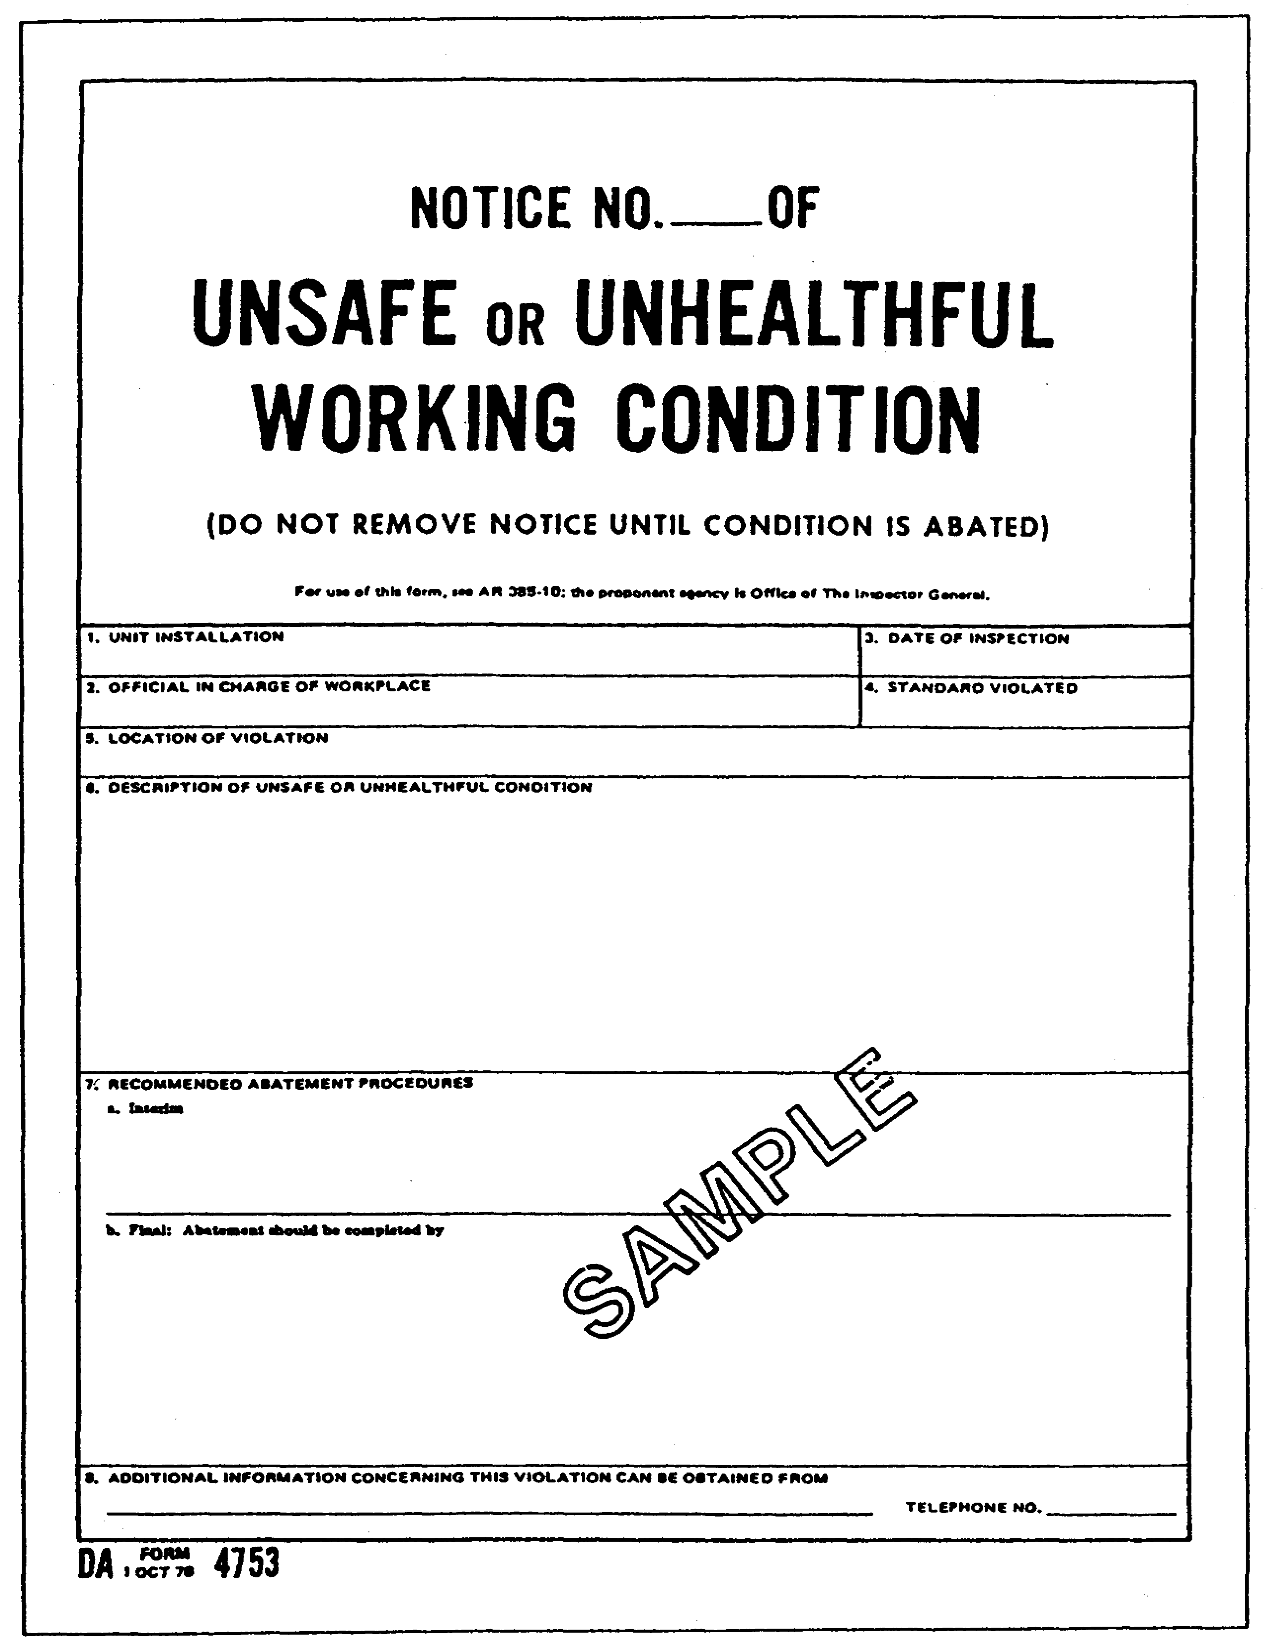

Figure 2-5. DA Form 4753

2-15 AV0584
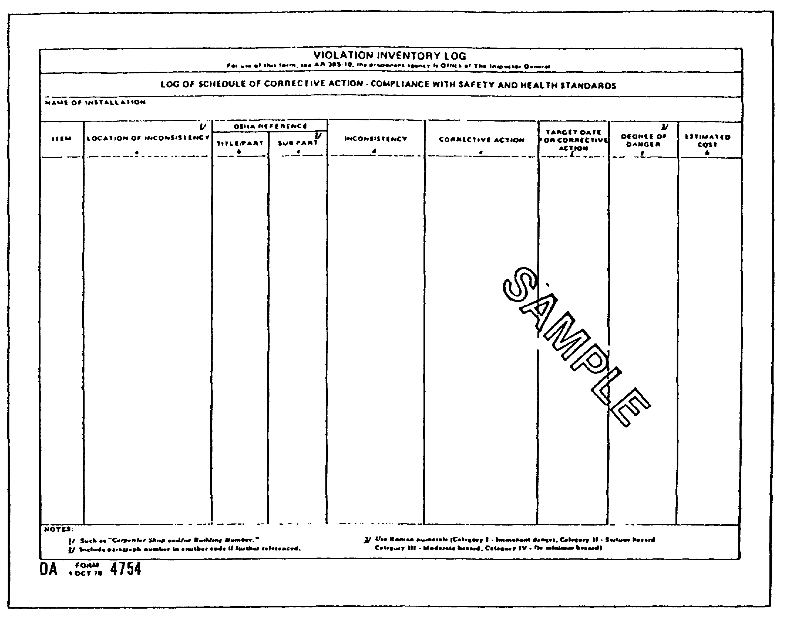

Figure 2-6. DA Form 4754

(2) Department of Labor (DOL) representatives shall--(a) Be admitted to conduct inspections at applicable workplaces reasonably, without delay, and at reasonable times.

(b) Initially report to the installation commander or his representative and shall be accompanied always on Army installations. They shall show proof of proper security clearance if entry into closed areas is required. A closing conference with the installation commander or his designee shall be arranged before the DOL inspector's departure. Employee representatives shall be invited to attend the closing conference.

(c) On request, be provided available safety and health information on work sites to be visited. Such information may include

2-16 AV0584
data on hazardous materials in use, copies of recent DOD inspection or survey reports, employee hazard reports, and abatement project information.

(3) When DOL representatives issue notices of hazardous or unhealthful conditions, local officials should treat such notices the same as similar, internal notices and provide for abatement of significant deficiencies.

(4) Response to DOL inspection reports shall start at the local level. Elevation of unresolved conflicts to higher echelons for interagency resolution shall be at the DOL's initiative by way of DOL channels. This provision, however, shall not inhibit normal internal communication within command channels to let higher echelons know of the results of DOL inspections and coordinate responses to the DOL.

(5) Regarding investigations of Army accidents that are solely a DOD responsibility under EO 12196, DOL officials may be shown or provided factual portions of pertinent accident investigation reports as defined in AR 385-40. DOL officials, on request, also may be authorized to accompany such Army investigations in an observer status. Separate, duplicate DOL investigations of Army accidents, either concurrent with or later to required Army investigations, are not contemplated. DOL officials, however, may inspect for residual hazardous conditions at the site of an Army accident.

10. REPORTING ACCIDENT CAUSAL FACTORS

Accident reporting procedures will conform with AR 385-40. Violations of standards discovered during accident investigations that are relevant to accident causation and that are not immediately correctable will be treated the same as hazards discovered during SASOHI.

11. REPORTS OF UNSAFE OR UNHEALTHFUL CONDITIONS

a. Reports of unsafe or unhealthful conditions by Army personnel are important in detecting hazards that cause accidents. Such reports will be handled at the operating level to assure prompt, efficient processing. Provision will be made, however, as outlined below for personnel to bring such complaints directly to installation level, bypassing intermediate commands or supervisory elements.

b. Commanders will publicize all channels for reporting unsafe or unhealthful conditions, emphasizing personnel responsibility for making such reports. Personnel will be directed to use the available means in the order of priority in Figure 2-7.

2-17 AV0584
c. Procedures for the Army Hazard Reporting System will be as follows:

(1) Reports under this program will be in writing on DA Form 4755 (Employee Report of Alleged Unsafe or Unhealthful Working Conditions). Normally, reports will be signed; however, anonymous reports will be investigated the same as other reports. Reports will be submitted directly to the installation OSH official, bypassing intermediate command elements.

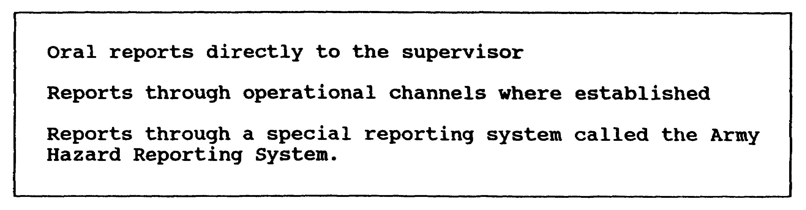

Figure 2-7. Report making priority sequence

(2) Persons submitting signed reports who request anonymity will not be revealed by the installation OSH official to anyone other than necessary members of his staff or other proper installation level staff. Action will be taken against those who violate this prohibition.

(3) Reports that appear to involve imminent danger situations will be investigated immediately by qualified inspectors. If an imminent danger situation is discovered, the inspector will follow the procedures outlined in AR 385-10, para 4-1f(1).

(4) All other reports will be investigated by safety or health personnel. The originator, if known, will be told in writing within 10 working days following the receipt of the hazard report of the results of the investigation. If this 10-workday suspense cannot be met, the originator should be provided with an interim response. If it is determined that a hazard exists, the reply will include a summary of the actions to be taken and an expected date for corrective action. Procedures for inspections outlined in AR 385-10, paragraph 4-1, will apply, if appropriate. If it is determined that a hazardous condition does not exist, the reply to the employee will include the basis for that determination. This reply will encourage informal contact by the individual submitting a report with installation safety and health officials if additional explanations are desired. It also will inform the individual of his right of appeal as outlined below. Every

2-18 AV0584
effort, to include consulting with a regional federal OSHA office and request for technical advice from the US Army Environmental Hygiene Agency, will be made to resolve the originator's questions or dissatisfaction. If a hazard report also involves a grievance action, the hazard report need not be processed unless it shows a need for priority action for safety or health reasons.

(5) If the originator is dissatisfied with the OSH official's response, the originator may appeal to the installation commander. The installation commander will review the finding and take proper action. If the originator is dissatisfied with the installation commander's response, the originator may appeal to the MACOM OSHA official. Such appeals will be sent through channels to the MACOM commander who will review the finding, investigate as necessary, and be sure the appropriateness of the installation level response. If the report of hazard is judged unfounded, a reply to the originator rejecting his appeal will tell him of the basis for the rejection and will advise him of his right to appeal to the Army assigned OSH official. On receipt of an appeal, he will review the case and reply to the originator with a statement of findings. If the appeal is rejected, the reply will advise the originator of his right to appeal to the DOD-appointed OSHA official.

NOTE: Personnel will not bypass review levels prescribed in (5) above.

(6) Reviews normally will be completed within 20 workdays. Personnel will be informed that, if an appeal is not acted on within 20 workdays, they may appeal to the next higher level for review.

(7) Copies of reports submitted under the Army Hazard Reporting System will be kept at accessible locations, including a Federal Record Retention Center, for at least five years following the end of the calendar year to which they relate.

d. Installation OSH officials will set up procedures with regional OSHA offices to assure that complaints filed directly to the OSHA office are referred to the installation for initial action. Procedures must take account of collective bargaining and employer-union agreements.

Part D--ANALYSIS OF CAUSAL RELATIONSHIPS

12. ORIGIN OF ACCIDENTS

The origin of accidents and the operating errors that immediately precede them can be found in defects associated with the management

2-19 AV0584
of the overall system. Accordingly, the commander and his safety staff must determine the training, motivation, task design, materiel, and environmental defects in the system that lead to operating errors and accidents.

13. PROCEDURES FOR GATHERING DATA

Hazards uncovered as a result of inspections, accident investigations, and personnel reports of hazards will be recorded on DA Form 4754. All other verified reports of operating errors should be added to this form. Where the capability exists, automatic data processing procedures may be substituted for this form.

14. PERIODIC ANALYSIS

The installation commander will assure that periodic analyses of accident data are conducted with the following objectives:

a. Identify the most significant areas of hazard accumulation. Consideration will be given to the significance these related groupings of hazards pose to mission accomplishment. Examples of such groupings may be related factors in motor vehicle accidents or a pattern of hazards showing the chance of a fire in a high dollar value facility. The result of this analysis will be a list of priority problem areas.

b. Assure that an analysis of the systemic origins of these priority problems is conducted. The systems related problems and deficiencies revealed by this analysis will become, with data collected from safety program evaluations and other information sources, the basis for planning a preventive effort.

15. MODIFICATION OF ANALYTICAL PROCEDURES

An installation commander may authorize analytical procedures other than those described above if, in his judgment, they better support his accident prevention objectives.

Part E--ACCIDENT PREVENTION: SAFETY PROMOTION, TRAINING, AND AWARDS

16. DECISIONS OF RISK

Because of operational requirements, resource limitations, and technological gaps, not all hazards can be eliminated. This requires commanders to make trade-off decisions. With the advice of the safety staff, they must decide what level of risk is correct in actual situations. In some cases, the level of risk is limited by legally binding mandates such as the Occupational Safety and Health

2-20 AV0584
Act. In others, no standards exist or standards are inadequate for the situation. Decision-making techniques are then required to make most risk decisions.

17. PHYSICAL STANDARDS

a. All standards set by OSHA following PL 91-596, Sections 6 and 19, are adopted as Army safety standards and will be followed within applicable Army workplaces comparable to private sector workplaces. Excluded are military unique equipment and systems and operations that are unique to the national defense mission, such as military aircraft, vessels, missiles and missile sites, early warning systems, combat vehicles, and tactical vehicles. Excluded also are similar military items and operations involving these systems, such as field maneuvers, military flight operations, and associated research, test, and development activities. OSHA standards do not apply under the following circumstances:

(1) Special Statutory Authorities

Certain operations are subject to mandatory safety standards or rules that derive from separate, specific statutory authority. The application of special functional standards does not exempt any workplace from other applicable safety criteria. Thus, a workplace in a munitions depot subject to the safety standards of special explosives also is subject to OSHA safety criteria for machine guarding, guardrails, and eye protection. Any publication that states job safety requirements for that workplace must take this into account.

(2) Status of Forces Agreements (SOFA)

In overseas workplaces where SOFA specifies different standards, SOFA standards take precedence.

b. When current standards in Army publications conflict with an applicable OSHA standard and provide a lower degree of protection, the OSHA standard will apply. When existing Army standards are equal to or exceed OSHA requirements in providing workplace safety, the Army requirement will apply.

c. Whenever possible, commanders will check the level of safety provided by set OSH health standards to determine if additional safeguards are required. Priority for these reviews will be given to high loss potential activities.

2-21 AV0584
d. Commanders will assure that publications carrying out Army OSHA criteria--

(1) Reach every applicable DA workplace in a form proper to the specific operation.

(2) Are clearly stated and understood by all affected personnel and are enforced.

(3) Are applied in the procurement process of goods and services and during the design and construction of new or upgraded facilities.

(4) Reflect new or revised DA OSHA criteria in a timely manner.

e. When, in the judgment of a MACOM commander, a set OSHA standard cannot be carried out in an applicable workplace, approval of alternate criteria will be requested by letter from the MACOM safety director's office to HQDA, ATTN: DAPE-HRS, for submission to the Assistant Secretary of Defense (Manpower, Reserve Affairs, and Logistics) for approval. These requests will be signed by the installation commander. The requests will reference the standard involved, state the reasons compliance is not possible, identify the difference in the proposed standard, and set up the basis for assuring that equivalent protection is provided. Alternate standards are not required to cover noncompliance situations involving interim alternate protective measures adopted while awaiting completion of an abatement on waivers issued under provisions of AR 385-10.

f. In some OSH situations, the most effective means to correct a hazardous situation may be through application of local alternate measures instead of set criteria. If this method is selected, installation commanders will consult with personnel representatives on the proposed procedure. They then will submit a request through the chain of command to MACOM level outlining the proposal including a description of the standard for which the variance is requested, an analysis supporting the equal or greater efficiency of the procedure in controlling hazards, and the comments of the personnel representative. The approving headquarters and submitting installation will keep records of variance while the variance is in effect and for one year after.

g. Where personnel of different DA commands work or carry out operations in the same DA installation, commands will consult with each other to resolve any conflict or potential conflict between safety standards affecting both. Problems that cannot be resolved at MACOM or lower level will be referred to HQDA, ATTN: DAPE-HRS, for a decision. DA commands experiencing any conflict with other DOD components or federal agencies related to safety standards that cannot be resolved

2-22 AV0584
at the local level will refer these problems to HQDA, ATTN: DAPE-HRS, describing the dispute and the problem it creates for the command.

h. In workplaces where no OSH standards have been established, standards will be set up using the latest edition of approved national consensus standards or local standards approved by MACOM Headquarters. If the MACOM approved standards have Armywide application, MACOMs will forward copies to HQDA, ATTN: DAPE-HRS, for review and approval. Those standards that are not related to military unique operations will be sent through channels to the Assistant Secretary of Defense (Manpower, Reserve Affairs, and Logistics) for review and submission to the DOL if approved for DOD-wide use.

18. VIOLATION CORRECTION POLICY

Consistent with the need for economy, the following priorities will be used to eliminate or reduce the effect of hazards:

a. Engineer to eliminate the hazard or fail-safe the device.

b. Guard or control the hazard.

c. Limit personnel exposures.

d. Provide protective clothing or equipment adequate to reduce injury potential.

e. Train and educate personnel to avoid hazards.

f. Use color coding and signs to alert personnel of hazards.

19. ABATEMENT PROGRAM PROCEDURES

a. Hazard Procedures

An analysis will be made of all hazards. DA Form 4756 (Figure 2-8) or a formal variance will be completed for all hazards recorded on DA Form 4754 that entail a risk assessment of III B or higher (Table 2-1) that are not correctable within 30 days of date of discovery. These procedures will be followed in the analyses of hazards.

(1) A risk assessment category will be assigned to each hazard. These categories will conform with criteria in Table 2-1. Hazards also will be assessed for cost correction, future intended use of the facility, and availability of desirable alternative methods of control.

2-23 AV0584
(2) Following this risk assessment, a decision will be made on the action required. If a variance is not right and resources permit, the hazards will be eliminated on a worst-first basis. If correction time will exceed 30 days, prepare a DA Form 4756 for each deficiency. Identical individual deficiencies may be grouped together into a single abatement plan. The plans will be kept current by adding new projects and by placing completed projects in a completed projects section. Violations in Category III C or below that cannot be immediately corrected will be shown as deferred on DA Form 4754 until resources for correction become available.

(3) Procedures such as spot-checking or sampling will be used to assure that interim control measures are being made.

(4) Copies of abatement plans will be placed in each unit (company, battery) or activity (carpenter shop, maintenance facility) where personnel notices are usually posted.

(5) Violations that are the responsibility of DOD, another Army command or installation, or an outside agency will be brought to the attention of the responsible official for action. The deficiency will be entered on DA Form 4754, but no abatement project need be prepared.

(6) Installation abatement project plans will be reviewed periodically by MACOM representatives to assure adequate resource allocation. These plans also are subject to review by HQDA.

b. Budgeting Procedures

Installation commanders will identify proper budgeting categories for all deficiencies and will assign proper priorities for all deficiencies. They also will assign proper priorities to the correction of these deficiencies.

20. SAFETY TRAINING AND EDUCATION STANDARDS

a. DA is tasked by OSHA and DOD to provide OSH training for employees, supervisors, collateral-duty OSH professionals, and management groups. The following are minimum requirements:

(1) Nonsupervisory Personnel Training

This training includes specialized job safety and health training right for the work performed to include the provisions of OSH criteria and hazards associated with any materials or operations in the workplace. It also includes informing employees of OSH complaint procedures and of their rights and obligations under this regulation.

2-24 AV0584
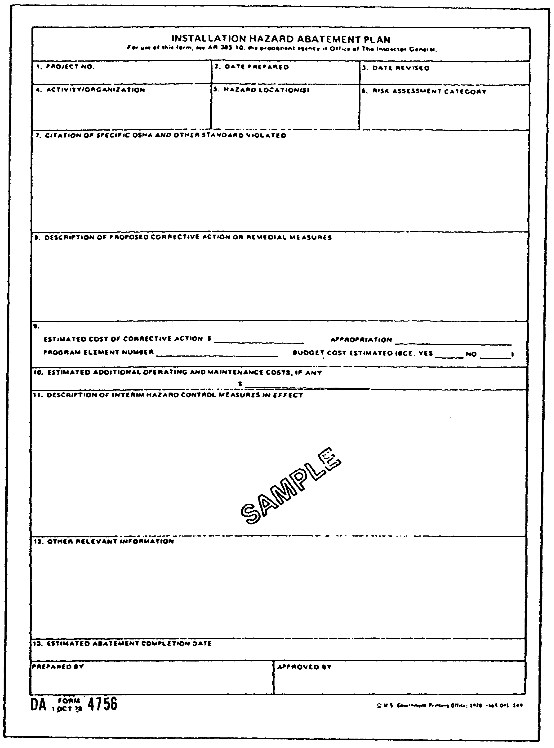

Figure 2-8. DA Form 4756

2-25 AV0584
Table 2-1. Risk assessment

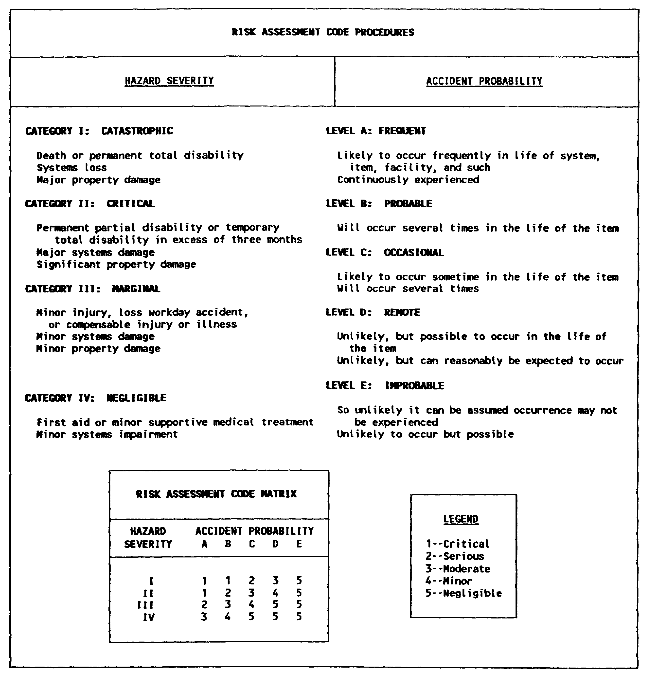

(2) Civilian Employee Representatives Training

This training includes training to prepare such representatives to help keep safe and healthful workplaces. The extent of training, in addition to that given other employees which is

2-26 AV0584
conducted during official time, is subject to local negotiation.

(3) Supervisor Training

This training includes training in the recognition and elimination of hazards and the development of other required skills to carry out the Army's program at the working level.

(4) Set OSH Official Training

This training includes training required for effective management of the command OSH requirements. DCSPER provides such training as outlined in an annual DA circular.

(5) OSH Professional Training

This training includes formal and informal training courses, educational programs, and other activities that will enable them to function effectively as professionals.

(6) Collateral Duty 08H Personnel Training

This training includes training required for duties specified by DA and MACOM programs.

b. Commanders will follow the special training and education requirements contained in 29 CFR Parts 1910, 1918, and 1926 in all applicable workplaces. Updated lists of these requirements will be published and distributed periodically by HQDA (DAPE-HRS).

c. Within a MACOM or installation, special situations and operations may dictate special training and educational needs. Commanders will rate these needs as prescribed in Part D of this subcourse and will start special programs, when necessary, to provide a satisfactory safety program. Training requirements should be coordinated with proper staff offices to assure acceptability and implementation.

d. The DOD poster, DD Form 2272 (DOD Occupational Safety and Health Protection Program)(Figure 2-9), or its equivalent will be posted in all workplaces to inform personnel of their responsibilities and rights and the procedures for exercising these rights.

e. Safety education and promotional materials such as films, posters, pamphlets, technical publications, and related materials are proven cost effective accident prevention tools. DCSPER will budget for

2-27 AV0584
funds to get selected promotional materials for Armywide distribution. Commanders at all levels will budget for funds to purchase locally required items.

21. MOTIVATION FOR SAFETY

a. Commanders will set up procedures to assure that personnel at all levels who have safety or OSH-related tasks associated with their jobs are identified. Commanders also will assure that the duty assignments and job descriptions of these personnel clearly reflect these responsibilities.

b. Based on clear identification and assignment of safety task, commanders will assure existence of procedures that watch the degree of compliance with assigned safety tasks. These procedures will be an integral part of overall job evaluation procedures.

22. SAFETY AWARDS

a. DA policy is to recognize outstanding effort and achievement in preventing accidents. All commanders will recognize their subordinate commands, installations, activities, and individuals when significant contributions are made to the efficiency, economy, or improvement of Army operations through accident prevention. Awards will be made to individuals and units based on their total safety record. Safety programs will be checked by using the checklist in Appendix A or a modified checklist tailored to a specific unit or installation.

b. The following standards will be used by commanders to recognize achievement in preventing accidents by units or individuals under their command or operational control. Commanders may use in-house awards instead of, or in addition to, those listed below.

(1) Certificate of Merit for Safety

Eligibility is based on completing at least one year of outstanding accident prevention achievement. The installation safety manager will be sure this.

(2) Safety Awards for Individuals

Commanders at all levels may present a US Army Safety Award to individuals who have at least one accident-free year. This award will normally be for those persons whose work requires constant alertness and safe working procedures. These are minimum criteria. More stringent criteria may be developed and applied at the local level.

2-28 AV0584
EXAMPLES: motor vehicle operators, heavy equipment operators, other mechanical equipment operators, and maintenance personnel

c. Army staff agencies and MACOMs may compete for the National Safety Council Army Award of Honor, Award of Merit, or Certificate of Commendation. They may take part in the National Safety Council Safe Driver Award Program if they are located within the CONUS. Additional information can be gotten from the National Safety Council, 1211 Spring Lake Drive, Itasca, IL 60143-3201.

d. A record of a safety award will be included in the recipient's official personnel folder. Awards for safe driving also will be included on the driver's qualification record, DA Form 348 (Equipment Operator's Qualification Record (Except Aircraft)).

e. Awards listed below will be presented to units or organizations meeting the criteria stated.

(1) The Award of Merit will be presented to units or organizations that have completed 12 consecutive months of flying without a mishap.

(2) The Award of Honor will be presented to units or organizations that have completed 24 consecutive months of flying without a mishap. (The Award of Merit is a step toward earning the Award of Honor).

(3) The Award of Excellence will be presented to units or organizations that have completed 36 consecutive months of flying without a mishap.

(4) Commands with Army aviation assets are encouraged to carry out using general safety certificates.

2-29 AV0584
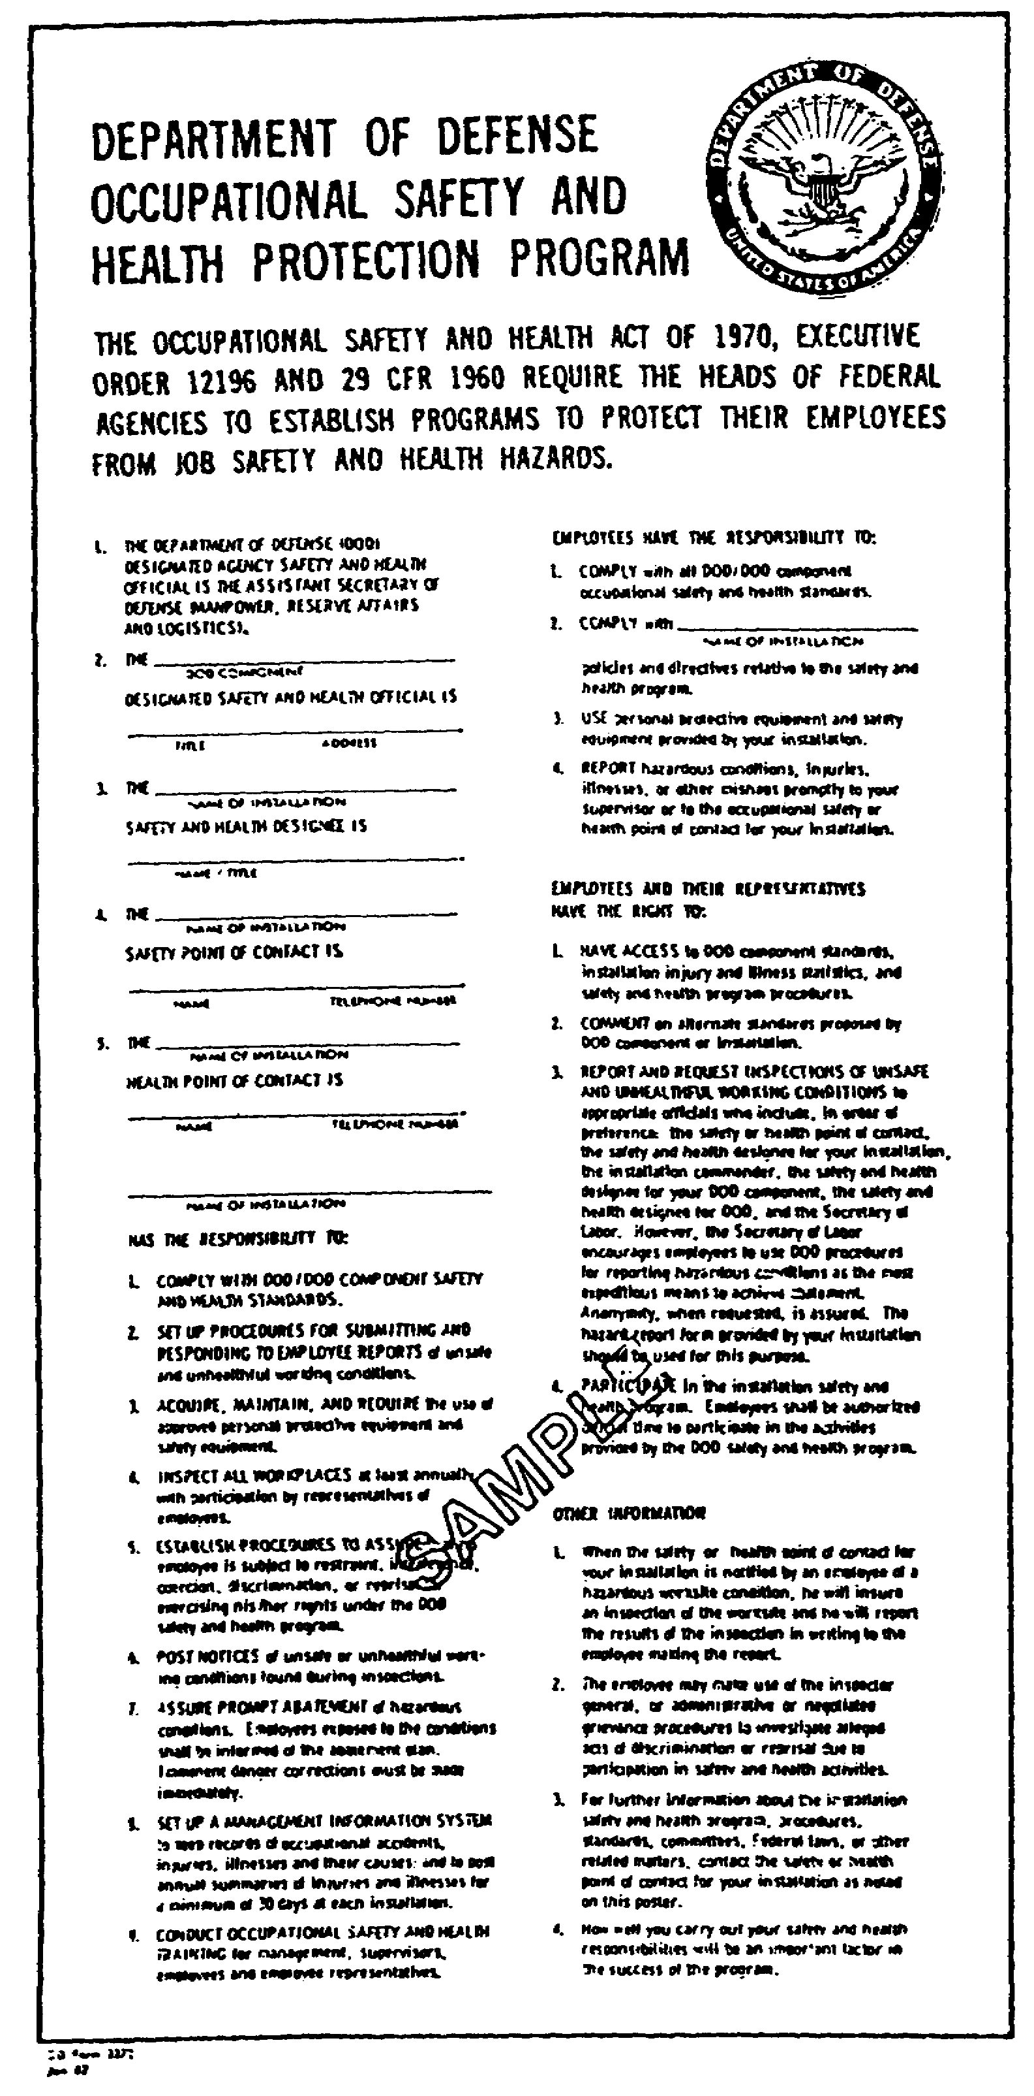

Figure 2-9. DD Form 2272

2-30 AV0584
LESSON 2

PRACTICE EXERCISE

The following items will test your grasp of the lesson material. Each item has only one correct answer. When you complete the exercise, check your answers with the answer key that follows. If you answer any item incorrectly, restudy that part of the lesson.

1. Who will act as the primary advisor on matters of aviation accident prevention within the DA?

A. ASA (IL&FM)
B. Commander, USASC
C. Director, Human Resources Development, DCSPER
D. Deputy Chief of Staff for Operations and Plans

2. Duties of the Command Safety Director, assigned by the installation commander, will include developing

A. policy and plans.
B. procedures and objectives.
C. projects specified in AR 385-10.
D. plans, policy, procedures, objectives, and projects specified in AR 385-10.

3. Which standard will apply when current standards in Army publications conflict with applicable OSHA standards and provide a lower degree of protection?

A. OSHA
B. work plan
C. Army publications
D. engineer directives

4. Policies, procedures, and guidelines for implementing the ASP are found in AR 385-10.

A. true
B. false

5. Providing a safe and healthful environment always is not one of the safety goals of the Army.

A. true
B. false

2-31 AV0584
6. Lessening the severity of injuries and occupational illnesses resulting from Army operations is one aim of Army safety goals.

A. true
B. false

7. Accident prevention is a command responsibility.

A. true
B. false

8. The Director, Human Resources Development, DCSPER, is the principal advisor and assistant to the Secretary of the Army for Army safety and OSHA matters.

A. true
B. false

9. MACOM and installation commanders are not concerned with providing enough funds and qualified staffing for the safety program.

A. true
B. false

10. SASOHI are mandatory and will be followed on all installation level inspections.

A. true
B. false

11. Hazards in category I are those that are critical and may cause severe injury, severe occupational illness, or major property damage.

A. true
B. false

12. Reports of unsafe or unhealthful conditions by Army personnel are important in detecting hazards that cause accidents.

A. true
B. false

13. Hazards uncovered as a result of inspections, accident investigations, and personnel reports of hazards are collected on DA Form 4754.

A. true
B. false

2-32 AV0584
14. In some OSH situations, the most effective means to correct a hazardous situation may be through application of local alternate measures instead of set criteria.

A. true
B. false

15. DA policy is to recognize outstanding effort and achievement in preventing accidents.

A. true
B. false

2-33 AV0584
LESSON 2

PRACTICE EXERCISE

ANSWER KEY AND FEEDBACK

Item Correct Answer and Feedback

1. B. Commander, USASC.

Self-explanatory. (page 2-7, Figure 2-4)

2. D. plans, policy, procedures, objectives, and projects specified in AR 385-10.

This staff official will report directly to the commander on all safety program and OSHA matters. (page 2-10, para 6a)

3. A. OSHA.

When current standards in Army publications conflict with an applicable OSHA standard and provide a lower degree of protection, the OSHA standard will apply. (page 2-21, para 17b)

4. A. true

AR 385-10 establishes the ASP and prescribes policies, procedures, and guidelines for implementing the safety program including the Occupational Safety and Health Act and DOD requirements throughout the Department of the Army. (page 2-1, INTRODUCTION)

5. B. false

One of the primary goals of the Army is to provide a safe and healthful environment at all times for all Army personnel and others exposed to Army operations. (page 2-2, para 1)

6. A. true

It improves employee morale and efficiency and minimizes the cost associated with loss of production, compensation payments, sick leave use, and other related expenses. (page 2-2, para 2a)

2-34 AV0584
Item Correct Answer and Feedback

7. A. true

Commanders must ensure compliance with the safety program and establish necessary additional requirements to ensure the safety of personnel under their control. (page 2-3, para 3b)

8. B. false

The Assistant Secretary of the Army (Installations, Logistics, and Financial Management) is the principal advisor and assistant to the Secretary of the Army for Army safety and OSHA matters. (page 2-4, para 4a)

9. B. false

Each MACOM and installation commander will provide sufficient funds and qualified staffing for the safety program. (page 2-10, para 6b)

10. A. true

Additional procedures also are authorized. (page 2-13, para 9)

11. B. false

Hazards in Category I are catastrophic (may cause death or loss of a facility). (page 2-14, para 9h)

12. A. true

Commanders will publicize all channels for reporting unsafe or unhealthful conditions, emphasizing personnel responsibility for making such reports. (page 2-17, para 11a and 11b)

13. A. true

All hazards uncovered as a result of inspections, accident investigations, and personnel reports of hazards should be consolidated on DA Form 4754. This will allow the commander and his safety staff to focus on underlying problems and corrective actions. (page 2-20, para 13)

2-35 AV0584
Item Correct Answer and Feedback

14. A. true

If this method is selected, installation commanders will consult with personnel representatives on the proposed procedure and submit a deviation package through channels to the MACOM. (page 2-22, para 17f)

15. A. true

All commanders will recognize their subordinate commands, installations, activities, and individuals when significant contributions are made to the efficiency, economy, or improvement of Army operations through accident prevention. (page 2-29, para 22a)

2-36 AV0584
LESSON 3

DRUG AND ALCOHOL ABUSE

Critical Task: None

OVERVIEW

LESSON DESCRIPTION:

This lesson will help you identify the impact of drug and alcohol
abuse on accidents and develop a successful drug and alcohol
abuse prevention program.

TERMINAL LEARNING OBJECTIVE:

ACTION: Identify the impact of drug and alcohol abuse on accidents and develop a successful drug and alcohol abuse prevention program.

CONDITION: You will use the lesson text to complete the action.

STANDARD: You will identify the impact of drug and alcohol abuse on accidents and develop a successful drug and alcohol abuse prevention program according to this lesson.

REFERENCE: The material in this lesson was derived from the following publications: AR 385-10; AR 385-40; and DOD Directive (DODD) 1000.3, Appendix F.

INTRODUCTION

Drugs that are abused can be classified in many ways, but there are six categories that are most commonly abused: alcohol, narcotics, stimulants, depressants, marijuana, and hallucinogens. Although it is recognized that abuses of other categories of drugs do exist within the Army, only alcohol abuse will be covered in this lesson.

In examining alcohol abuse, you must remember that alcohol consumption is common in the United States. From a safety point of view, it is not necessary for alcohol abuse to be present for its use to be addressed by a safety program. It is only necessary for using alcohol to be present and classified as an accident causation factor.

3-1 AV0584
1. ALCOHOL AS AN ACCIDENT CAUSATION FACTOR

A recent review of Army accidents showed that somewhat less than 3 percent of all accident reports explicitly show involvement of alcohol or drugs as an accident causation factor. If that's true, alcohol involvement in accidents is not a big problem. The problem, however, is there is good evidence that the data is grossly inaccurate. Indeed, supervisors do not show on the accident report that alcohol is an accident causation factor even when they know or at least have excellent evidence showing alcohol involvement is a part of the problem. There are supervisors who prefer to tolerate the problem drinker and cover up for the individual rather than give the person meaningful help. This type of accident underreporting even extends to fatal accidents. One major Army command reported that 38 percent of its fatal privately owned vehicles (POV) accidents involved alcohol as a causation factor. Data from the supporting medical command clearly showed 52 percent of the fatalities involved alcohol. The tendency of supervisors to underreport accidents involving alcohol has simply led to burying the problem rather than dealing with it in an open and systematic manner. If our reported accident data understates the problem, then just what is the actual extent of the alcohol problem in Army accidents? Let's look at the problem and the best available evidence of alcohol involvement in several key areas.

a. Driving

National accident statistics show that 50 to 55 percent of all vehicle accidents involving a fatality shows alcohol as a causation factor. Evidence shows that the percentage is much higher for drivers between 16 and 25. One study of teenage vehicle related fatalities conducted in a populace county showed that nearly 100 percent of all fatalities in this age group involved alcohol. Analyses of POV accidents at installations with heavy troop concentrations support contentions that as many as 75 percent of all soldier fatalities in POVs involved using alcohol by the soldier driver. If so, this would equate to over 200 alcohol related fatalities annually in this area alone.

b. Pedestrians

Army data shows that in a recent year, 19 soldier pedestrians were killed. Nine of these reports definitely showed alcohol as an involved factor with an additional four strongly pointing to alcohol. This data closely matches a study done in an Eastern state showing that 74 percent of that state's pedestrian fatalities involved alcohol.

3-2 AV0584
c. Recreational Accidents

In one year 5 of 22 reported Army recreational swimming related drownings explicitly involved alcohol. If the trend of national data were applied to the Army recreational drownings, at least half, or 11, involved alcohol.

d. On-duty Accidents

Alcohol involvement in on-duty injuries appears even more grossly underreported. Of 10,998 reported on-duty military injuries and fatalities in one year, only 34 or three-tenths of one percent were reported to involve alcohol. Only one in 2,800 civilian injuries showed alcohol involvement. Based on various national data on drinking patterns, there is good evidence to suspect extensive alcohol involvement in work accidents. While alcohol shows up as a significant causal factor in off-duty accidents, current evidence suggests that it is a dominant factor in most these accidents. Army accident data also shows that alcohol is not a problem in on-duty accidents. However, if the Army and civilian work force has a normal distribution of problem drinkers compared to the private sector, as studies show, then the Army has at least 50,000 problem drinkers. These employees have at least three times the chance of incurring a disabling injury compared to their counterparts. Combining total on-duty military and civilian and off-duty military injuries, there is good evidence that alcohol does figure in at least 15 to 25 percent of all injuries and fatalities. Every so often the Army conducts a sampling of its military population to determine key data related to using alcohol and drugs. The findings of the most recent survey are interesting about accidents and accident causes. Consider these survey findings.

(1) A significant number of Army, military, and civilian employees drink alcoholic beverages before and during their work day.

- Within two hours before work at least once in the last 12 months: 44,000.

- During lunch break: 99,000.

- During work breaks: 29,000.

- On the job: 18,000.

(2) Many soldiers drink large amounts of alcohol at one time.

- Eight or more beers in one day at least once in the last 12 months: 430,000.

3-3 AV0584
- Eight or more glasses of wine in one day at least once in the last 12 months: 248,000.

- Eight or more shots of hard liquor in one day at least once in the last 12 months: 357,000.

(3) The Army is incurring a high incidence of problem drinker behavior among service members who consume alcohol.

- Bodily struck someone in one or more incidents in the last 12 months while drinking: 70,000.

- Awoke unable to remember what happened while drinking the night before: 178,000.

- First took a drink in the morning: 83,000.

- Couldn't stop drinking before becoming drunk: 125,000.

- Were sick because of drinking: 264,000.

(4) There are high incidences of dangerous behavior among Army personnel associated with drug and alcohol use.

- Arrested for driving under the influence (DUI) in the last 12 months: 19,000.

- Hurt in an accident connected with drinking: 19,000. (Eight thousand more were hurt in accidents involving drugs. These alcohol- and drug-related cases form 42 percent of ALL accidents reported in the survey.) ·

- Caused injury to others or damage to property as a result of drinking: 16,000. (Six thousand more cases involved drugs.)

(5) Alcohol has adversely affected the job performance of soldiers.

- Came to work with hangovers at least once in the last 12 months: 185,000.

- Were so hungover, they got to work late or had to leave early: 109,000.

- Were drunk or high at least once on the job because of drinking: 87,000. (Seventy-eight percent of these were high two times or more on the job.)

3-4 AV0584
- Reported being high on drugs while at work at least once in the last 12 months: 90,000.

(6) What all this data reveals is that there are many people, military and civilian, at their jobs under the influence of alcohol, drugs, or both, or are suffering from the aftereffects of alcohol or drugs. These people make more mistakes by far than their noneffected coworkers. As a result, they experience at least three times as many accidents as their nonabuser coworkers. A conservative estimate is that alcohol and drugs are not only a factor in 15 to 25 percent of all Army accidents but also a factor in nearly 50 percent of all fatalities.

2. CONTROLLING ALCOHOL AS AN ACCIDENT CAUSATION FACTOR

a. The problem of alcohol abuse is a major factor in Army accidents. What is being done to deal with the problem? In addition to the efforts of commanders and supervisors, there are three installation staff organizations that have special involvement in controlling alcohol abuse as an accident causation factor. These are the safety office, the Alcohol and Drug Abuse Prevention and Control Office (ADAPCO), and the Provost Marshal's Office (PMO). The responsibilities of these offices in relationship to the accident implications of alcohol can be viewed in Figure 3-1.

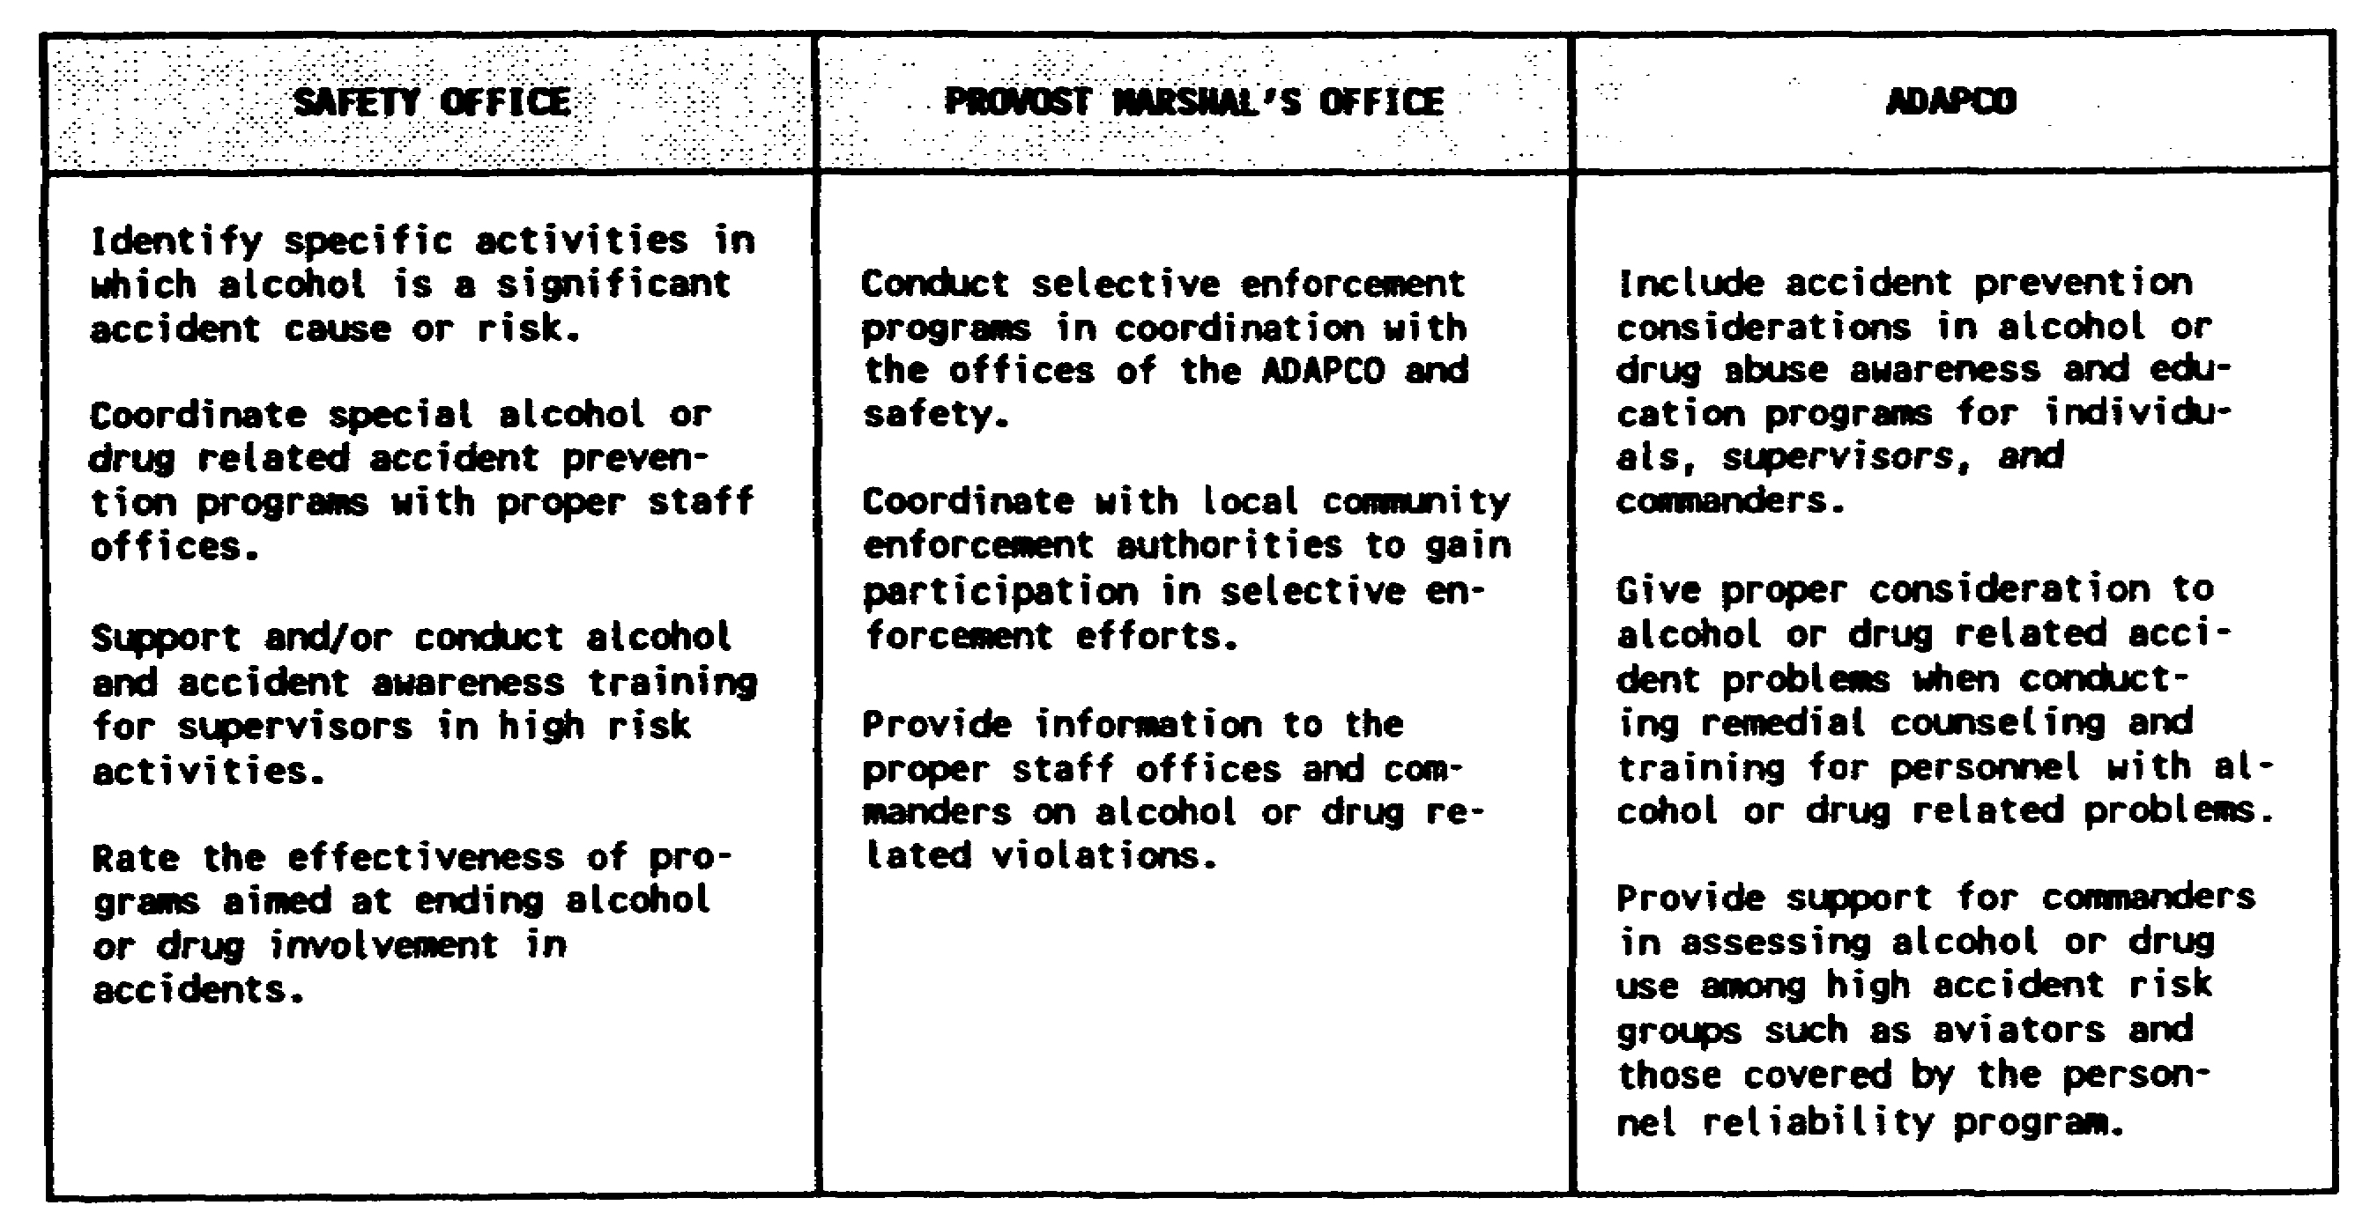

Figure 3-1. Staff organization responsibilities

3-5 AV0584
b. Since the focal point of this program is accident prevention, it is up to the safety office to take the leading role. The involvement of the PMO and ADAPCO should be within the scope of their existing missions and should be supportive of the overall objectives of those offices. The specific accident prevention programs described in paragraph 4 that involve cooperative effort of the safety office, PMO, and ADAPCO are examples.

3. SPECIFIC PROGRAMS

Three programs are essential to the control of alcohol as an accident causation factor. All three programs are encouraged, but not mandated, by existing Army regulations.

a. Selective Enforcement

The purpose of selective enforcement is not to catch offenders and punish them. That is only the means. The purpose is to create an awareness by the service member and an incentive not to display certain dangerous and often illegal behaviors while driving, swimming, or playing sports under the influence of alcohol. Since the real purpose is to deter these dangerous behaviors, selective enforcement programs will have the greatest effect when accompanied by effective punishment and broad publicity efforts. (Posters and other handout materials to support such efforts are available from the USASC.) What counts is not so much the actual level of enforcement but the perceived level of enforcement completed with the expected results of being caught. It follows that selective enforcement combined with ongoing or proper seasonal education and promotion programs directed at alcohol induced behavioral problems will have a far greater effect than either selective enforcement or education and promotion used alone. The safety office has to play the leading role in these efforts. Based on Armywide accident information, there should be four areas targeted for selective enforcement.

(1) Driving Under the Influence of Alcohol or Drugs and Pedestrians Obviously Under the Influence of Alcohol or Drugs

These first two areas are primarily the responsibility of the PMO and have a sound basis in law. Drunk driving and public intoxication are against the law in virtually all jurisdictions. An example of a highly productive selective enforcement program directed at DUI at a major post is described at Appendix B. The appendix depicts the results of the program that was conducted with effective education or promotion programs and good strong sanctions.

3-6 AV0584
(2) Swimming While Intoxicated

This area is the principal responsibility of the Morale Support Activity staff office. Lifeguard personnel should enforce posted rules at authorized swimming locations on swimming while intoxicated as they do rules to control other dangerous behavior. Military police and commanders should be prepared to support enforcement of these rules.

(3) Army Supervised Sports Involving Excessive Use of Alcohol

This, also, is the principal responsibility of the Morale Support Activity staff office. Participants in Army supervised sporting events should not use alcohol, nor should a person apparently affected by alcohol be allowed to participate. The official in charge of the game must exercise full authority under the rules to manage this aspect and should have full command support if of an incident.

b. Supervisor Awareness Program

(1) AR 600-85 requires alcohol or drug awareness training of supervisors and leaders. It is in the interests of the Army to assure that the accident prevention implications of alcohol and drugs receive proper emphasis in this training. The Civilian Personnel Office (CPO) normally manages alcohol related training for civilians. In the past, however, typically little or no special emphasis has been placed on the accident related aspects of the alcohol problem. Similar alcohol awareness training also is required for military supervisors. As for civilian training, the accident prevention content of this training will be determined by the effectiveness of the safety office in convincing the training manager of the importance of accidents as an alcohol abuse effect. The fact sheet at Appendix C provides useful information for managers responsible for conducting supervisor training. AR 600-85 directs continuing supervisor alcohol awareness training, not just a one-time shot. The safety office--

(a) Has the responsibility to provide the information and staff help necessary to convince the CPO of the need for emphasis on the accident implications of the problem.

(b) Needs to provide the factual and motivational information necessary to support effective CPO training.

(c) Has the responsibility to provide continual accident prevention awareness items on alcohol abuse, such as alerts and notices.

3-7 AV0584
(2) Part of the basis for generating supervisor interest in the accident prevention implications of alcohol abuse is substantiating its involvement in accidents. As resources permit, safety managers should assure that the chance of alcohol as an accident causation factor is fully checked during the accident investigation process.

c. Remedial Actions

(1) The ADAPCO provides a complete array of counseling and abuser management programs. These programs, however, need to be increased by special programs specifically directed at the accident prevention aspects of alcohol abuse. Two suggested courses include a formal DUI Counterattack Course and a Preventive Education Course.

(a) The DUI counterattack training has proven highly effective in applications within the Army and in some civilian organizations. The number of DUI repeat offenders among DUI course graduates is well below that of control groups. A synopsis of a DUI Counterattack Course is at Appendix D.

(b) A supportive Preventive Education Course tends specifically to deal with alcohol abuse as a factor in antisocial and general unsafe behavior. This course provides an essential means of directly addressing these undesirable behaviors in a group context with maximum economy and efficiency. A synopsis of a preventive education course is at Appendix E.

(2) When these courses are fully integrated with the magistrate system, military justice system, and the ADAPCO program, they provide valuable options to magistrates, commanders, and ADAPCO counselors. Safety personnel may choose to participate directly in the development and conduct of such courses or may choose to coordinate development of the courses with the education office and ADAPCO.

3-8 AV0584
LESSON 3

PRACTICE EXERCISE

The following items will test your grasp of the lesson material. Each item has only one correct answer. When you complete the exercise, check your answers with the answer key that follows. If you answer any item incorrectly, restudy that part of the lesson.

1. The installation staff organizations with special involvement in controlling alcohol abuse as an accident causation factor are the

A. PMO.
B. ADAPCO.
C. Safety Office.
D. PMO, ADAPCO, and Safety Office.

2. Because of underreporting of alcohol as a causation factor of all accidents, reports show that

A. less than 3 percent explicitly involve drugs or alcohol as a cause factor.
B. 38 percent of fatal POV accidents involve alcohol.
C. 52 percent of all fatalities involve alcohol.
D. all of the above are correct.

3. What age group is most frequently in fatal accidents involving alcohol?

A. 16-25
B. 16-32
C. 18-24
D. 30-35

4. What office, with command support, can help control accident causation through lifeguards enforcing intoxication rules with swimmers?

A. PMO
B. ADAPCO
C. Recreation Activities Office
D. Morale Support Activity Staff Office

3-9 AV0584
5. Data reveals that individuals under the effect of alcohol, drugs, or both

A. are factors in 15 to 25 percent of all Army accidents and in nearly 50 percent of all fatalities.
B. experience at least four times as many accidents as their nonabuser coworkers.
C. make five times more mistakes than their unaffected coworkers.
D. are included in all of the above.

6. A study done on pedestrian fatalities in an Eastern state shows that alcohol was involved in what percentage of the fatalities?

A. 24
B. 35
C. 74
D. 92

7. National accident statistics show that percent of vehicle accidents involving a fatality have alcohol as a causation factor.

A. 20-25
B. 50-55
C. 65-70
D. nearly 100

8. The trend of national data shows that of recreational drownings involve alcohol.

A. 22 percent
B. at least half
C. over 80 percent
D. 30 to 35 percent.

3-10 AV0584
LESSON 3

PRACTICE EXERCISE

ANSWER KEY AND FEEDBACK

Item Correct Answer and Feedback

1. D. PMO, ADAPCO, and Safety Office.

These are in addition to the primary efforts of the commanders and supervisors. (page 3-5, para 2a)

2. A. less than 3 percent explicitly involve drugs or alcohol as a cause factor.

There is good evidence that the data is grossly inaccurate because of supervisors covering up for subordinates. (page 3-2, para 1)

3. A. 16-25.

Self-explanatory. (page 3-2, para 1a)

4. D. Morale Support Activity Staff Office. Lifeguard personnel should enforce posted rules at authorized swimming locations regarding swimming while intoxicated. MPs and commanders should support the enforcement of these rules. (page 3-7, para 3a(2) and (3))

3-11 AV0584
Item Correct Answer and Feedback

5. A. are factors in 15 to 25 percent of all Army accidents and in nearly 50 percent of all fatalities.

Self-explanatory. (page 3-5, para 1d(6))

6. C. 74.

Not only is drinking and driving dangerous, drinking and walking can be just as fatal. (page 3-2, para 1b)

7. B. 50-55.

Self-explanatory. (page 3-2, para 1a)

8. B. at least half.

Self-explanatory. (page 3-3, para 1c)

3-12 AV0584

